Lower One Controlled Inquiry: French

Topic: French / Français
Inquiry: Why learn French? / Pourquoi apprendre le français?

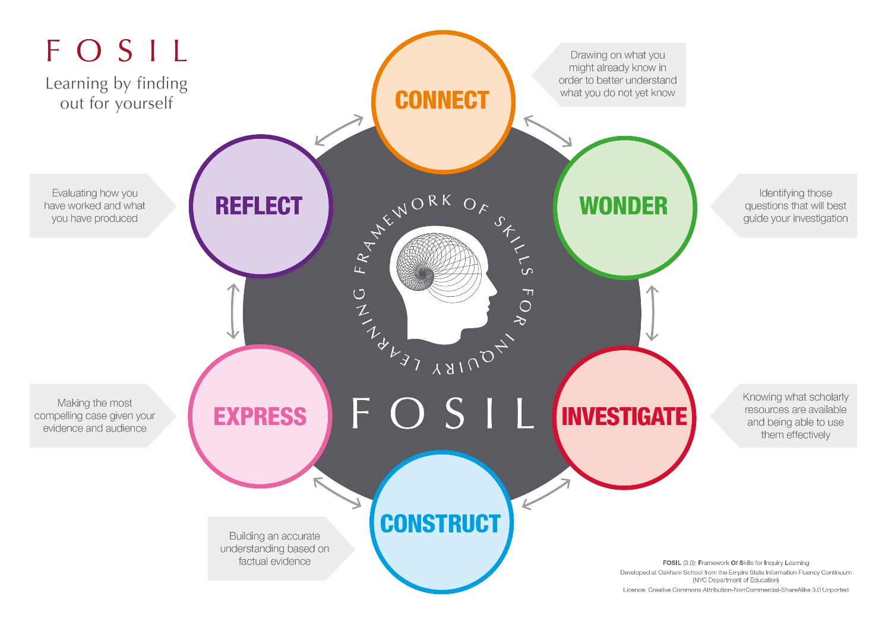

Why Learn French Inquiry Journal by Oakham School is licensed under a Creative Commons Attribution-NonCommercial-ShareAlike 4.0 International License.

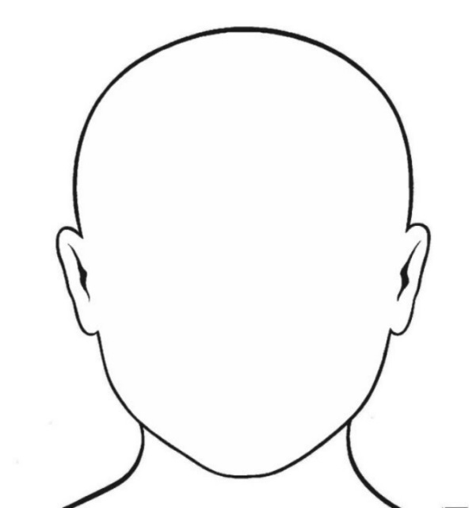
What do I already know about my topic?
Qu’est-ce que je connais déjà à propos de cette matière ?

French
Le Français

Identifying questions to guide my investigation
Identifier des questions pour guider mes recherches

I already know | I wonder

Finding information | Working with information
Trouver des informations | Travailler avec des informations
How does this information help me to answer the question?
Comment cette information m’aide t-elle à répondre à la question?
Explain the relevance of the information you have found.

What information have I found? / Quelle(s) information(s) ai-je trouvé?
You can either copy out the information word for word (quote it), making sure you use quotation marks (“…”), or write it in your own words (paraphrase).

Source (Title and Date) / Origine (Titre et date):

Source (Title and Date) / Origine (Titre et date):

What information have I found? / Quelle(s) information(s) ai-je trouvé?
You can either copy out the information word for word (quote it), making sure you use quotation marks (“…”), or write it in your own words (paraphrase).

How does this information help me to answer the question?
Comment cette information m’aide t-elle à répondre à la question?
Explain the relevance of the information you have found.

Why learn French? / Pourquoi apprendre le français?
Job title  (in English) | Job title  (in French) | What does this job entail?  What does someone who has this job do? | Source of evidence (title and type of source): | Why might knowing French be useful for this job?

Job title (in English) | Job title (in French) | What does this job entail?  What does someone who has this job do? | Source of evidence (title and type of source): | Why might knowing French be useful for this job?

