Lower One Controlled Inquiry: The 20th Century

Topic: The 20th Century
Inquiry: Which decade of the 20th Century would have been the best decade to live through and why?

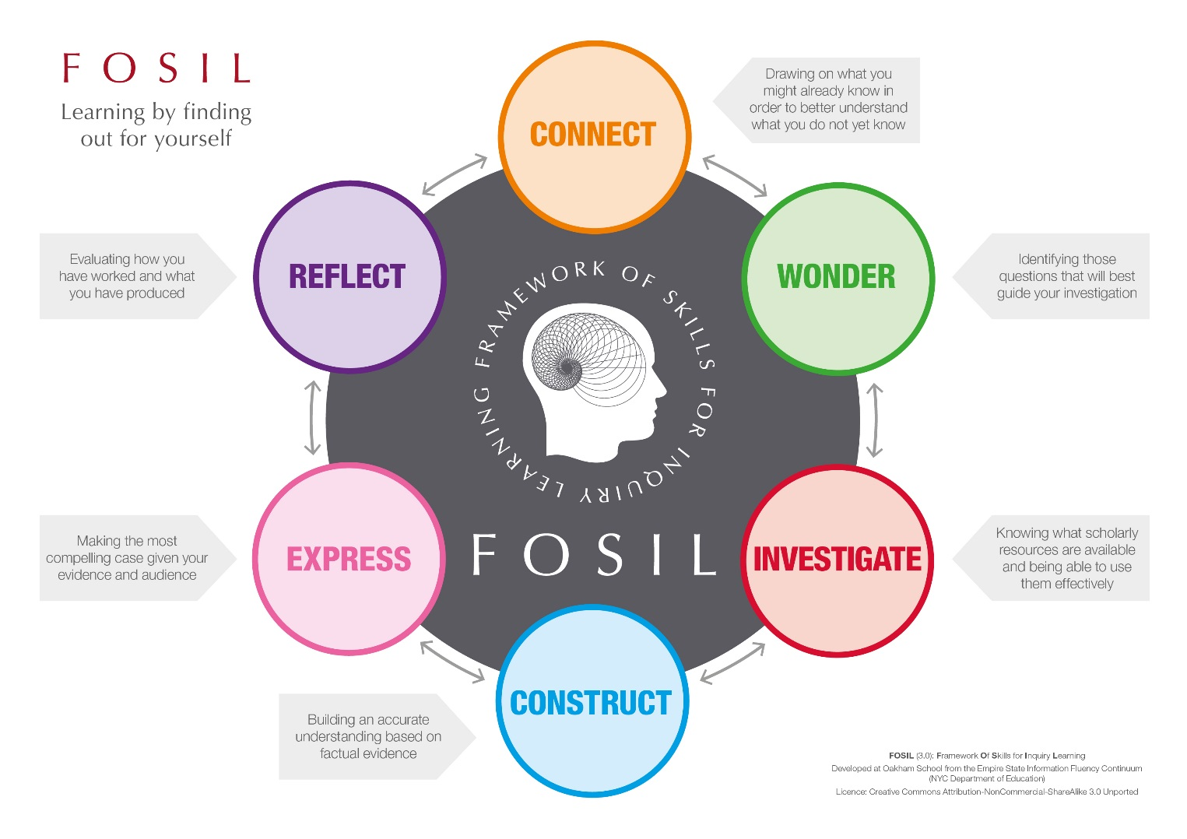
20th Century Inquiry Journal by Oakham School is licensed under a Creative Commons Attribution-NonCommercial-ShareAlike 4.0 International License.
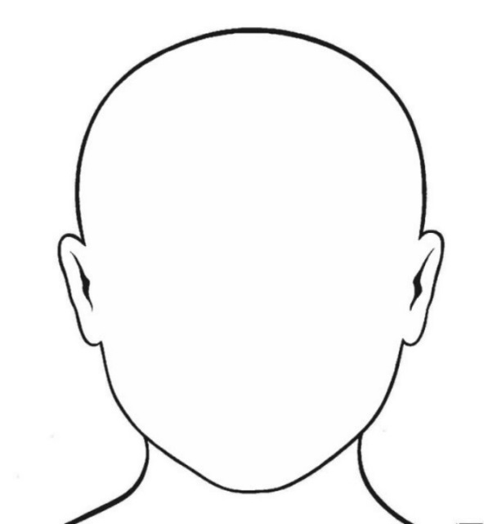
Topic

The 20th Century

What do I already know about my topic?

Identifying questions to guide my investigation
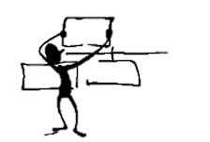

Questions I can already answer | Questions I still need to ask

Finding information | Working with information
Source (Title and Date):
What information have I found?
You can either copy out the information word for word (quote it), making sure you use quotation marks (“…”), or write it in your own words (paraphrase).

How does this information help me to answer the question?
Explain the relevance of the information you have found.

Source (Title and Date):
What information have I found?
You can either copy out the information word for word (quote it), making sure you use quotation marks (“…”), or write it in your own words (paraphrase).

How does this information help me to answer the question?
Explain the relevance of the information you have found.

Source (Title and Date):
What information have I found?
You can either copy out the information word for word (quote it), making sure you use quotation marks (“…”), or write it in your own words (paraphrase).

How does this information help me to answer the question?
Explain the relevance of the information you have found.

Main points from my research (in my own words)
Conclusion:
Topic:
Main point:
Evidence and Examples to support this main point
•
•
•
Sources of evidence (title and type of source):
•
•
•
Sources of evidence (title and type of source):
•
•
•
Main point:
Evidence and Examples to support this main point
•
•
•
Main point:
Evidence and Examples to support this main point
•
•
•
Sources of evidence (title and type of source):
•
•
•

Bibliography

Book | Author:
Website | Date Published:
Magazine | Page no. / URL:
Other | Publisher / Website:
 | Title / Webpage:

Book | Author:
Website | Date Published:
Magazine | Page no. / URL:
Other | Publisher / Website:
 | Title / Webpage:

Book | Author:
Website | Date Published:
Magazine | Page no. / URL:
Other | Publisher / Website:
 | Title / Webpage:

How am I doing?

Statement | What I think  (Tick if you agree) | What my teacher thinks  (Leave blank for your teacher)
I answered my research question.
My main ideas are clearly presented.
I provided evidence for my main ideas.
My final project is written in my own words.
My final project is neat, clear and well organised.
I checked my grammar and spelling.
I used more than one source of evidence
I used both print and electronic sources of evidence.
I cited the sources of my information.
I presented the project in a way my friends would find interesting and engaging.

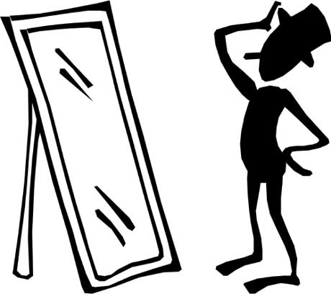

How did I do?
Strengths
Why was it good?
What I did well

1.

2.

3.
What could have been better?
How can I improve it next time?
Goals

1.

2.

3.

