Lower One Controlled Inquiry: Alfred the Great

Topic: Alfred the Great
Inquiry: What was so great about Alfred the Great?

All stories must start somewhere.

By the end of this inquiry, you should have a good understanding of why this is a good place, and time, to start ours.

So, then, let the telling of our story begin – what exactly was so great about Alfred the Great?

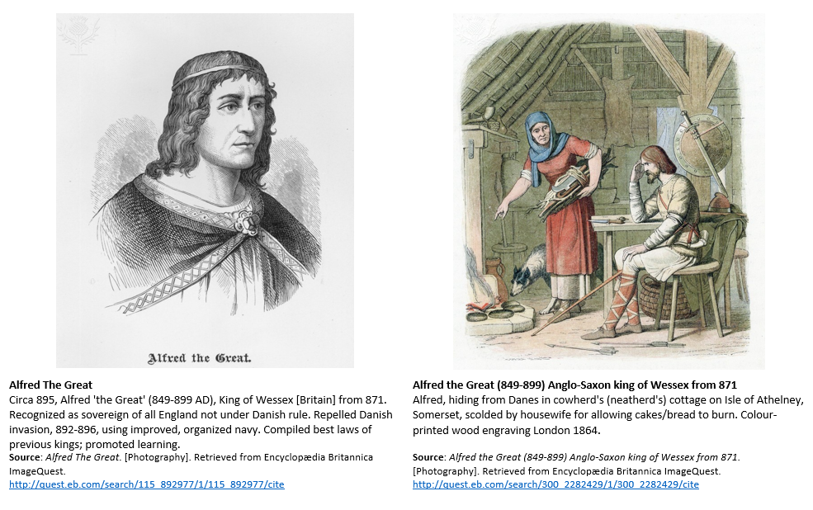

Alfred the Great Inquiry Journal by Oakham School is licensed under a Creative Commons Attribution-NonCommercial-ShareAlike 4.0 International License.

The world belongs to me because I understand it.
Honoré de Balzac, quoted by Saul Bellow in The Closing of the American Mind (Bloom, 1987, p. 15).

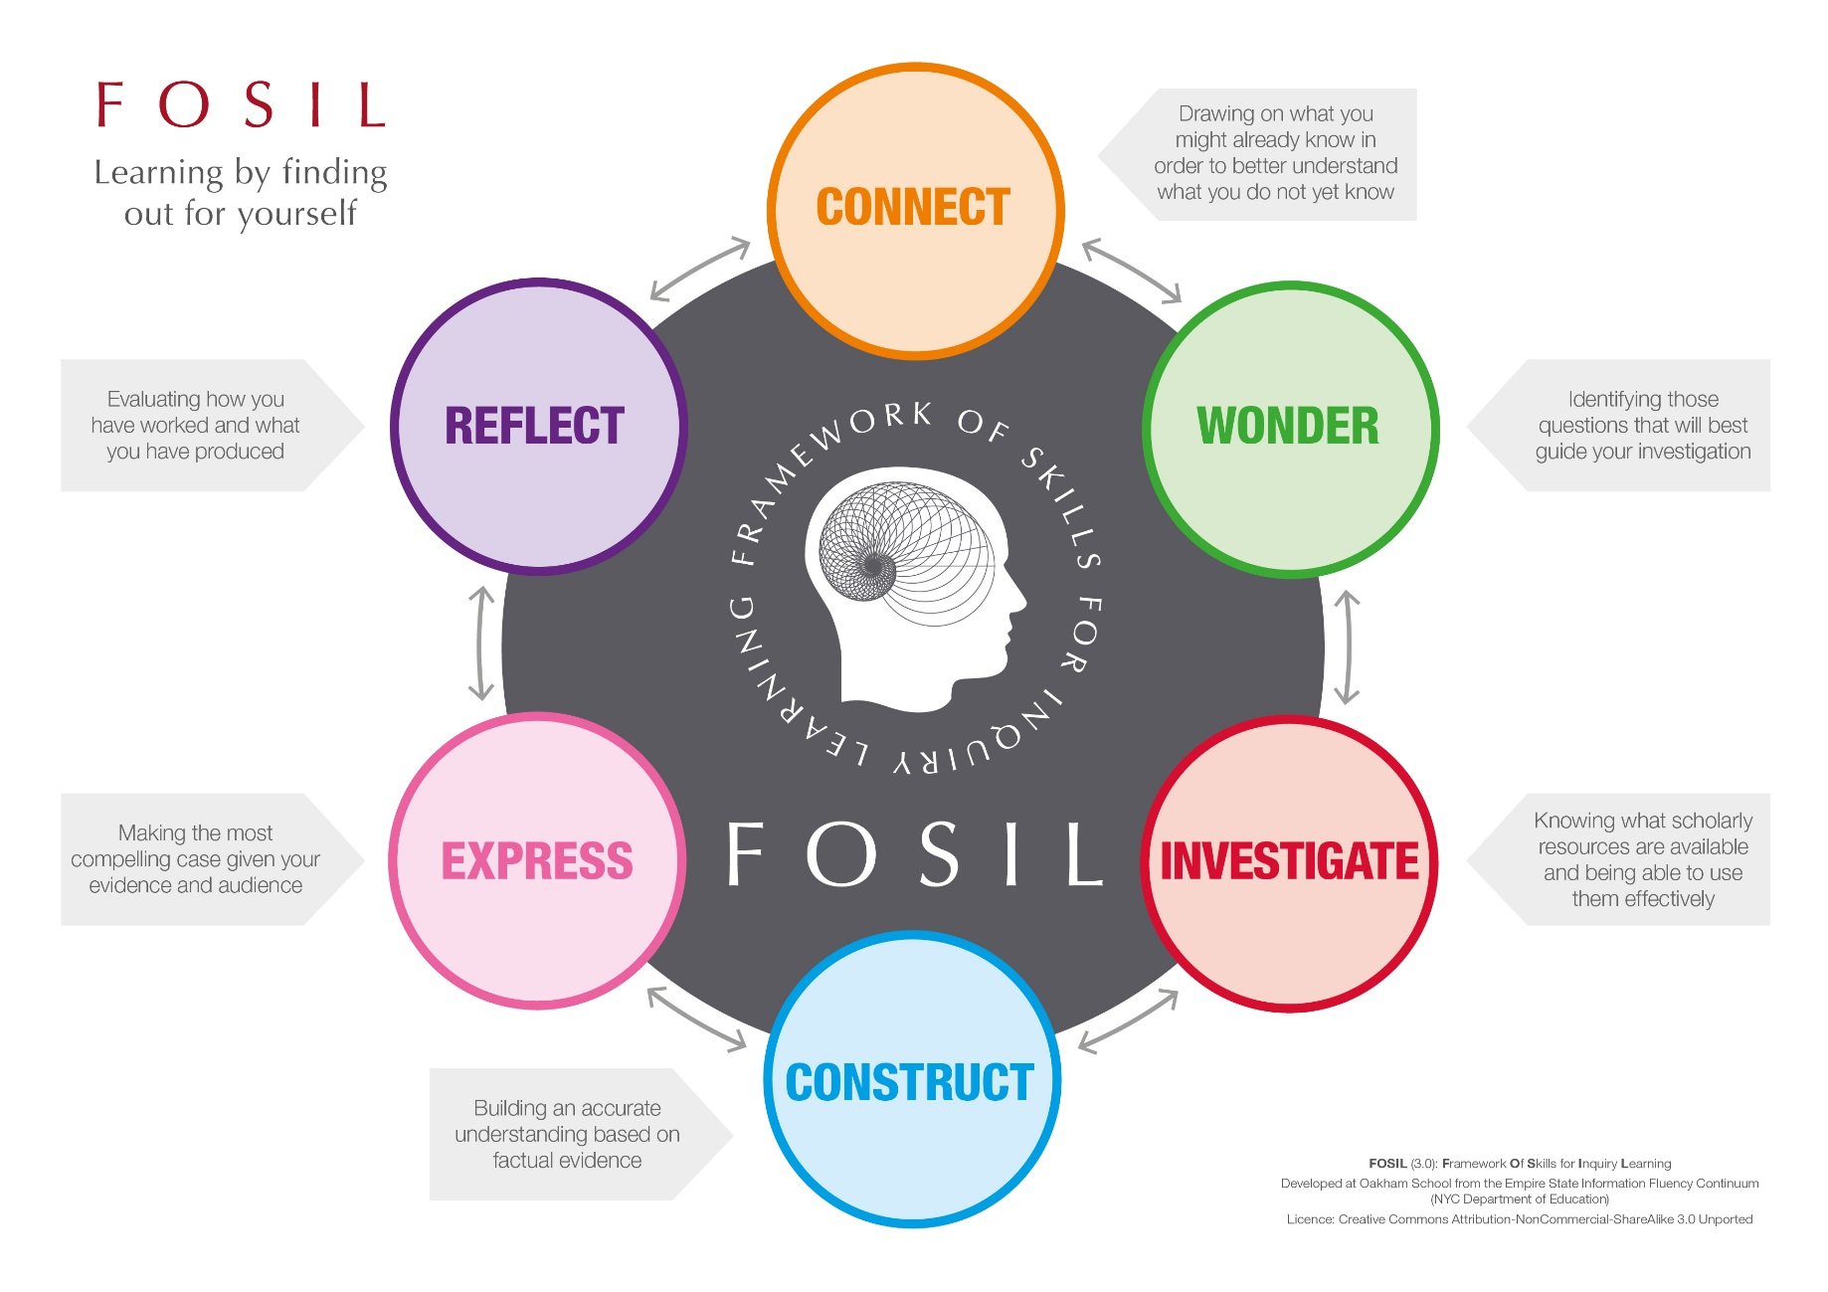

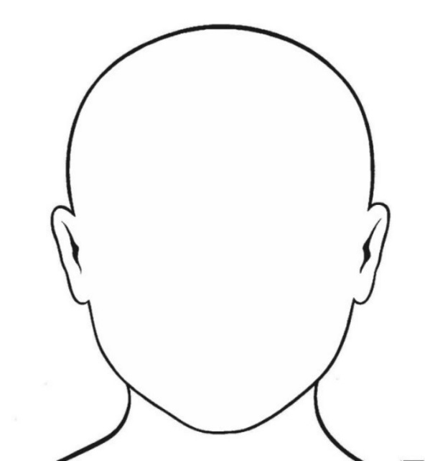
Topic

What do I already know about my topic?

Identifying questions to guide my investigation
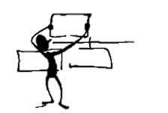

I already know | I wonder

Finding information | Working with information
Source (Title and Date):
What information have I found?
You can either copy out the information word for word (quote it), making sure you use quotation marks (“…”), or write it in your own words (paraphrase).

How does this information help me to answer the question?
Explain the relevance of the information you have found.

Source (Title and Date):
What information have I found?
You can either copy out the information word for word (quote it), making sure you use quotation marks (“…”), or write it in your own words (paraphrase).

How does this information help me to answer the question?
Explain the relevance of the information you have found.

Source (Title and Date):
What information have I found?
You can either copy out the information word for word (quote it), making sure you use quotation marks (“…”), or write it in your own words (paraphrase).

How does this information help me to answer the question?
Explain the relevance of the information you have found.

Main points from my research (in my own words)
Question:

Main point:
Source of evidence (title and type of source):
Main point:
Source of evidence (title and type of source):
Main point:
Source of evidence (title and type of source):

Bibliography

Book | Author:
Website | Date Published:
Magazine | Page no. / URL:
Other | Publisher / Website:
 | Title / Webpage:

Book | Author:
Website | Date Published:
Magazine | Page no. / URL:
Other | Publisher / Website:
 | Title / Webpage:

Book | Author:
Website | Date Published:
Magazine | Page no. / URL:
Other | Publisher / Website:
 | Title / Webpage:

How am I doing?

Statement | What I think  (Tick if you agree) | What my teacher thinks  (Leave blank for your teacher)
I answered my research question.
My main ideas are clearly presented.
I provided evidence for my main ideas.
My final project is written in my own words.
My final project is neat, clear and well organised.
I checked my grammar and spelling.
I used more than one source of evidence
I used both print and electronic sources of evidence.
I cited the sources of my information.
I presented the project in a way my friends would find interesting and engaging.

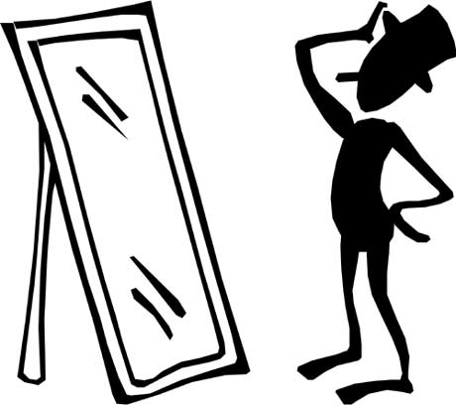

How did I do?
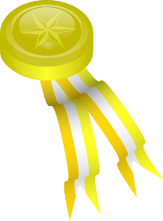
Strengths
Why was it good?
What I did well
How can I improve it next time?
What could have been better?
Goals

3.

2.

1.

2.

3.

1.

