Lower One Controlled Inquiry: The Cold War

Topic: The Cold War
Inquiry: What were the global effects of the Cold War?

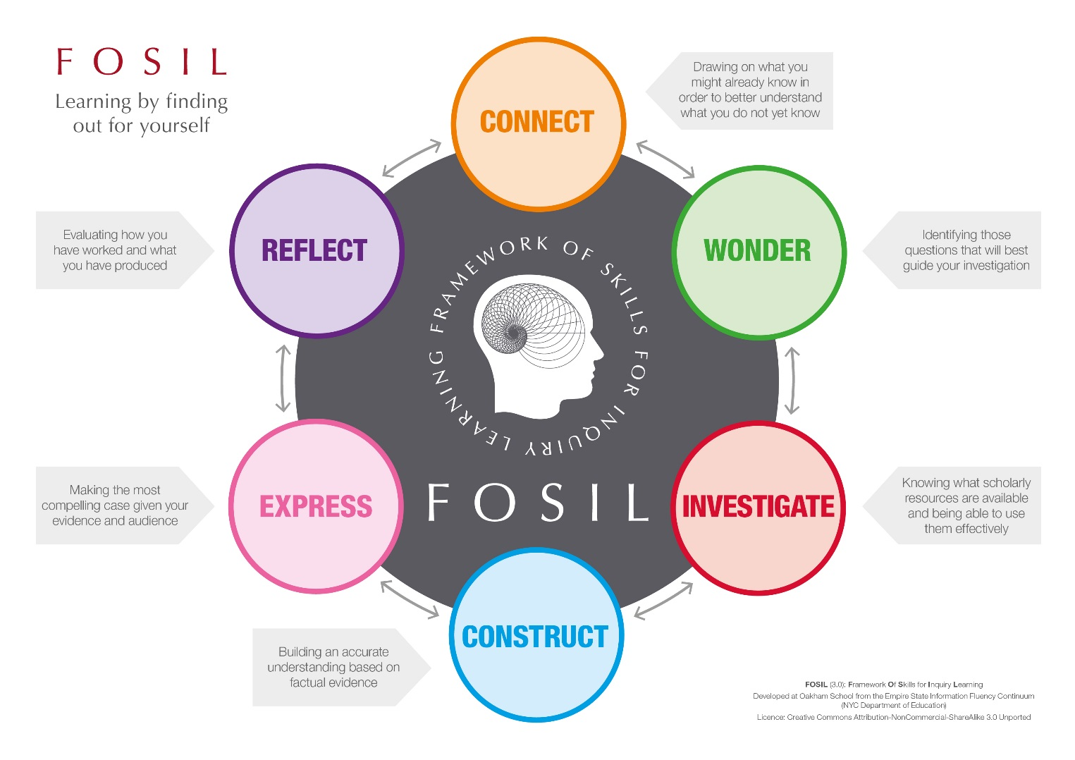
Cold War Inquiry Journal by Oakham School is licensed under a Creative Commons Attribution-NonCommercial-ShareAlike 4.0 International License.
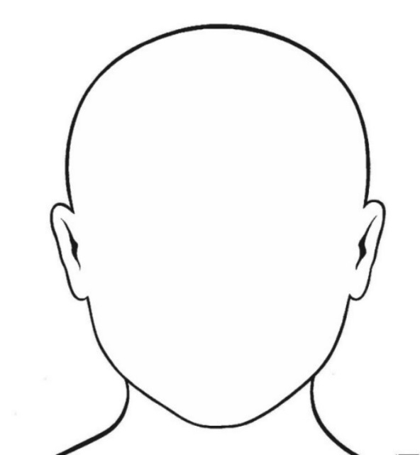
Topic

The
Cold War

What do I already know about my topic?

Identifying questions to guide my investigation
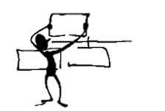

Questions I can already answer | Questions I still need to ask

Finding information | Working with information
Source (Title and Date):
Cold War. (2019). In Encyclopædia Britannica. Retrieved from https://school.eb.co.uk/levels/foundation/article/Cold-War/440092
What information have I found?
You can either copy out the information word for word (quote it), making sure you use quotation marks (“…”), or write it in your own words (paraphrase).

How does this information help me to answer the question?
Explain the relevance of the information you have found.

Source (Title and Date):
Cold War. (2019). In Encyclopædia Britannica. Retrieved from https://school.eb.co.uk/levels/foundation/article/Cold-War/440092

What information have I found?
You can either copy out the information word for word (quote it), making sure you use quotation marks (“…”), or write it in your own words (paraphrase).

How does this information help me to answer the question?
Explain the relevance of the information you have found.

Source (Title and Date):

What information have I found?
You can either copy out the information word for word (quote it), making sure you use quotation marks (“…”), or write it in your own words (paraphrase).

How does this information help me to answer the question?
Explain the relevance of the information you have found.

Source (Title and Date):

What information have I found?
You can either copy out the information word for word (quote it), making sure you use quotation marks (“…”), or write it in your own words (paraphrase).

How does this information help me to answer the question?
Explain the relevance of the information you have found.

Main points from my research (in my own words)
Conclusion:
Topic: … was a significant event in the Cold War because …
Main point:
Evidence and Examples to support this main point
•
•
•
Sources of evidence (title and type of source):
•
•
•
Sources of evidence (title and type of source):
•
•
•
Main point:
Evidence and Examples to support this main point
•
•
•
Main point:
Evidence and Examples to support this main point
•
•
•
Sources of evidence (title and type of source):
•
•
•

Bibliography

Book | Author:
Website | Date Published:
Magazine | Page no. / URL:
Other | Publisher / Website:
 | Title / Webpage:

Book | Author:
Website | Date Published:
Magazine | Page no. / URL:
Other | Publisher / Website:
 | Title / Webpage:

Book | Author:
Website | Date Published:
Magazine | Page no. / URL:
Other | Publisher / Website:
 | Title / Webpage:

Fact sheet - How are we doing?

Statement | What we think  (Tick if you agree) | What my teacher thinks  (Leave blank for your teacher)
Fact sheet
We considered why our event was important and significant.
We presented our main ideas clearly.
We provided evidence for our main ideas.
Our fact sheet is written in our own words.
Our fact sheet is neat, clear and well organised so our classmates should be able to understand everything.
We checked our grammar and spelling.

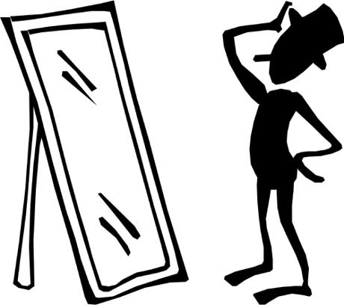

Presentation - How are we doing?

Statement | What I think  (Tick if you agree) | What I think  (Tick if you agree) | What I think  (Tick if you agree)
Presentation | Event | Event | Event
It is clear which event the group is talking about
I understand where the event took place
I understand when the event took place
I understand why the event took place
I was told why the group thought their event was significant
The topic was presented in an interesting and engaging way

How did I do?
Strengths
Why was it good?
What I did well

1.

2.

3.
What could have been better?
How can I improve it next time?
Goals

1.

2.

3.

