First Form Controlled Inquiry: CREST Project

Topic: Heating and Cooling

By the end of this inquiry, you should have researched, built and tested something that reduces heat transfer as part of its job. Your teacher will give you some ideas.

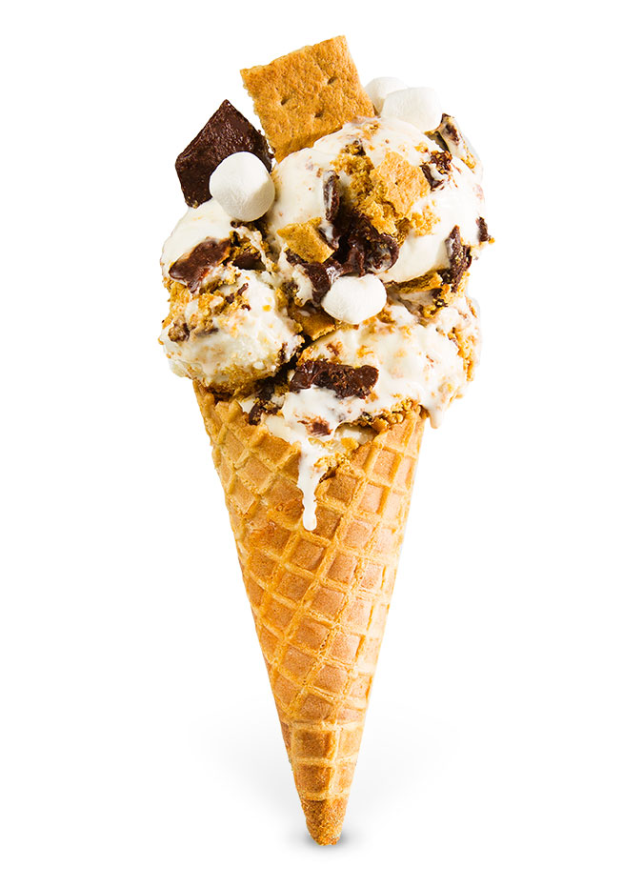

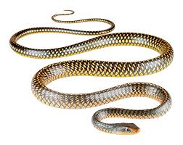

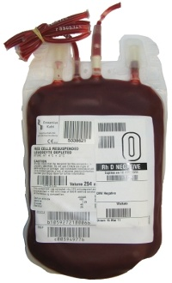
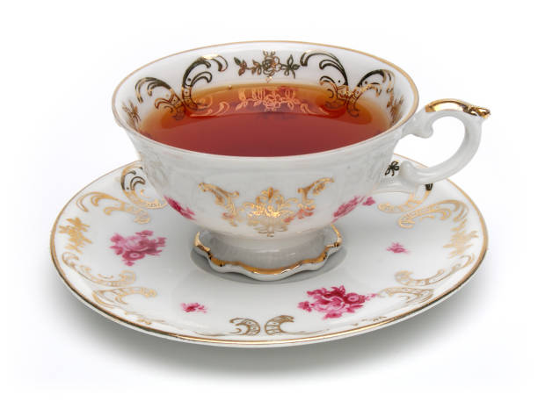
CREST Heat Transfer Journal by Oakham School is licensed under a Creative Commons Attribution-NonCommercial-ShareAlike 4.0 International License.
The world belongs to me because I understand it.
Honoré de Balzac, quoted by Saul Bellow in The Closing of the American Mind (Bloom, 1987, p. 15).

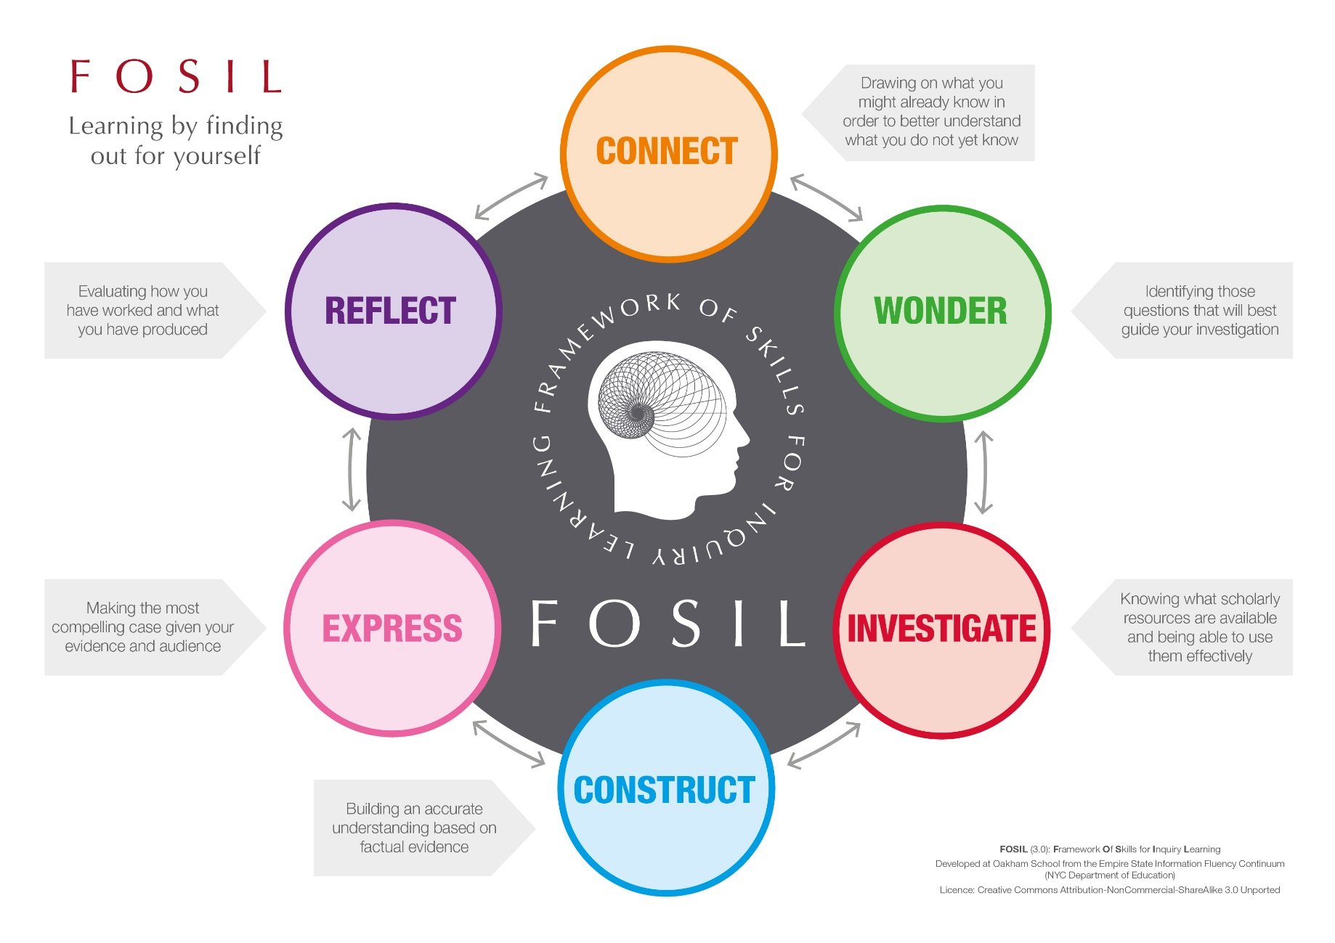
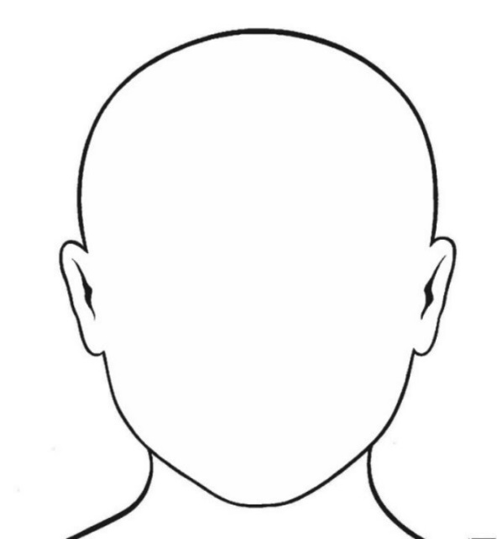
Example
Topic

Heat Transfer

When our bodies get too warm, we sweat.

The sweat cools us down.

What do I already know about my topic?

Identifying questions to guide my investigation
Example
Inquiry question: Does evaporation affect the speed of heat loss?

 | How will this help me in my inquiry?
What do I already know?  Sweating cools our bodies down.  The sweat evaporates from the skin.  Heat is lost from our bodies in this way because heat energy is used to turn the sweat from a liquid into a gas. | I will need to reduce the amount of evaporation that can occur in my experiment.  I think I can reduce evaporation by using a lid.
What do I still need to find out ? | How could I find out?
Does using a lid reduce the amount of heat lost from my experiment? | I will see how fast heat is lost from hot water in a cup with a lid.  I will compare this with a similar cup without a lid.  I will measure how the temperature of hot water drops over a fixed period of time using a thermometer and a stopwatch.

Identifying questions to guide my investigation
Inquiry question:

How will this help me in my inquiry?
What do I already know?
What do I still need to find out ? | How could I find out?
Identifying questions to guide my investigation
Inquiry question:

How will this help me in my inquiry?
What do I already know?
What do I still need to find out ? | How could I find out?
Identifying questions to guide my investigation
Inquiry question:

How will this help me in my inquiry?
What do I already know?
What do I still need to find out ? | How could I find out?

Finding information | Working with information
Example
Source: Book Website Magazine Other: ________________
Author: Sam Holyman, Phil Routledge and David Sang Book title / Webpage: Fusion 1
Date Published: 2008 Book publisher / Name of Website: Nelson Thornes
Book page no./ Website URL: 90-91

What information have I found?
You can either copy out the information word for word (quote it), making sure you use quotation marks (“…”), or write it in your own words (paraphrase). You might want to draw a diagram.

The particles in liquids are always bouncing off each other and passing energy between them. Sometimes one particle gets so much energy from the others that it can escape from the surface as a gas. The liquid left behind is colder (because the particle that escaped has carried lots of energy away!). This is called heat loss by EVAPORATION. This is what happens when you sweat.
How does this information help me with my inquiry?
Explain how this information will help you to design something to reduce heat transfer.

To stop the fast particles carrying the heat energy away from my container, I will trap them by using a lid. I need to do an experiment to find out how much difference this makes.

Source: Book Website Magazine Other: ________________
Author: Book title / Webpage:
Date Published: Book publisher / Name of Website:
Book page no./ Website URL:

What information have I found?
You can either copy out the information word for word (quote it), making sure you use quotation marks (“…”), or write it in your own words (paraphrase). You might want to draw a diagram.

How does this information help me with my inquiry?
Explain how this information will help you to design something to reduce heat transfer.

Source: Book Website Magazine Other: ________________
Author: Book title / Webpage:
Date Published: Book publisher / Name of Website:
Book page no./ Website URL:

What information have I found?
You can either copy out the information word for word (quote it), making sure you use quotation marks (“…”), or write it in your own words (paraphrase). You might want to draw a diagram.

How does this information help me with my inquiry?
Explain how this information will help you to design something to reduce heat transfer.

Source: Book Website Magazine Other: ________________
Author: Book title / Webpage:
Date Published: Book publisher / Name of Website:
Book page no./ Website URL:

What information have I found?
You can either copy out the information word for word (quote it), making sure you use quotation marks (“…”), or write it in your own words (paraphrase). You might want to draw a diagram.

How does this information help me with my inquiry?
Explain how this information will help you to design something to reduce heat transfer.
Gathering experimental data: Pilot
Purpose of experiment | We need to do some quick ‘rough tests’ to find out what values would be suitable for the variables that we might want to keep the same in all the rest of our experiments. We might not use these results to draw any conclusions about heat transfer, but it is important to record the results to explain the way we chose to do the rest of our experiments.
Variables:
For a fair test, we are likely to need to fix the volume of water used, and to decide how long to measure the temperature for. To design our experiments we will also need to have some idea of the likely starting temperature of the water.
Maximum SAFE volume of water in cup (measure using cold water) = ___________ ml
Method (in brief)
- Choose two different volumes of water to test (record in table below).
- Pour the first volume of water into the cup then, as soon as the thermometer reading stops going up, record the temperature of water and start a timer.
- Record the temperature again after 5 minutes.
- While you are waiting, discuss with your group what you are going to need to control in your main experiment to keep the test fair.
- Repeat with the second volume (or, if you have enough equipment, do both at the same time).
- Calculate how much the temperature of the water has fallen.
Results
Volume of water in cup  (ml)  (Independent variable) | Starting temperature  (°C) | Temperature after 5 minutes  (°C) | Temperature drop  (°C)  (Dependent variable)

Conclusion: What do our results tell us?
- Choose a suitable (fixed) volume of water to use in our main experiment: _____________ ml

- How long would be reasonable to measure the temperature drop for (remembering that the temperature will drop more slowly as we use different methods to reduce heat loss)?
___________________

- What else are we going to need to take care to control?
Gathering experimental evidence: Experiment 1
Example
Purpose of experiment | We want to find out whether putting a lid on our container will affect the rate of cooling.
Fair testing: the things we will keep the same in each experiment.
Variable | Value
Time interval
Starting temperature

Variables: the things that will change in each experiment
Independent (or input) variable: We are going to change…

Whether or not our container has a lid

Dependent (or output) variable: We are measuring the temperature drop of the water in a fixed time interval

Results (you might not use all the rows on every sheet)
Does container have a lid?  (Independent variable) | Starting temperature  (°C)  (the same, or almost the same, every time) | Finishing temperature  (°C) | Temperature drop  (°C)  (Dependent variable)
No lid
Lid

Method: Explains briefly what we are planning to do.
Conclusion: What do our results tell us? How do they help us answer our question? It is often a good idea to plot a graph at this point to help you to understand and communicate your results.

Gathering experimental evidence: Experiment 2
Purpose of experiment | We want to find out
Fair testing: the things we will keep the same in each experiment.
Variable | Value
Time interval
Starting temperature

Variables: the things that will change in each experiment
Independent (or input) variable: We are going to change…

Dependent (or output) variable: We are measuring the temperature drop of the water in a fixed time interval

Results (you might not use all these rows on every sheet)
___________________  (Independent variable) | Starting temperature  (°C)  (the same, or almost the same, every time) | Finishing temperature  (°C) | Temperature drop  (°C)  (Dependent variable)

Method: Explains briefly what we are planning to do.
Conclusion: What do our results tell us? How do they help us answer our question? It is often a good idea to plot a graph at this point to help you to understand and communicate your results.

Gathering experimental evidence: Experiment 3
Purpose of experiment | We want to find out
Fair testing: the things we will keep the same in each experiment.
Variable | Value
Time interval
Starting temperature

Variables: the things that will change in each experiment
Independent (or input) variable: We are going to change…

Dependent (or output) variable: We are measuring the temperature drop of the water in a fixed time interval

Results (you might not use all these rows on every sheet)
___________________  (Independent variable) | Starting temperature  (°C)  (the same, or almost the same, every time) | Finishing temperature  (°C) | Temperature drop  (°C)  (Dependent variable)

Method: Explains briefly what we are planning to do.
Conclusion: What do our results tell us? How do they help us answer our question? It is often a good idea to plot a graph at this point to help you to understand and communicate your results.

Gathering experimental evidence: Experiment 4
Purpose of experiment | We want to find out
Fair testing: the things we will keep the same in each experiment.
Variable | Value
Time interval
Starting temperature

Variables: the things that will change in each experiment
Independent (or input) variable: We are going to change…

Dependent (or output) variable: We are measuring the temperature drop of the water in a fixed time interval

Results (you might not use all these rows on every sheet)
___________________  (Independent variable) | Starting temperature  (°C)  (the same, or almost the same, every time) | Finishing temperature  (°C) | Temperature drop  (°C)  (Dependent variable)

Method: Explains briefly what we are planning to do.
Conclusion: What do our results tell us? How do they help us answer our question? It is often a good idea to plot a graph at this point to help you to understand and communicate your results.

Main points from my research (in my own words)
Question:

Example
Main point:
In evaporation, fast moving particles in a liquid pick up enough energy from other particles to escape as a gas, which leaves the rest of the liquid colder. To stop this I am going to use a lid on my container.
My experiments also show that a lid slows down heat loss.
Source of evidence (title and type of source):
Fusion 1 (Book)
Experiments.
Main point:
Source of evidence (title and type of source):
Main point:
Source of evidence (title and type of source):
Main point:
Source of evidence (title and type of source):
How am I doing?

Statement  (Tick if you agree, and make a brief comment if you can – particularly if you don’t think you achieved something) | What my teacher thinks  (Leave blank for your teacher)
We answer our research question.
Our main ideas are clearly presented (our presentation has a clear structure and is easy to understand).
We provide evidence for our main ideas using scientific theory – we use the words conduction, convection and radiation (and possibly evaporation).
We provide evidence for our ideas by referring to the results of the experiments we did.
We explain what we did to make sure that our experiments were fair.
We use graphs to display the results of our experiments clearly.
Graphs have: Sensible scale, Axes labelled (with units)
Our presentation is written in our own words, with any direct quotations in quotation marks.
We have checked our grammar and spelling, and checked that all quantities mentioned have units.
We used more than one source of evidence.
We cited the sources of our information (made it clear where our information came from – perhaps on a slide at the end).
We have presented the project in a way our friends will find interesting and engaging. We do not plan to read directly from the slides.
I understand more about heat transfer than I did when the project started.
I worked well with my team, and we found ways to divide the tasks up between us so that everyone did a fair share of the work.

How did I do?
Strengths
Why was it good?
What I did well
How can I improve it next time?
What could have been better?
Goals

3.

2.

1.

2.

3.

1.

