How am I doing?

Statement | What I think  (Tick if you agree) | What my teacher thinks  (Leave blank for your teacher)
I answered my research question.
My main ideas are clearly presented.
I provided evidence for my main ideas.
My final project is written in my own words.
My final project is neat, clear and well organised.
I checked my grammar and spelling.
I used more than one source of evidence
I used both print and electronic sources of evidence.
I cited the sources of my information.
I presented the project in a way my friends would find interesting and engaging.

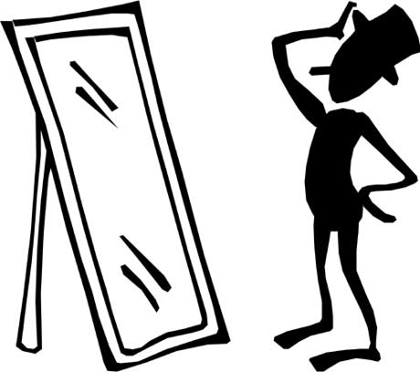
How am I doing? by Oakham School is licensed under CC BY-NC-SA 4.0.

