**Identifying questions to guide my investigation**

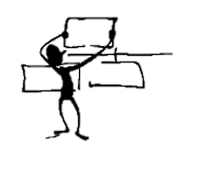

|  |  |
| --- | --- |
| I already know | I wonder |
|  |  |

[Identifying Questions](https://fosil.org.uk/resources/) by [Oakham School](http://www.oakham.rutland.sch.uk) is licensed under a [Creative Commons Attribution-NonCommercial-ShareAlike 4.0 International License](http://creativecommons.org/licenses/by-nc-sa/4.0/).