Name: Class:
Science Fictional Writing: Contents page
Your completed inquiry booklet should contain these pages in this order. Find them/ print them off and staple them together, with this page on the front, to hand in. Don’t forget to put your name on this page!
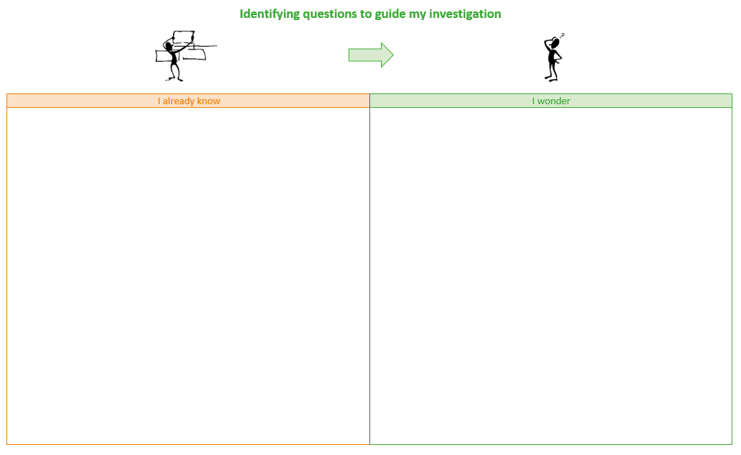 | - Identifying questions to guide my investigation  (if you have a copy of this – don’t worry if you don’t)
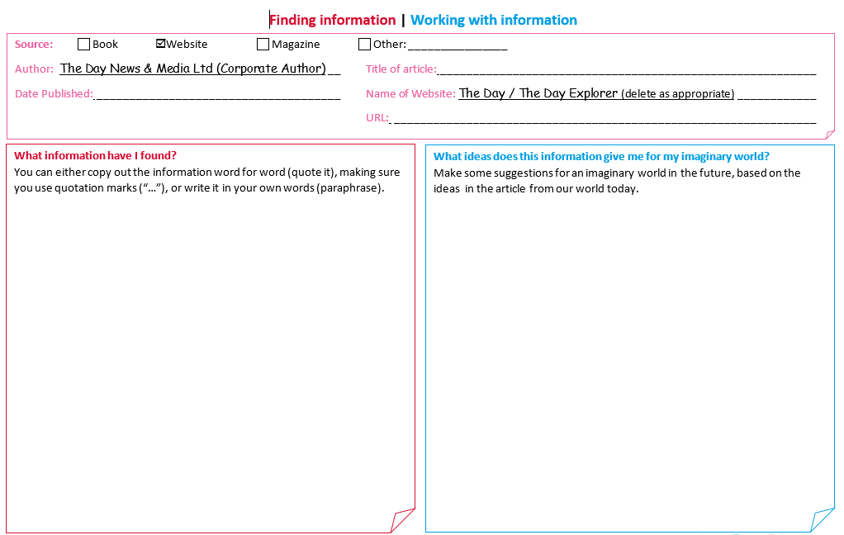 | - Your investigative journal pages  If you are printing these out, be careful NOT to print any extra ‘blank’ journal pages after the ones you filled in!
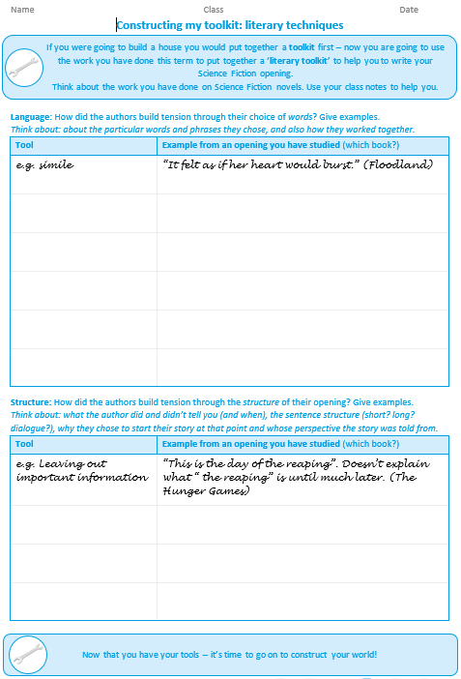 | - Constructing my toolkit
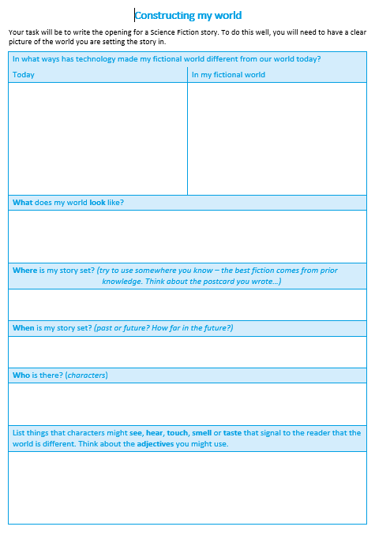 | - Constructing my world
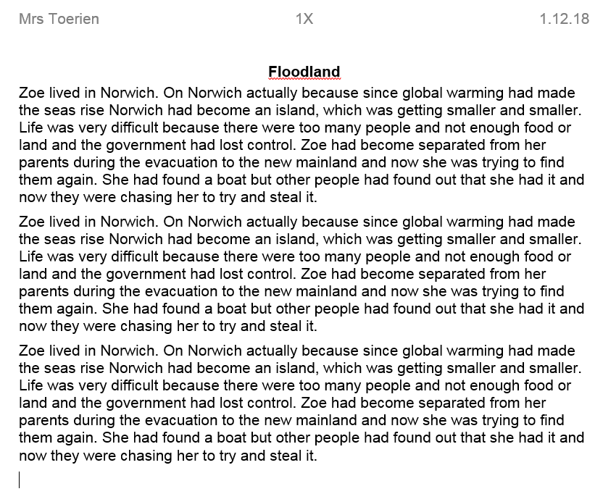 | - First draft of your opening  (if you remembered to save one)
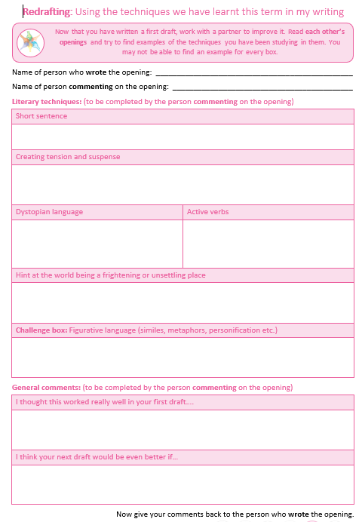 | - Redrafting: using the literary techniques I have learnt this term in my writing
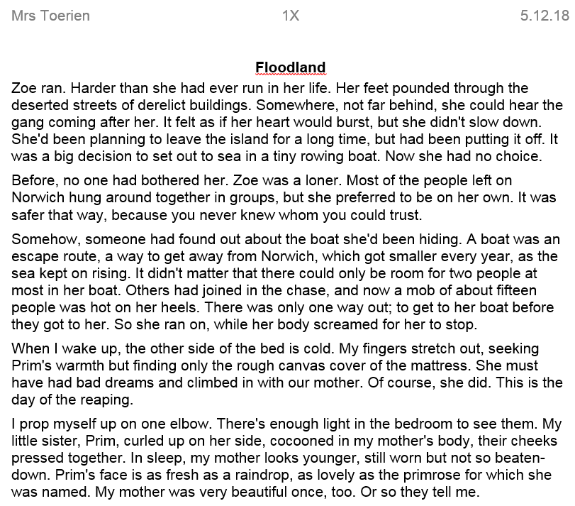 | - Second draft of your opening
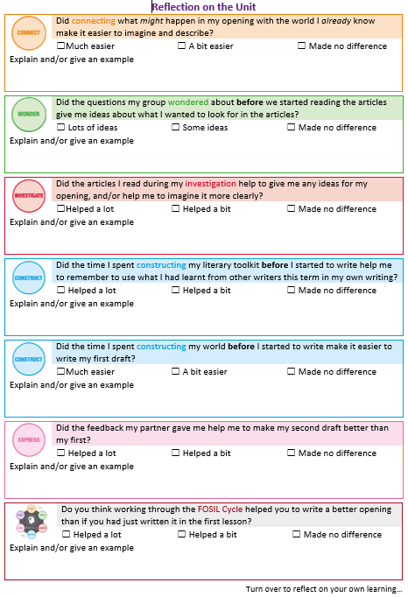 | - Reflection on the unit

Identifying questions to guide my investigation
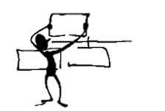

I already know | I wonder

1. Going places:
How technological developments in the way we travel could shape the future
1. The Day “Index” page must be open before some links will take you directly to the article. If a link does not take you to the article you expect, leave the web browser open and click the link again.
2. Do not read all the articles – choose a few. Start with the articles from The Day but if you find these difficult, the articles from The Day Explorer are designed to be shorter and easier to read.

Self-driving cars |  | Other transport on Earth
Driverless cars ponder who should die first  Uber self-driving car kills US pedestrian  Google takes giant leap in self-driving cars |  | Flying cars lift off in fight for the future  Worldwide rocket travel is another mad idea  Cynics ridicule Uber's plan for flying cars
Why driverless cars will be the end of an era  Briefing: self-driving-cars  Google car crash casts doubt on robot powers |  | Google secretly tests electric flying taxis  The Hyperloop

Space travel
World's most powerful rocket set for lift off
Two tourists to fly around the moon in 2018
Race to make Moon Earth's eighth continent
Sputnik is 60 as new space race beckons
Take asteroid threat seriously say scientists
Meet Space Force, Trump's new military branch
Moon or Mars: choosing humanity's new home
The new satellite: on the hunt for alien planets
First luxury space hotel due to open in 2022
The bright red car drifting through space
All aboard the new mission to the moon
The real truth about daily life in Outer Space
What life on Mars might really be like?
Liquid water found on Mars
India joins space elite with mission to Mars
Chinese robot lands on the Moon
Two tourists to fly around the Moon in 2018

Alien life (as a consequence of Space exploration)
America's secret UFO research unit revealed
Not that far: a planet where life is likely
How to talk to aliens without being killed
Alien hunting telescope runs out of fuel
Weird space object could come from aliens
The new planet that could support alien life
Seven beautiful earth sized planets found
Exomars blasts off in search of alien life

2. The Stuff of Life:
How technological developments in the way we understand and modify living things could shape the future
1. The Day “Index” page must be open before some links will take you directly to the article. If a link does not take you to the article you expect, leave the web browser open and click the link again.
2. Do not read all the articles – choose a few. Start with the articles from The Day but if you find these difficult, the articles from The Day Explorer are designed to be shorter and easier to read.

Human genetic modification
Fear and celebration at first edited embryo
Landmark UK vote approves three person babies
Moral storm as designer babies get green light
The future: godlike elites and useless masses
Scientists cure diseases before birth

Plant and animal genetic modification
Fears over genetically modified super fish
Trade secrets: bananageddon
How gene editing could destroy world's pests
Purple mutant tomatoes headed for UK shops

Mammoths one step closer to re-birth

Other genetic technologies
Gene scientists in secret talks on replicants
How to find out your entire genetic make-up
How technology is shaping the future of love
Scientists transplant memories into snails
Genetics dream: Personalised medicine for everyone
Introducing the world's first monkey clones

Human technological modification (cyborgs)
How science is transforming entertainment
Brains bionics and the future of bodies
The plan to merge human brains with computers

3. The Robots are Coming:
How technological developments in Artificial Intelligence and robotics could shape the future
1. The Day “Index” page must be open before some links will take you directly to the article. If a link does not take you to the article you expect, leave the web browser open and click the link again.
2. Do not read all the articles – choose a few. Start with the articles from The Day but if you find these difficult, the articles from The Day Explorer are designed to be shorter and easier to read.

Robots and AI at work
Get ready for a fourth industrial revolution
Happy birthday NHS. Now bring on the robots
2017 in review: The year the robots got smart
How machines will revolutionise the workplace
How robots will run the schools of the future
Facebook robots spark new panic over AI
Now even our pets could be robots too
Your new robot puppy
Chinese robot passes national medical exams
How machines will revolutionise the workplace
Robocops fuel fears of machines eating jobs
The age of robot chefs

Rights for robots
The curious ethics of cruelty to robots
Robots are electronic persons says EU
Star wars and the quest for robot rights

Robots and AI at home
Amazon promises to fix Alexa's creepy laugh
The friendly chatbot that mimics your voice
Google unveils next steps in AI Technology
How relying on computers leads to disaster
How technology is shaping the future of love
How robots could take over your home
Invasion of the home help robots
Are computers getting too clever?

Robots and AI at war
Terminate scientists vow to block killer bots
Threat of killer robots imminent warns Musk
Armchair assassins enter ethical minefield

Finding information | Working with information
Source: Book Website Magazine Other: ________________
Author: The Day News & Media Ltd (Corporate Author) Title of article:
Date Published: Name of Website: The Day / The Day Explorer (delete as appropriate)
URL:

What information have I found?
You can either copy out the information word for word (quote it), making sure you use quotation marks (“…”), or write it in your own words (paraphrase).

What ideas does this information give me for my imaginary world?
Make some suggestions for an imaginary world in the future, based on the ideas in the article from our world today.
Source: Book Website Magazine Other: ________________
Author: The Day News & Media Ltd (Corporate Author) Title of article:
Date Published: Name of Website: The Day / The Day Explorer (delete as appropriate)
URL:

What information have I found?
You can either copy out the information word for word (quote it), making sure you use quotation marks (“…”), or write it in your own words (paraphrase).

What ideas does this information give me for my imaginary world?
Make some suggestions for an imaginary world in the future, based on the ideas in the article from our world today.

Source: Book Website Magazine Other: ________________
Author: The Day News & Media Ltd (Corporate Author) Title of article:
Date Published: Name of Website: The Day / The Day Explorer (delete as appropriate)
URL:

What information have I found?
You can either copy out the information word for word (quote it), making sure you use quotation marks (“…”), or write it in your own words (paraphrase).

What ideas does this information give me for my imaginary world?
Make some suggestions for an imaginary world in the future, based on the ideas in the article from our world today.
Source: Book Website Magazine Other: ________________
Author: The Day News & Media Ltd (Corporate Author) Title of article:
Date Published: Name of Website: The Day / The Day Explorer (delete as appropriate)
URL:

What information have I found?
You can either copy out the information word for word (quote it), making sure you use quotation marks (“…”), or write it in your own words (paraphrase).

What ideas does this information give me for my imaginary world?
Make some suggestions for an imaginary world in the future, based on the ideas in the article from our world today.

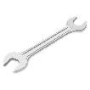
Constructing my toolkit: literary techniques
If you were going to build a house you would put together a toolkit first – now you are going to use the work you have done this term to put together a ‘literary toolkit’ to help you to write your Science Fiction opening.
Think about the work you have done on Science Fiction novels. Use your class notes to help you.

Language: How did the authors build tension through their choice of words? Give examples.
Think about: about the particular words and phrases they chose, and also how they worked together.
Tool | Example from an opening you have studied (which book?)
e.g. simile | “It felt as if her heart would burst.” (Floodland)

Structure: How did the authors build tension through the structure of their opening? Give examples.
Think about: what the author did and didn’t tell you (and when), the sentence structure (short? long? dialogue?), why they chose to start their story at that point and whose perspective the story was told from.
Tool | Example from an opening you have studied (which book?)
e.g. Leaving out important information | “This is the day of the reaping”. Doesn’t explain what “ the reaping” is until much later. (The Hunger Games)
Now that you have your tools – it’s time to go on to construct your world!

Constructing my world
Your task will be to write the opening for a Science Fiction story. To do this well, you will need to have a clear picture of the world you are setting the story in.
In what ways has technology made my fictional world different from our world today?
Today | In my fictional world
What does my world look like?
Where is my story set? (try to use somewhere you know – the best fiction comes from prior knowledge. Think about the postcard you wrote…)
When is my story set? (past or future? How far in the future?)
Who is there? (characters)
List things that characters might see, hear, touch, smell or taste that signal to the reader that the world is different. Think about the adjectives you might use.

Redrafting: Using the techniques we have learnt this term in my writing
Now that you have written a first draft, work with a partner to improve it. Read each other’s openings and try to find examples of the techniques you have been studying in them. You may not be able to find an example for every box.

Name of person who wrote the opening:
Name of person commenting on the opening:
Literary techniques: (to be completed by the person commenting on the opening)
Short sentence
Creating tension and suspense
Dystopian language | Active verbs
Hint at the world being a frightening or unsettling place
Challenge box: Figurative language (similes, metaphors, personification etc.)
General comments: (to be completed by the person commenting on the opening)
I thought this worked really well in your first draft….
I think your next draft would be even better if…
Now give your comments back to the person who wrote the opening.
Planning my next draft (to be completed by the person who wrote the opening)
What worked well in my first draft?
How can I make my second draft even better? (you may not have something for each heading. Give examples)
Things to add: (e.g. Use more adjectives, such as…)
Things to change: (e.g. Include some shorter sentences, for example…)
Things to take out: (e.g. Don’t tell the reader … so early in the story)

Ready to improve your work?
Use all the feedback you have been given to make the next draft even better.
Remember to save a copy of BOTH DRAFTS so your teacher can see what you have improved.

Reflection on the Unit
 | Did connecting what might happen in my opening with the world I already know make it easier to imagine and describe?
 | ☐Much easier | ☐ A bit easier | ☐ Made no difference
Explain and/or give an example

 | Did the questions my group wondered about before we started reading the articles give me ideas about what I wanted to look for in the articles?
 | ☐ Lots of ideas | ☐ Some ideas | ☐ Made no difference
Explain and/or give an example

 | Did the articles I read during my investigation help to give me any ideas for my opening, and/or help me to imagine it more clearly?
 | ☐Helped a lot | ☐ Helped a bit | ☐ Made no difference
Explain and/or give an example

 | Did the time I spent constructing my literary toolkit before I started to write help me to remember to use what I had learnt from other writers this term in my own writing?
 | ☐ Helped a lot | ☐ Helped a bit | ☐ Made no difference
Explain and/or give an example

 | Did the time I spent constructing my world before I started to write make it easier to write my first draft?
 | ☐Much easier | ☐ A bit easier | ☐ Made no difference
Explain and/or give an example

 | Did the feedback my partner gave me help me to make my second draft better than my first?
 | ☐ Helped a lot | ☐ Helped a bit | ☐ Made no difference
Explain and/or give an example

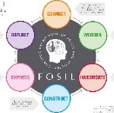 | Do you think working through the FOSIL Cycle helped you to write a better opening than if you had just written it in the first lesson?
 | ☐ Helped a lot | ☐ Helped a bit | ☐ Made no difference
Explain and/or give an example

Turn over to reflect on your own learning…
Reflection on my learning
Things to think about:
- the opening I produced (What was good about it? What could I do even better next time?)
- the work I did to produce it (Did I make good use of my time? What might I do differently next time?)
- what I think I learnt from this Inquiry that might help me in the future.

What went well?
What could I do even better next time?

What do you think?
You were asked to write an opening for a dystopian story but, given all you have read, do you think the future will be better or worse than the present (or a bit of both)? Why?

