Supporting EPQs at Oakham
FOSIL Tools Booklet
Supporting EPQs at Oakham by Oakham School is licensed under CC BY-NC-SA 4.0.
Section A: FOSIL Research Tools

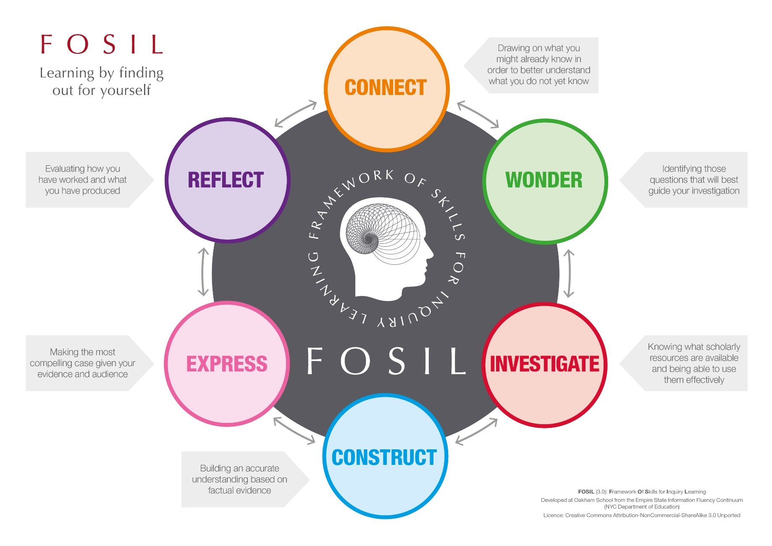
My initial thoughts on research topic

What might I research?
Investigative Journal

Source: Title (citation)
Type of source: | Book, Subscription Database (reference as Website or Article in a Periodical), Website, Article in a Periodical, Film, Interview, Other:
Finding information relevant to my inquiry:  Either copy the information word for word (quote it), making sure you use quotation marks (“…”), or write it in your own words (paraphrase). |  | Discussing the relevance of this information to my inquiry:  Take care to highlight why, of all of the information that you could have chosen, you have chosen this information.
Comment on source: Consider the quality of this source. You might find a tool like the CRAAP test (e.g. https://libguides.ioe.ac.uk/evaluating/craap) helpful.
Investigative Journal

Source: Title (citation)
Type of source: | Book, Subscription Database (reference as Website or Article in a Periodical), Website, Article in a Periodical, Film, Interview, Other:
Finding information relevant to my inquiry:  Either copy the information word for word (quote it), making sure you use quotation marks (“…”), or write it in your own words (paraphrase). |  | Discussing the relevance of this information to my inquiry:  Take care to highlight why, of all of the information that you could have chosen, you have chosen this information.
Comment on source: Consider the quality of this source. You might find a tool like the CRAAP test (e.g. https://libguides.ioe.ac.uk/evaluating/craap) helpful.

Investigative Journal

Source: Title (citation)
Type of source: | Book, Subscription Database (reference as Website or Article in a Periodical), Website, Article in a Periodical, Film, Interview, Other:
Finding information relevant to my inquiry:  Either copy the information word for word (quote it), making sure you use quotation marks (“…”), or write it in your own words (paraphrase). |  | Discussing the relevance of this information to my inquiry:  Take care to highlight why, of all of the information that you could have chosen, you have chosen this information.
Comment on source: Consider the quality of this source. You might find a tool like the CRAAP test (e.g. https://libguides.ioe.ac.uk/evaluating/craap) helpful.

Investigative Journal

Source: Title (citation)
Type of source: | Book, Subscription Database (reference as Website or Article in a Periodical), Website, Article in a Periodical, Film, Interview, Other:
Finding information relevant to my inquiry:  Either copy the information word for word (quote it), making sure you use quotation marks (“…”), or write it in your own words (paraphrase). |  | Discussing the relevance of this information to my inquiry:  Take care to highlight why, of all of the information that you could have chosen, you have chosen this information.
Comment on source: Consider the quality of this source. You might find a tool like the CRAAP test (e.g. https://libguides.ioe.ac.uk/evaluating/craap) helpful.
Investigative Journal

Source: Title (citation)
Type of source: | Book, Subscription Database (reference as Website or Article in a Periodical), Website, Article in a Periodical, Film, Interview, Other:
Finding information relevant to my inquiry:  Either copy the information word for word (quote it), making sure you use quotation marks (“…”), or write it in your own words (paraphrase). |  | Discussing the relevance of this information to my inquiry:  Take care to highlight why, of all of the information that you could have chosen, you have chosen this information.
Comment on source: Consider the quality of this source. You might find a tool like the CRAAP test (e.g. https://libguides.ioe.ac.uk/evaluating/craap) helpful.

Investigative Journal

Source: Title (citation)
Type of source: | Book, Subscription Database (reference as Website or Article in a Periodical), Website, Article in a Periodical, Film, Interview, Other:
Finding information relevant to my inquiry:  Either copy the information word for word (quote it), making sure you use quotation marks (“…”), or write it in your own words (paraphrase). |  | Discussing the relevance of this information to my inquiry:  Take care to highlight why, of all of the information that you could have chosen, you have chosen this information.
Comment on source: Consider the quality of this source. You might find a tool like the CRAAP test (e.g. https://libguides.ioe.ac.uk/evaluating/craap) helpful.

How Trustworthy is your Source? CRAAP Testing
Use this guide to help you when you use the CRAAP test table to rate a resource.
 | Ask yourself…
Currency | When was the information written and last updated?  - How important is it that your information is up-to-date? Is it a science, technology, current affairs or health-related topic?  - When was the Web page originally published, last updated or revised? Are all of the links on the page functional?
Relevance | Is this the information you need for your topic?  - Does this information help you answer your question?  - Is it written at the right level (not too simple or too complicated)?  - Is there a better source you could use with similar information?  - Is it the right type of information (e.g. have you been asked to find data, primary sources, expert opinions…)?
Authority | What qualifies this author to provide information on this topic? How can you tell whether they know what they are talking about?  - Who is responsibility for the information on the page (the author, creator, sponsor?). This might be a ‘corporate author’ (a group or organisation rather than an individual).  - Are there any credentials given – academic qualifications, job title, employment history? Use a search engine to do some quick background research on the author (or corporate author) – what qualifies them to write about this topic? Being an expert in an entirely different field doesn’t count! Do they have a good reputation?  - Learn about the organization on their home page. Look for “About Us” link – but don’t rely on this. Check what others are saying about it too.
Accuracy | Is the information backed up by evidence? Are there any sources cited?  - Where did the information on the page come from? Did the sponsor/author of the page create the information?  - Are there cited sources or links to the original source of the information? Do these sources look trustworthy? Watch out for articles with long lists of sources that are just articles from the same publication or websites with no authority. Can you find the original sources?  - Can you check any of the information in other independent sources or from your own knowledge?  - Are there obvious spelling, grammar or layout errors?  - This site from the University of Georgia (http://guides.libs.uga.edu/factchecknews) has an excellent list of fact checking organisations, which includes the UK based https://fullfact.org/ and https://mediabiasfactcheck.com/ which rates news sources for both factual accuracy and bias.
Purpose | What was this source written for? Is there any obvious bias?  - Why has the page been created? Is it to inform, teach, sell, entertain or persuade? Is there obvious bias or does the author seem fair and objective?  - Is the information based on facts or is it opinion? Is the author using good evidence for their opinion?  - If the site is linked to an organisation, does that group have a particular agenda?  - Use a site like https://www.computerhope.com/jargon/num/domains.htm to check the meaning of the domain suffix (e.g. .edu is a US education site)  - If it is a news source try a site like https://mediabiasfactcheck.com/ to assess accuracy and bias.

CRAAP Testing Table: Websites
Read the separate CRAAP Testing Guide then use this table to help you decide how to rate your resource. Remember: A low score for Authority or Accuracy means you should be very careful about using a source, even if it scores highly in every other category.
 | 0 | 1 | 2 | 3
Currency | I can’t find out when this page was published or last revised. | The creation/last revision date is 5 or more years ago. | The site/article was lastupdated between 2 and 5 years ago. | The site/article was last updated within the last 2 years.
Relevance | The page may mention my topic but isn’t relevant to my question, or doesn’t have the type of information I need. | This gives some general background but doesn’t cover my main question. Or the level is too hard or too easy. | This will addresses my question and will give me some useful information but isn’t quite what I am looking for. | This gives me most of what I need to answer my question and is exactly the right type and level of information.
Authority | I either cannot find out who wrote this (person or organisation) or there is evidence that the author or the organisation has a history of being misleading on this topic. | The author is named but has nothing obvious that qualifies him/her to write about this topic).  Or the organisation has questionable authority. | The author is named but the degree of expertise on this topic is not that high.  Or the organisation is well-known but degree of expertise on this topic is unclear. | The author is a respected expert on this topic.  Or the organisation is well-known and has a good reputation on this topic.
Accuracy | Obvious spelling, grammar or layout errors.  Or it isn’t clear where the information comes from – it might just be someone’s opinion. | Sources are mentioned vaguely, but not enough information is given to find them.  Or sources are cited but they are clearly not trustworthy. | Sources that seem trustworthy are given for some but not all of the information. Some links may be broken, but I could probably find the original sources. Images may not be referenced. | Trustworthy sources clearly given to back up claims, including enough information to find the original sources easily. Any images/ photos are labelled.
Purpose | The purpose is to sell or promote an idea or service. The page presents an unbalanced, biased view. It is not backed up with facts or they are distorted. A background check on the author or organisation may suggest strong bias. | The purpose may be to sell something or promote an idea, but the page also provides some clearly referenced, accurate factual information. Argument seems one-sided. | The purpose is to educate. There may be some bias (which may be acknowledged) but opinion is logical and backed by evidence. | The purpose is to provide high-quality scholarly information. Enough factual evidence is given to justify any opinions and may include graphs, charts, tables or statistics. Effort is made to address both sides of an argument.

Total score | 0-3 points | 4-7 points | 8-11 points | 12-15 points
/15 | Highly questionable source – do not use. | Might be useful for initial ideas or but do not cite in academic work. | Good source for academic work but confirm information with other sources | Excellent source for academic work.
CRAAP Testing: Websites by Oakham School is licensed under a Creative Commons Attribution-NonCommercial-ShareAlike 4.0 International License. Based on Thinking Critically about Web Information from Ron E. Lewis Library and Evaluating information by Meriam Library

Drawing conclusions by looking at multiple perspectives
Question:
Some people think… | UNDISPUTED FACTS (with sources) | But other people think…
Facts added from this perspective (with sources) |  | Facts added from this perspective (with sources)
Opinions/interpretations/predictions from this perspective (with sources) |  | Opinions/interpretations/predictions from this perspective (with sources)
Your interpretation and conclusions (make sure you discuss the quality of each source – have you CRAAP tested them?)

Drawing conclusions by looking at multiple perspectives
Question:
Some people think… | UNDISPUTED FACTS (with sources) | But other people think…
Facts added from this perspective (with sources) |  | Facts added from this perspective (with sources)
Opinions/interpretations/predictions from this perspective (with sources) |  | Opinions/interpretations/predictions from this perspective (with sources)
Your interpretation and conclusions (make sure you discuss the quality of each source – have you CRAAP tested them?)

Drawing conclusions by looking at multiple perspectives
Question:
Some people think… | UNDISPUTED FACTS (with sources) | But other people think…
Facts added from this perspective (with sources) |  | Facts added from this perspective (with sources)
Opinions/interpretations/predictions from this perspective (with sources) |  | Opinions/interpretations/predictions from this perspective (with sources)
Your interpretation and conclusions (make sure you discuss the quality of each source – have you CRAAP tested them?)

Bibliography

Insert your Word generated bibliography here.

A useful guide to using APA 6th Edition referencing system can be found here:

https://guides.lib.monash.edu/citing-referencing/apa

Section B: Supervisions, Specialist Advice and Production Log
Preparing for the Planning Review (Supervision 2)

This tool uses the Cornell noting system to help you organise your questions and their answers during a meeting with your supervisor as part of your Planning Review of the Production Log.

- Before your meeting, write your questions down in the left hand column.
- During the meeting, note down the answers to your questions in the right hand column.
- After the meeting, summarise what you have found out, what it means for your inquiry, and what you need to do next in the bottom box overleaf.
- Now write up your Planning Review of the Production Log.

Date of meeting

EPQ inquiry area or research question
Questions | Answers to my questions
What are my next steps in planning, researching and deadlines that I will set myself?

What do I intend to do, by when?

What resources will I use?

Other questions for my supervisor.

My summary of the comments and advice from my supervisor.

Modifications I have made as a result of my discussion with my supervisor.

What does this mean for my inquiry? What do I need to do next?

Preparing for the Mid Project Review (Supervision 3)

This tool uses the Cornell noting system to help you organise your questions and their answers during a meeting with your supervisor as part of your Mid Project Review of the Production Log.

This page records your outline plan when you have completed your research.

- Before your meeting, think about the questions in the left hand column and add your own questions to the list. Answer any questions you can in the right hand column.
- During the meeting, add more information to the right hand column.
- After the meeting, summarise what you have found out, what it means for your inquiry, and what you need to do next in the bottom box overleaf.
- Now write up your Mid Project Review of the Production Log.

Date of meeting

EPQ inquiry area or research question
Questions | Answers to my questions
Is my project following my original plan?

How has my plan developed?

Other questions for my supervisor.

My summary of the comments and advice from my supervisor.

What modifications have I made as a result of my discussion with my supervisor at this stage?

What does this mean for my inquiry? What do I need to do next?
What is my final project title?

What are my planned next steps to complete my project?

Preparing for the Project Product Review (Supervision 5)

This tool uses the Cornell noting system to help you organise your questions and their answers during a meeting with your supervisor as part of your Project Product Review of the Production Log.

This page records the (near) completion of your project product.

- Before your meeting, think about the questions in the left hand column and add your own questions to the list. Answer any questions you can in the right hand column.
- During the meeting, add more information to the right hand column.
- After the meeting, summarise what you have found out, what it means for your inquiry, and what you need to do next in the bottom box overleaf.
- Now write up your Project Product Review of the Production Log.

Date of meeting

EPQ inquiry area or research question
Questions | Answers to my questions
Outline the successes, failures, additions and/or changes you made as you followed the plan in your mid-project review.

How did your project deviate from your revised plan (from the mid-project review)?

Other questions for my supervisor.

My summary of the comments and advice from my supervisor at this final stage

Modifications I have made as a result of discussion with my supervisor at this final stage

What do I need to do to complete my product?

Using my Academic Specialist (Meeting 1)

This tool uses the Cornell noting system to help you organise your questions and their answers during a meeting with your academic specialist.

- Before your meeting, write your questions down in the left hand column.
- During the meeting, note down the answers to your questions in the right hand column.
- After the meeting, summarise what you have found out, what it means for your inquiry, and what you need to do next in the bottom box overleaf.

Date of meeting

EPQ inquiry area or research question
Questions for my specialist | Answers to my questions

What does this mean for my inquiry? What do I need to do next?

Using my Academic Specialist (Meeting 2)

This tool uses the Cornell noting system to help you organise your questions and their answers during a meeting with your academic specialist.

- Before your meeting, write your questions down in the left hand column.
- During the meeting, note down the answers to your questions in the right hand column.
- After the meeting, summarise what you have found out, what it means for your inquiry, and what you need to do next in the bottom box overleaf.

Date of meeting

EPQ inquiry area or research question
Questions for my specialist | Answers to my questions

What does this mean for my inquiry? What do I need to do next?

Using my Academic Specialist (Meeting 3)

This tool uses the Cornell noting system to help you organise your questions and their answers during a meeting with your academic specialist.

- Before your meeting, write your questions down in the left hand column.
- During the meeting, note down the answers to your questions in the right hand column.
- After the meeting, summarise what you have found out, what it means for your inquiry, and what you need to do next in the bottom box overleaf.

Date of meeting

EPQ inquiry area or research question
Questions for my specialist | Answers to my questions

What does this mean for my inquiry? What do I need to do next?

