Form 1 Inquiry: Why couldn’t they cure the Black Death in the Middle Ages?
Over the next few lessons you will be investigating this question and presenting your findings in a report.
Connect: (Fill this in before you start the inquiry)
Why do you think this is an important question for Historians to answer?

Now conduct your inquiry
You MUST ensure you go through ALL of the stages of the FOSIL cycle to succeed.

Reflect: (Fill this in when you have finished the inquiry)
What do you think now about why this is important for Historians? Can you add anything to your previous answer?
Why couldn't they cure the Black Death by Oakham School is licensed under CC BY-NC-SA 4.0.

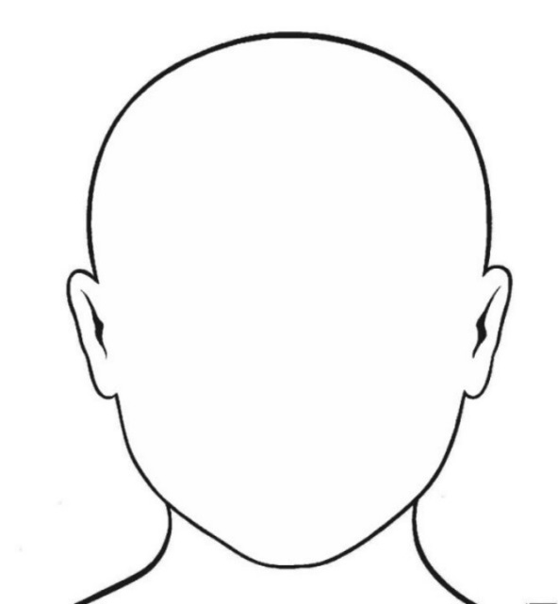
The Black Death
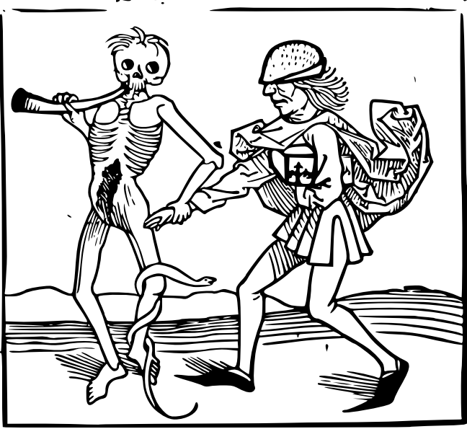

Anything else I know that might be useful:
Which countries did it spread to?
When did it happen?
What were the symptoms?
What do I think I already know about my topic?

What questions do I need to ask to help me to answer the inquiry question:
Why couldn’t they cure the Black Death in the Middle Ages?
Why…?
What…?
How…?
If…?
When…?
Who…?
Where…?
Which three of these questions would be the most useful in helping me to answer the inquiry question? Why?

will help me because
1. The question

will help me because
2. The question

will help me because
3. The question

Investigative Journal
Use the 5 Evidence Sets to make notes that will help you to answer your questions. Don’t forget to make a note of the sources used to find your information. Put the ‘source number’ in a circle next to each piece of information in the table. E.g.
1a
Which of my question(s) am I trying to answer? | What information have I found?  Don’t forget that any direct quotes must be in quotation marks. Put the ‘source number’ next to each piece of information to show where it came from. | What does this tell me about why medieval people couldn’t cure the Black Death?

Investigative Journal (continued)
Don’t forget to make a note of the sources used to find your information. Put the ‘source number’ in a circle next to each piece of information in the table.
Which of my question(s) am I trying to answer? | What information have I found?  Don’t forget that any direct quotes must be in quotation marks. Put the ‘source number’ next to each piece of information to show where it came from. | What does this tell me about why medieval people couldn’t cure the Black Death?

EVIDENCE SET 1
Which inquiry question could this evidence set help with?
…………………………………………………………………………………………………………………………………

Sources removed due to copyright restrictions – insert your own using appropriate textbooks, following your local copyright laws and guidelines
Source 1c
Source 1a
Source 1b
EVIDENCE SET 2
Source 2d
Source 2c
Which inquiry question could this evidence set help with?
…………………………………………………………………………………………………………………………………

Source 2a
EVIDENCE SET 3
Sources removed due to copyright restrictions – insert your own using appropriate textbooks, following your local copyright laws and guidelines
Source 2b
Source 2e
Source 3c
Which inquiry question could this evidence set help with?
…………………………………………………………………………………………………………………………………
Sources removed due to copyright restrictions – insert your own using appropriate textbooks, following your local copyright laws and guidelines
Source 3f
Source 3e
Source 3d
Source 3a
Source 3b

EVIDENCE SET 4
Source 4d
Which inquiry question could this evidence set help with?
…………………………………………………………………………………………………………………………………
Sources removed due to copyright restrictions – insert your own using appropriate textbooks, following your local copyright laws and guidelines
Source 4c
Source 4b
Source 4a
EVIDENCE SET 5
Source 5c
Which inquiry question could this evidence set help with?
…………………………………………………………………………………………………………………………………
Sources removed due to copyright restrictions – insert your own using appropriate textbooks, following your local copyright laws and guidelines

Source 5e
Source 5b
Source 5d

Source 5a

Ranking reasons in order of importance
I think this factor had the greatest impact because:

I think this factor had the least impact because:

Stick reason 1 here

Stick reason 2 here

Stick reason 4 here

Stick reason 3 here

Final Report
Use this box to briefly describe what the Black Death was so that the reader understands what you are talking about. What key words or knowledge might you need to include?
Use this box to tell the reader your decision as to which reason was the most important and to explain why.
Reason 1: Use this box to describe the reason using key words and knowledge and explain why that stopped people curing the Black Death.
Reason 2: Use this box to describe the reason using key words and knowledge and explain why that stopped people curing the Black Death.
Reason 3: Use this box to describe the reason using key words and knowledge and explain why that stopped people curing the Black Death.
Reason 4: Use this box to describe the reason using key words and knowledge and explain why that stopped people curing the Black Death.
You may want to add a picture here, but think carefully about how it will help your argument and whether it needs labelling.

Black Death Glossary
Glossary, n. A collection of glosses; a list with explanations of abstruse, antiquated, dialectal, or technical terms; a partial dictionary. (OUP. (2018). Glossary, n1. Retrieved from OED Oxford English Dictionary: http://www.oed.com/view/Entry/79143)

Term | Meaning | Example of the term in use

