Name: Class:
Computer Science teacher (initials):

Are there hidden computers in my home?

Hidden Computers Inquiry Journal by The FOSIL Group is licensed under CC BY-NC-SA 4.0.

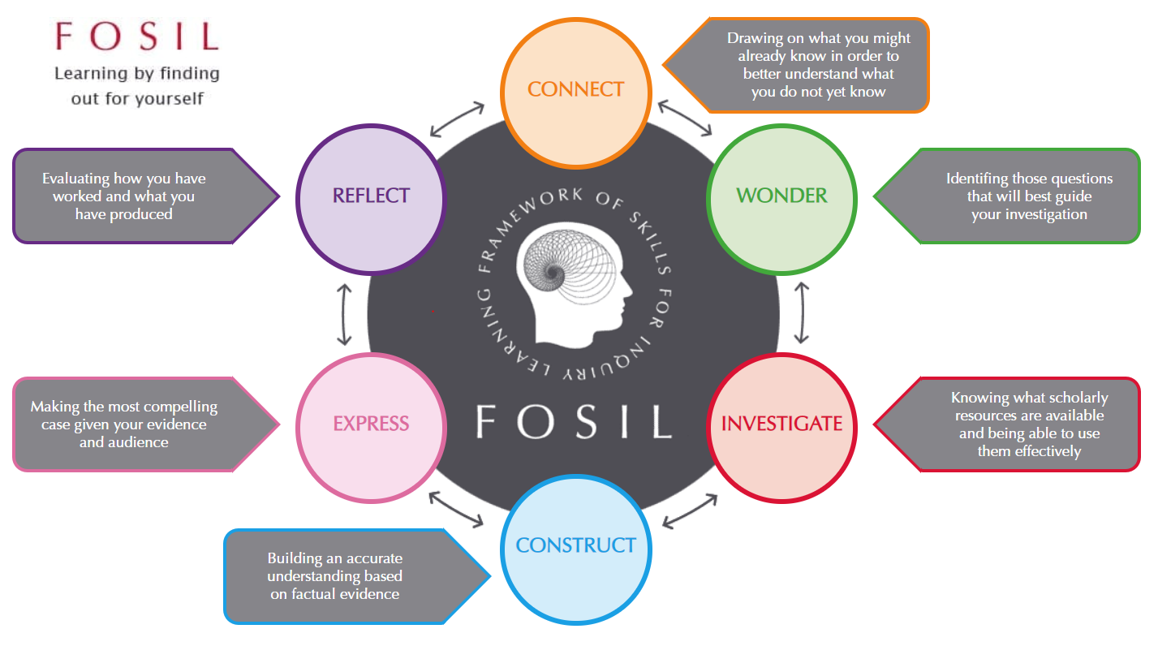
What computers do I have / know about?
Do my computers have anything in common?
Computer

Anything else I know that might be useful:
What do I think I already know about different computers?

What computer hardware do I know?
Hidden computers?

What things in my home might contain a hidden computer?

For example:
my washing machine?
What questions do I need to ask to help me to answer the inquiry question:
Are there hidden computers in my home?
Why…?
What…?
How…?
If…?
When…?
Who…?
Where…?
Which three of these questions would be the most useful in helping me to answer the inquiry question? Why?

will help me because
1. The question

will help me because
2. The question

will help me because
3. The question

Investigative Journal
Use the Resource Pack to make notes that will help you to answer your questions. Put the ‘source number’ next to each piece of information to show where it came from.
Which of my question(s) am I trying to answer? | What information have I found?  Don’t forget that any direct quotes must be in quotation marks. | Source number | What does this tell me about computers?

Investigative Journal (continued)
Use the Resource Pack to make notes that will help you to answer your questions. Put the ‘source number’ next to each piece of information to show where it came from.
Which of my question(s) am I trying to answer? | What information have I found?  Don’t forget that any direct quotes must be in quotation marks. | Source number | What does this tell me about computers?

Investigative Journal (continued)
Use the Resource Pack to make notes that will help you to answer your questions. Put the ‘source number’ next to each piece of information to show where it came from.
Which of my question(s) am I trying to answer? | What information have I found?  Don’t forget that any direct quotes must be in quotation marks. | Source number | What does this tell me about computers?

Investigative Journal (continued)
Use the Resource Pack to make notes that will help you to answer your questions. Put the ‘source number’ next to each piece of information to show where it came from.
Which of my question(s) am I trying to answer? | What information have I found?  Don’t forget that any direct quotes must be in quotation marks. | Source number | What does this tell me about computers?

Investigative Journal (continued)
Use the Resource Pack to make notes that will help you to answer your questions. Put the ‘source number’ next to each piece of information to show where it came from.
Which of my question(s) am I trying to answer? | What information have I found?  Don’t forget that any direct quotes must be in quotation marks. | Source number | What does this tell me about computers?

Computer Hardware Glossary

Term | Meaning | Example of the term in use
Input
Output
Processing

Expressing my ideas
Use everything you have done so far to help you to write an informative article about the inquiry question: Are there hidden computers in my home?

Setting up my document
- Open Word
- If you have opened Word Online, rather than the Word application, click on “Open in Desktop App” on the top ribbon
- Open the Academic Writing Template by choosing:
File -> | New-> School Templates-> | Academic Writing Template
 | 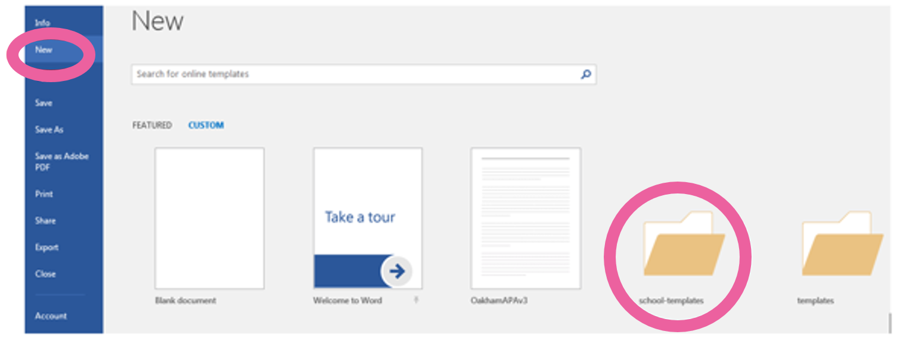
- Double click in the header and add your name, date and class

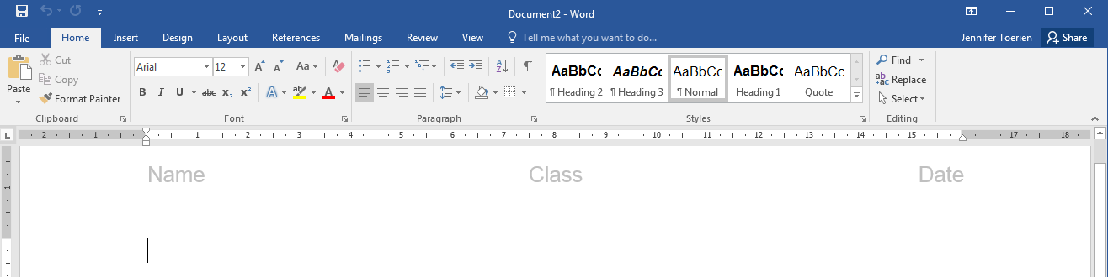

Saving my work
- Before you start typing, save your document in the Computer Science folder in your Work Drop Box W:\Computing
- Give it a sensible name, like Hidden Computers Inquiry DRAFT 1
Time to start writing…

Print out your first draft and stick or staple it here

Redrafting: In response to feedback
Now that you have written a first draft, work with a partner to improve it. Give your workbook to your partner and try to judge how informative each other’s work is. Fill in the page below in your partner’s workbook.

Name of person commenting:
Factual Information: How much factual information did your partner present about computers? Give examples.
Think about: Did they: define a computer? Define parts of a computer?
Facts presented (in brief)

Inference: How did your partner build upon the facts they found to draw new conclusions?
Think about: Have they been able to write about devices in their home that they think are computers? Have they been able to present good reasoning based on facts presented earlier?
Device | Quality of reasoning (how convincing are they?)
General comments: (to be completed by the person commenting on the opening)
I thought this worked really well in your first draft….
I think your next draft would be even better if…
Now give your comments back to the person who wrote the opening
Print out your second draft and stick or staple it here
Reflecting on the Unit
 | Did connecting what I already know about computers / types make it easier to start researching?
 | ☐Much easier | ☐ A bit easier | ☐ Made no difference
Explain and/or give an example

 | Did the questions my group wondered about before we started reading the articles give me ideas about what I wanted to look for in the articles?
 | ☐ Lots of ideas | ☐ Some ideas | ☐ Made no difference
Explain and/or give an example

 | Did the articles I read during my investigation help me to learn about computer hardware?
 | ☐Helped a lot | ☐ Helped a bit | ☐ Made no difference
Explain and/or give an example

 | Did the time I spent constructing (answering what does this tell me about computers?) make it easier to write my first draft?
 | ☐Much easier | ☐ A bit easier | ☐ Made no difference
Explain and/or give an example

 | Did the feedback my partner gave me help me to make my second draft better than my first?
 | ☐ Helped a lot | ☐ Helped a bit | ☐ Made no difference
Explain and/or give an example

 | Do you think working through the FOSIL Cycle helped you to write a better article than if you had just written it in the first lesson?
 | ☐ Helped a lot | ☐ Helped a bit | ☐ Made no difference
Explain and/or give an example

