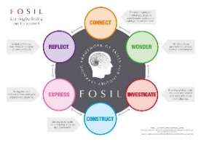
Paris Inquiry Reflection Journal

How good were the questions I asked for the inquiry? How do I know?

How well did I use the sources (print and web)?

How well did I plan my presentation with my group?

How happy was I with my written script and how could I have improved it?

How happy was I with my written script and how could I have improved it?

Did I learn much from this inquiry? (French? About Paris? About doing research? Other?)

