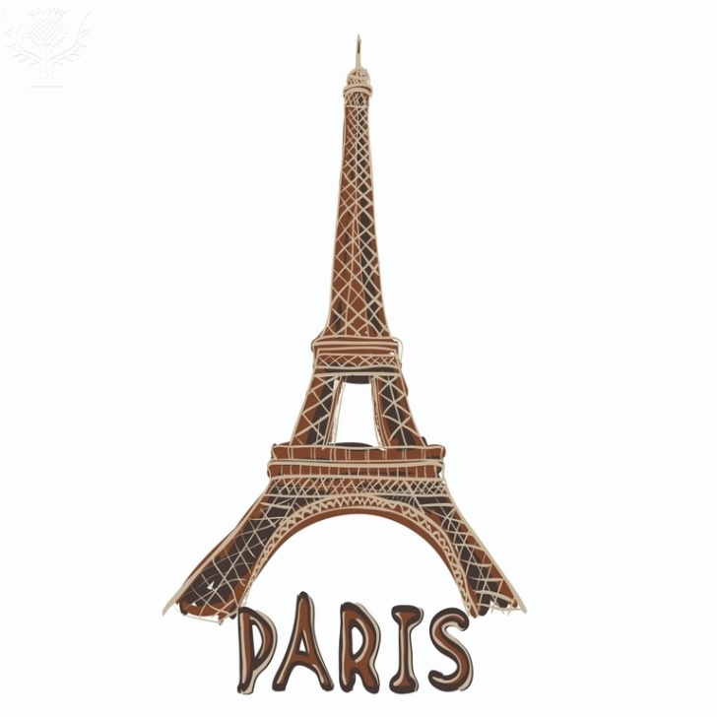

1

**What attracts me to new places?**



**Inquiry Question:**

**Paris is one of the most visited cities in the world. Would it be high on your list? Why or why not?**

Eiffel Tower, Paris. France. [Clip Art]. Retrieved Encyclopædia Britannica ImageQuest. [https://quest.eb.com/search/186_2694056/1/186 from _2694056/cite](https://quest.eb.com/search/186_2694056/1/186_2694056/cite)

**What do I already know about Paris?**

**What questions do I need to ask about Paris to see if it has what I am looking for?**

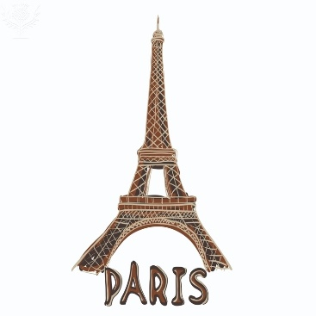

2

Museums and art galleries

Cafés, bars and restaurants

Parks and gardens

Monuments

Children’s attractions

Shops and markets



3

**Topic(s) we are investigating:**

What questions do we need to ask when we are investigating?

**Why…?**

**What…?**

**How…?**

**If…?**

**When…?**

**Who…?**

**Where…?**

**Investigative Journal – print sources**

4a

Use the Resource Pack to make notes that will help you to answer your questions. *Put the ‘source number’ next to each piece of information to show where it came from.*

|  |  |  |  |
| --- | --- | --- | --- |
| **Which of my questions am I trying to answer?** | **What information have I found?**  *Don’t forget that any direct quotes must be in quotation marks.* | **Source number** | **How does this information make be feel about visiting Paris?** |
|  |  |  |  |
| Eiffel Tower, Paris. France**French words and phrases which might impress my teacher – and their English meaning:** | | | |

**Investigative Journal – online sources**

4b

Use the list of recommended websites to answer your questions. *Put the name of the website, and the URL next to each piece of information to show where it came from.*

|  |  |  |  |
| --- | --- | --- | --- |
| **Which of my questions am I trying to answer?** | **What information have I found?**  *Don’t forget that any direct quotes must be in quotation marks.* | **Source name and URL** | **How does this information make be feel about visiting Paris?** |
|  |  |  |  |
| Eiffel Tower, Paris. France**French words and phrases which might impress my teacher – and their English meaning:** | | | |

**PREP**

5

**After researching ……………………………………………, these are reasons why Paris might be high on my list of places to visit:**

**And these are reasons why Paris might NOT be high on my list of places to visit:**



Is there anything I would still like to know more about:

6

**In our opinion, Paris would/would not be high on our list of places to visit, because:**

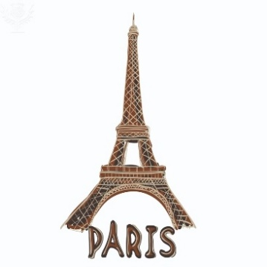

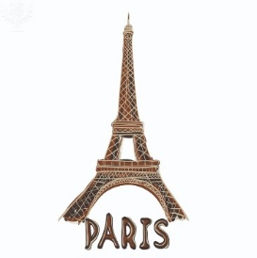**Main points for our presentation**

7

If we are giving a guided tour of Paris, we think we should include:

Activity/Place:

Reason:

Activity/Place:

Reason:

Activity/Place:

Reason:

Activity/Place:

Reason:

Activity/Place:

Reason:

Activity/Place:

Reason: