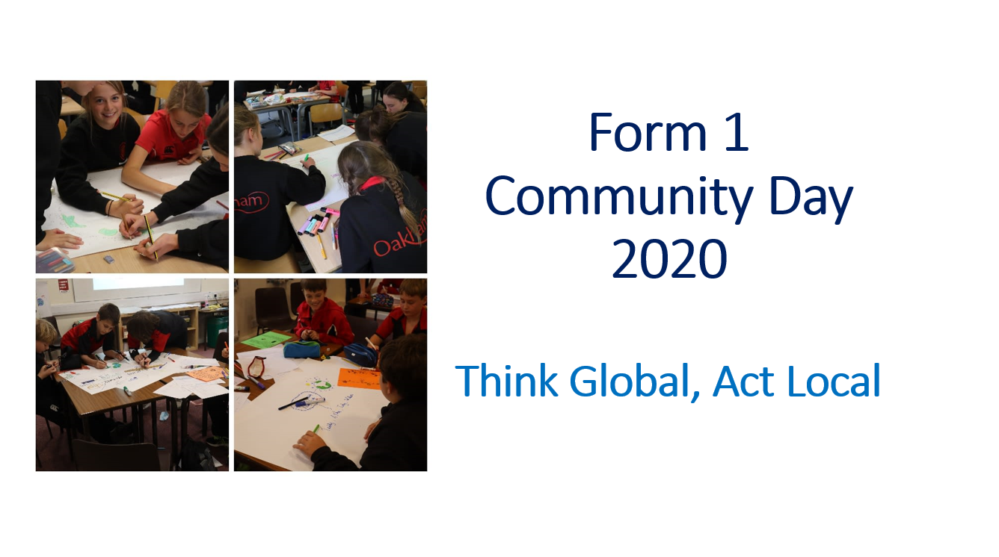



Before, I used to …

**How did my life change during lockdown?**

But during lockdown, I …

 **Investigating others’ experiences of lockdown** 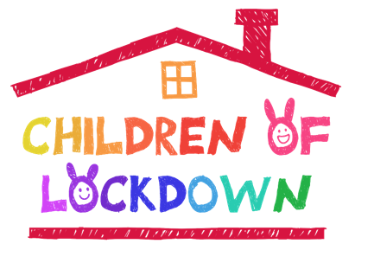

|  |  |  |
| --- | --- | --- |
| Whose experience is this?  Who are they? Where do they live? | How is this person's story similar to and  different from your story? | What do we discover about what they value? |
|  |  |  |
| Source (tick which one):   * UNICEF * STORYCHEST |
|  |  |  |
| Source (tick which one):   * UNICEF * STORYCHEST |
|  |  |  |
| Source (tick which one):   * UNICEF * STORYCHEST |

 **Investigating others’ experiences of lockdown** 

|  |  |  |
| --- | --- | --- |
| Whose experience is this?  Who are they? Where do they live? | How is this person's story similar to and  different from your story? | What do we discover about what they value? |
|  |  |  |
| Source (tick which one):   * UNICEF * STORYCHEST |
|  |  |  |
| Source (tick which one):   * UNICEF * STORYCHEST |
|  |  |  |
| Source (tick which one):   * UNICEF * STORYCHEST |

**Investigating ideas for helping my community**

**Investigating ideas for helping my community**

**Source:** Title of article:

Name of Website: The Day / Togetherband / Voices of Youth / UN (delete as appropriate)

**What information have I found?**What courses of action does the article suggest?

**What ideas for action does this information give me?**

What could we do locally? What would be good for our community? What are we able to do?

**Source:** Title of article:

Name of Website: The Day / Togetherband / Voices of Youth / UN (delete as appropriate)

**What information have I found?**What courses of action does the article suggest?

**What ideas for action does this information give me?**

What could we do locally? What would be good for our community? What are we able to do?

**Practical ways to make life better in our communities after COVID-19**

Think about some problems you want to solve in your community (local, national or global) and what action YOU could take to improve the situation. Choose between 6 and 8 of these actions to put on your poster. Then decide who in your group will be responsible for each. Don’t forget to make sure someone is in charge of giving the poster a TITLE and someone makes a section explaining what you understand by ‘community’.

|  |  |  |  |
| --- | --- | --- | --- |
| **C:\Users\JAT~1.OAK\AppData\Local\Temp\smiley-150837_1280.png**  **Problem we want to solve** | **C:\Users\JAT~1.OAK\AppData\Local\Temp\volunteer-1888823_1280.png**  **Action we want to take** | **Use this idea on our poster?**  **(✓)** | **C:\Users\JAT~1.OAK\AppData\Local\Temp\painter-161318_1280.png**  **Who will put this on our poster?** |
|  |  |  |  |
|  |  |  |  |
|  |  |  |  |
|  |  |  |  |
|  |  |  |  |
|  |  |  |  |
|  |  |  |  |
|  |  |  |  |
|  |  |  |  |

Designing the TITLE?

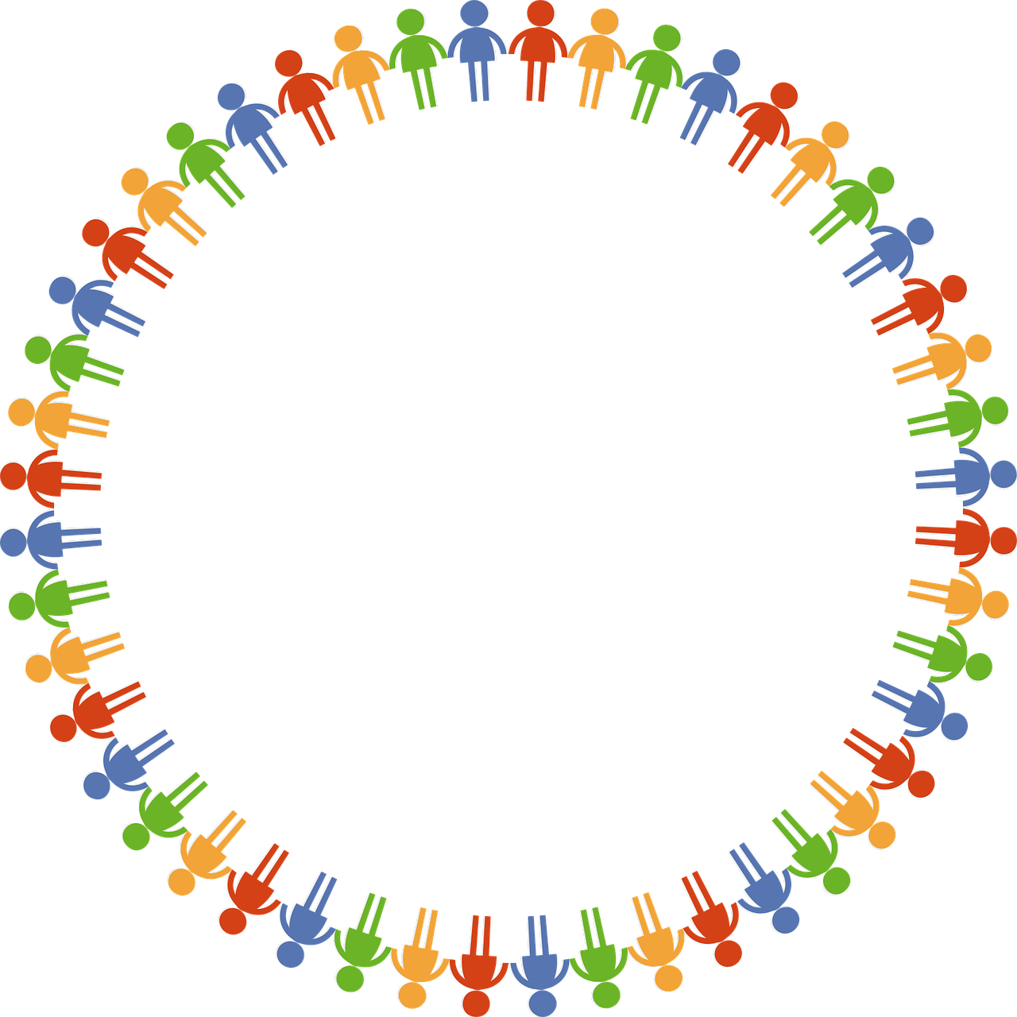

Who will be responsible for…

**F1 Community Day Reflections**

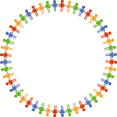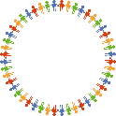

We have talked a lot today about changing the world by changing our community. But this will only happen if **you** decide to act on what you have learnt today.

Only you can decide how important that is to you.

What types of action do you think are most likely to be effective, long-term? Which are **you** most likely to stick to?

*Small things you do often? Big projects? Things you do alone? Things you do with friends or family? Local or global?*

Of the actions discussed today, which are *you* most likely to **actually** **take**?

What could you do practically to make it more likely that you **will** do this?

Do you think the pandemic will really change anything? Do you think it needs to?

What is the most important thing that you will take away from today?

**MYP COMMUNITY DAY: SERVICE AND ACTION - WHAT NEXT?**

Following on from our Community Day, you should choose one action that you think **you** could actually take to help improve life, health and well-being in your immediate community, particularly considering the current Covid pandemic. **Be realistic,** if you choose something manageable, you will have a much greater chance of succeeding! You can always take more actions when you get into the swing of things.

|  |  |  |
| --- | --- | --- |
| The action I will take to help improve life  in my community is:  Date: |  | What have you done so far?  Have you encountered any difficulties?  Date: |
|  |  |  |
| Have you noticed any positive effects  from your action?  Date: |  | What have you done recently?  What is your next step?  Date: |
|  |  |  |
| Have you managed to get others involved in  what you are doing?  Date: |  | Do you need to do anything more or  differently to make more of an impact?  Date: |
|  |  |  |
| Do you believe you have made a positive  impact on your community through your action?  Date: |  | How successful have you been at maintaining what you set out to do? Sometimes this is hard.  Date: |