PIRATE RESEARCH TASK 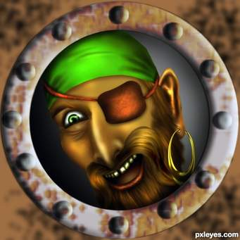

We want you to tell us more about pirates. This will mean doing your research. There are some links below which might give you some starting points. Remember, also, to make use of the books in the library. You may focus on any aspect of piracy and explain / present your learning in any way you choose (e.g. a treasure map of facts, a pirate song, quiz questions, a debate speech on your views of piracy, based on what you have learnt etc.).
Famous Pirates
Undertake some research to find out about famous pirates: https://www.history.com/news/8-real-life-pirates-who-roved-the-high-seas
https://www.history.com/news/5-notorious-female-pirates
and
https://www.youtube.com/watch?v=Qp-OcoziWoo

Find out about one of the most famous pirates:
https://www.google.com/search?q=Blackbeard+https%3A%2F%2Fwww.youtube.com%2Fwatch%3Fv%3D--+QdMC9qGQQ&rlz=1C1TEUA_enGB583GB641&oq=Blackbeard+https%3A%2F%2Fwww.youtube.com%2Fwatch%3Fv%3D--+QdMC9qGQQ&aqs=chrome..69i57.1078j0j4&sourceid=chrome&ie=UTF-8

See if you can find out about corsairs, privateers, buccaneers and pirates. Was there a difference between
them? Investigate some of these terms and what they mean by looking at different websites. Here are a
couple to get you started. https://www.rmg.co.uk/discover/explore/golden-age-piracy

https://www.britannica.com/story/pirates-privateers-corsairs-buccaneers-whats-the-difference

Life as a Pirate
Find out about the life and times of a pirate. What was it actually like and what was booty?
https://www.rmg.co.uk/discover/explore/golden-age-piracy

Find out about pirate myths https://www.youtube.com/watch?v=p3fztn2roaw

Here’s a teaser … Under British Law, pirates could still be executed until 1998. True or false? Why not create
your own true or false quiz.

Places
Find out about where pirates roamed. Investigate the Mediterranean, Caribbean and the Pacific coast of
Central America. https://www.dkfindout.com/uk/history/pirates/
https://www.rmg.co.uk/explore/who-were-real-pirates-caribbean
https://www.loc.gov/rr/program/bib/pirates/index.html
https://www.rmg.co.uk/discover/explore/golden-age-piracy

Pirate Maps
Peruse some pirate maps
https://www.nationalgeographic.com/culture/2018/12/pirate-maps-all-over-the-map/
and then try your hand at making your own. Think about how you could make it appear that it was an
ancient document. https://www.youtube.com/watch?v=YJy-Ppkt7wI
https://www.nationalgeographic.org/article/pirate-caribbean/

Pirate Songs and Language
Spoken Language - o Learn to speak like a pirate: https://reference.yourdictionary.com/resources/pirate-terms-phrases.html

http://www.elizabethan-era.org.uk/the-pirate-song.htm

Why not listen or try to learn a pirate song? Here is a collection of songs you might have heard of – The
Pirate Song, A Sailor Went To Sea Sea Sea, What Shall We Do With A Drunken Sailor and The Big Ship Sails On
The Alley-Alley-O https://www.letsplaykidsmusic.com/4-pirate-songs-for-kids/

A Pirate went to sea
https://www.youtube.com/watch?v=YOA3he2Gv4M

Over the Deep Blue Sea
https://www.youtube.com/watch?v=lCPJhybHBkA

Port Side Pirates! by Debbie Harter and Oscar Seaworthy
https://www.youtube.com/watch?v=_qAngsMJD3I

Traditional Songs
Why not listen to some traditional sea shanties being sung by the Fisherman’s Friends, a singing group from
Port Isaac, Cornwall. They shot to fame after signing a record deal with Universal Music.
https://www.youtube.com/watch?v=p3afGi3REu8

