**Could you**

**EPQ?**

**EPQ at a glance**

Find a topic that fascinates you

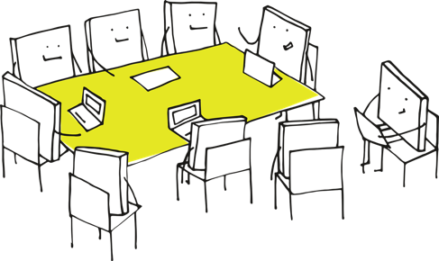

Learn the skills that you need in the 30-hour taught course to inquire into that topic

* EPQ is worth up to 28 UCAS points (half an A-level)
* Very highly regarded by universities and employers because of the independent study skills it provides
* Hugely personally rewarding



…plus a presentation about your project

OR

Spend 90 hours independently (with support) over the course of a year investigating your own research question and produce either….



a 5,000-word research report

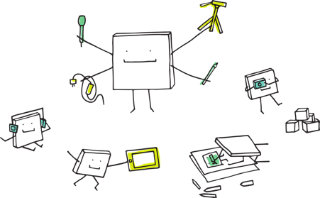

an artefact and a 1,000-word research report