Name:

Class:

Year 6 Signature Work Inquiry:
Cool water bottles
Experimental Journal
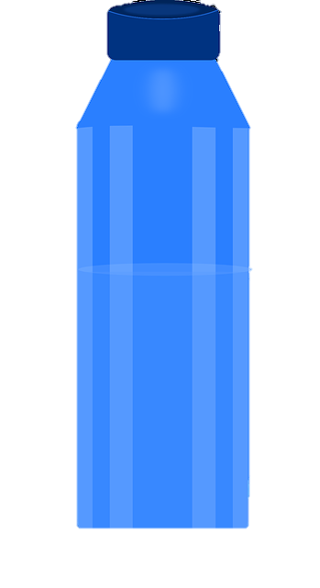

Table of Contents
Introduction 2
A Fair Test 3
Pilot experiment 1 4
Pilot experiment 2 5
Making our experiment fair 6
Gathering experimental evidence: Experiment 1 7
Gathering experimental evidence: Experiment 2 9
Gathering experimental evidence: Experiment 3 (Extension) 10

Introduction

We know that water is good for us and want to find ways to encourage each other to drink plenty of water at school without generating unnecessary plastic pollution. One way might be to try to keep the water in our bottles cool, so it tastes better for longer. In Science we are going to investigate which materials might be best for keeping our drinks cool.

We have already discovered that the same materials that are good at keeping things cool are also good at keeping them warm. We think it will be easier to measure temperature changes for water heating up than cooling down, so that is what we plan to do in our tests.

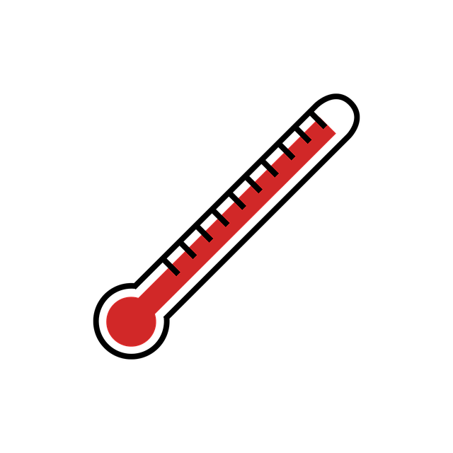

A Fair Test
You are going to investigate a range of different materials to see which are the best insulators by wrapping them around a cup of hot water and measuring the temperature drop.

You need to make a FAIR comparison between the different insulators, so must think about ALL the different things that might affect the temperature of the water and decide how to control these.
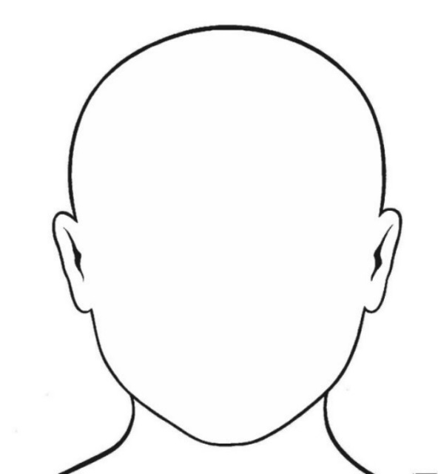
Which variables might affect the final temperature of the water?

Pilot experiment 1
Purpose of experiment | To see what the highest starting temperature is that we can reasonably achieve as a class
Hot water and steam will burn you. Be very careful not to spill. Do NOT hold the measuring cylinder or beaker while you pour water into them – stand them on the bench.

Method:
- Collect a measuring cylinder, beaker, lid, thermometer, stopwatch, clamp stand and safety spectacles. Put on the safety specs!
- Set up your apparatus so that you can lower the thermometer and lid into the measuring cylinder using the clamp stand. Slide the lid on the thermometer to around the 20°C mark.
- Preheat your apparatus: Collect around 200ml of hot water in your beaker. CAREFULLY pour 100ml into the measuring cylinder and gently lower the thermometer into it. Wait for at least 30 seconds.

- One person raise the thermometer and empty out the measuring cylinder while the other empties the beaker and CAREFULLY collects around 200ml of freshly boiled water in the beaker.
- Carefully pour 100ml of freshly boiled water into the measuring cylinder.
- Quickly lower the thermometer into the measuring cylinder until the lid (still at around the 20°C mark in the thermometer) touches the top of the measuring cylinder.
- As soon as the thermometer reading stops rising, record the temperature in the table below.
- Go back to step 4 and repeat this twice.

Results
Attempt | Starting temperature  (°C)
1
2
3

Conclusion:
What was the second lowest temperature you recorded (we’ll assume the lowest might have been a mistake)?_______

Circle the highest temperature you think you could comfortably manage to get above every time? It must be at least 2 degrees below the temperature recorded above.
70°C 75°C 80°C 85°C 90°C 95°C

Circle the value that your whole class agrees you can all comfortably manage every time as a starting temperature?
70°C 75°C 80°C 85°C 90°C 95°

Pilot experiment 2
Purpose of experiment | To see how the rate of cooling changes over time
Method:
- Set up your apparatus as before. Don’t forget to wear your safety specs.
- Preheat the apparatus as before.
- One person raise the thermometer and empty out the measuring cylinder while the other empties the beaker and CAREFULLY collects around 200ml of freshly boiled water in the beaker.
- Carefully pour 100ml of freshly boiled water into the measuring cylinder.
- Quickly lower the thermometer into the measuring cylinder until the lid (still at around the 20°C mark in the thermometer) touches the top of the measuring cylinder.
- As soon as the temperature has fallen to the starting temperature your class agreed in the last experiment, start the stopwatch and record this first starting temperature below.
- Record the temperature every minute for 10 minutes.

You are going to plot a line graph of these results in your Maths lessons to help you to understand and communicate what they tell you.
Results
Time  (min) | Water temperature  (°C)
0 | T₀ =
1
2
3
4
5 | T₅ =
6
7
8
9
10 | T₁₀ =

Calculate the temperature change over the first five minutes: T₅ – T₀ = __________ (°C)
Calculate the temperature change over the second five minutes: T₁₀ – T₅ = _________ (°C)
Conclusion:
Does the water cool the fastest over the first five minutes or the second five minutes? ________________
In what way do you think the starting temperature of the water affects how rapidly it cools? When the water is ____________ it cools ________
If you want to do a fair test, does it matter what the starting temperature of the water is? _________

Making our experiment fair
We want to test how effective different insulating materials are. To do this fairly we will need to:
Change one variable (the input or independent variable): The material we wrap the cup in
Measure one variable (the output or dependent variable): The temperature drop of the water

Keep all the other variables the same.

What are the other variables? What values will we choose?
Variable | Value
How long we let the water cool for | 10 minutes
Starting temperature ()  (roughly) | _____°C
Volume of water | 100ml
Lid or no lid? | Lid
Position of lid on thermometer | At 20°C mark
Number of layers of material | 1

We will also keep the type of container the same (a 100ml plastic measuring cylinder). Are there any other variables that matter?

Gathering experimental evidence: Experiment 1
Purpose of experiment | We want to find out which material keeps the water hottest for longest
Method:
- Collect two sets of apparatus per group. Set up your apparatus as before.
- Decide which materials your group will test. Make sure at least one group in the class tests every material. Record your materials in the table below. Fill in the first line of the table using the results from page 5.
- Wrap your first material around one measuring cylinder and secure it with two rubber bands. Gently pull the material down so that you can see the 100ml mark. Preheat this apparatus.
- One person raise the thermometer and empty out the measuring cylinder while the other empties the beaker and CAREFULLY collects around 200ml of freshly boiled water in the beaker.
- Carefully pour 100ml of freshly boiled water from the beaker into the measuring cylinder.
- Quickly lower the thermometer into the measuring cylinder until the lid (still at around the 20°C mark in the thermometer) touches the top of the measuring cylinder. Pull your insulation back up so it covers the whole cylinder.
- As soon as the temperature has fallen to the starting temperature your class agreed in the last experiment, start the stopwatch and record this first starting temperature below.
- After 10 minutes have passed, record the finishing temperature.
- While you are waiting for your first experiment to finish, start a second one with a different material. Don’t forget to keep an eye on that stopwatch!
- Record your ‘temperature drop’ results in the class spreadsheet.

Results (you might not use all these rows)
Insulating material  (Independent variable) | Starting temperature  (°C)  (should be about the same every time) | Finishing temperature (after 10 minutes)  (°C) | Temperature drop in 10 minutes  (°C)  (Dependent variable)
No material (control)  Fill in this row using your results from page 5 | T₀ = | T₀ =

Conclusion: What do our results tell us? How do they help us answer our question?

Whole class results

Material  (Independent variable) | Average Temperature drop in 10 minutes  (°C)  (Dependent variable)
No material (control)
Bubble wrap
Cotton
Felt
Fleece
Foil
Hessian
Gauze
Leatherette
Vinyl

Conclusion: What do the whole class results tell us? How do they help us answer our question?

You are going to plot a bar chart of these results in your ICT lessons to help you to understand and communicate what they tell you.

Gathering experimental evidence: Experiment 2
Purpose of experiment | To show how much better your chosen insulating material is at keeping water warm than the measuring cylinder alone
Method: Choose the insulating material that you think would be best for a water bottle cover.
Which did you choose and why? ___________________________________________________
______________________________________________________________________________
- Wrap your material around the measuring cylinder and secure it with two rubber bands. Gently pull the material down so that you can see the 100ml mark. Preheat this apparatus.
- One person raise the thermometer and empty out the measuring cylinder while the other empties the beaker and CAREFULLY collects around 200ml of freshly boiled water in the beaker.
- Carefully pour 100ml of freshly boiled water from the beaker into the measuring cylinder.
- Quickly lower the thermometer into the measuring cylinder until the lid (still at around the 20°C mark in the thermometer) touches the top of the measuring cylinder. Pull your insulation back up so it covers the whole cylinder.
- As soon as the temperature has fallen to the starting temperature your class agreed in the first pilot experiment, start the stopwatch and record this first starting temperature below.
- After 10 minutes have passed, record the finishing temperature.
- Record the temperature every minute for 10 minutes.

Conclusion:
Look back at your results on page 4. Has your insulating material made a significant difference to the finishing temperature of the water? Do you think it would be a suitable material to make a water bottle cover from? Why? Why not?

You are going to plot a line graph of these results in your Maths lessons to help you to understand and communicate what they tell you.
Results
Time  (min) | Water temperature  (°C)
0
1
2
3
4
5
6
7
8
9
10

Gathering experimental evidence: Experiment 3 (Extension)
Purpose of experiment | We want to find out how much difference adding extra layers of insulating material makes to the final temperature of the water
Method:
- Choose ONE insulating material to investigate further. Which one did you choose and why? ________________________________________________________________________________
- Fill in the 0 and 1 layer rows of the table using the class data from page 8 for ‘no material’ and your material.
- Wrap 2 layers of your material around the measuring cylinder and secure it with two rubber bands. Gently pull the material down so that you can see the 100ml mark. Preheat this apparatus.
- One person raise the thermometer and empty out the measuring cylinder while the other empties the beaker and CAREFULLY collects around 200ml of freshly boiled water in the beaker.
- Carefully pour 100ml of freshly boiled water into the measuring cylinder.
- Quickly lower the thermometer into the measuring cylinder until the lid (still at around the 20°C mark in the thermometer) touches the top of the measuring cylinder. Pull your insulation back up so it covers the whole cylinder.
- As soon as the temperature has fallen to the starting temperature your class agreed in the first pilot experiment, start the stopwatch and record this first starting temperature below.
- After 10 minutes have passed, record the finishing temperature.
- While you are waiting for your first experiment to finish, start a second one with 3 layers of insulation.

Results (you might not use all these rows)
Number of layers of insulating material  (Independent variable) | Starting temperature  (°C)  (aim for the same, or almost the same, every time) | Finishing temperature (after 10 minutes)  (°C) | Temperature drop in 10 minutes  (°C)  (Dependent variable)
0
(Fill in using the data on page 8)
1
(Fill in using the data on page 8)
2
3
4

Conclusion: What do our results tell us? How do they help us answer our question?

You might want to stick your graph of temperature against time for no material and your chosen material on this page
You might want to stick your bar chart of the temperature change in 10 minutes with a range of different insulators on this page

