Year 6 Signature Work Inquiry: Cool water bottles
Design Brief
We already know…
We want to encourage each other to use reusable water bottles and to drink more water. To do this we are going to design ‘cool’ water bottle covers.
Design a water bottle cover that will:
- Keep the water in your bottle cool for longer
- Protect your bottle
- Make your bottle look attractive

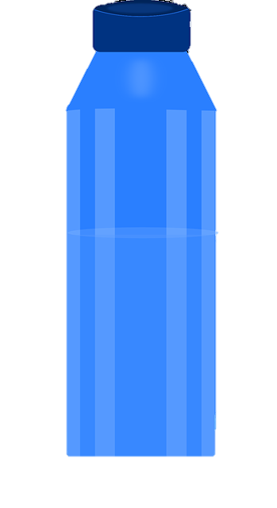
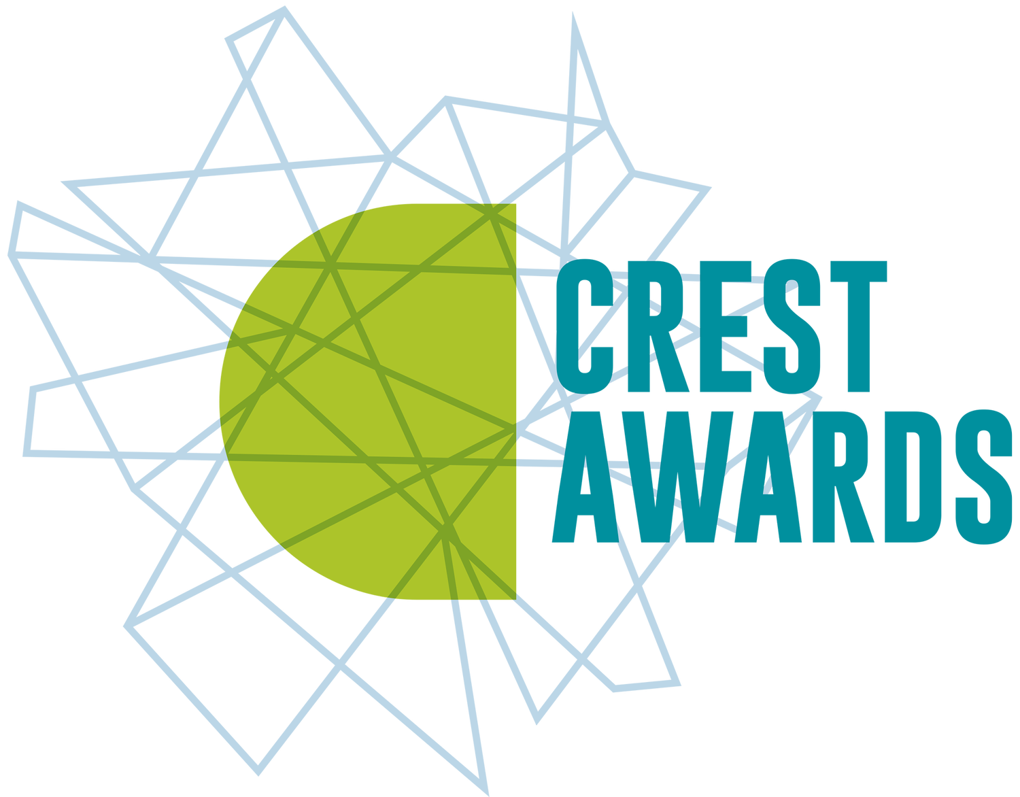

Who is my target market? What are they looking for in a water bottle cover?
You are going to make a prototype out of neoprene that you will keep for yourself. You are also going to imagine how your product might be different if you were making it for a target market in the school. Use the data sheet to answer the questions below.
When you see the symbol, this means you are making your own personal design decision and there is no right answer.

Look at Graph A.
- Circle the two groups most likely to bring a water bottle to school every day.
Infants | Juniors | Lower Seniors | Upper Seniors | Sixth Form
- Circle the group least likely to bring a water bottle to school every day.
Infants | Juniors | Lower Seniors | Upper Seniors | Sixth Form
Look at Graph B.
- Circle the group who are most likely to own an insulated bottle.
Infants | Juniors | Lower Seniors | Upper Seniors | Sixth Form
- Circle the group least likely to own an insulated bottle.
Infants | Juniors | Lower Seniors | Upper Seniors | Sixth Form

Which group do you want to design your cover for? Why?

Look at Graph C.
- Circle the thing that the group you chose thinks is most important in a water bottle cover. Infants weren’t asked this question so if you picked them, use the Juniors’ answer.
None of these things matter | All the same | Carry handle | Colour or design | Protects | Insulates
Look at Graph D.
- What colour did most students in your chosen group prefer? If they seemed to like two colours almost equally, give both.

If you were designing a cover for this group, what colour would you make it?

Now have a look at the materials your teacher has provided. What colour do you want to use for your prototype (you are making this for yourself, so choose a colour you like!)

Look at Graph E.
- What is the most money that most people in your chosen group be prepared to pay for a water bottle cover?
£20 or over | Under £20 | Under £15 | Under £10 | Under £5 | Nothing!
This will affect your choices AFTER you have made your prototype about which materials you would make a final design out of and how many layers you would use. It won’t affect the design of your prototype.

Year 6 Signature Work Inquiry: Cool water bottles
Data Sheet

My Water Bottle Design
This design is for YOU – you will have a chance later to explain how it might be different for your target group. Your cover needs to fit your water bottle, so you need to take some measurements.
1.5 cm seam for sewing
Circumference of cover needed for my bottle.
Take a tape measure or piece of string and wrap it loosely around your bottle AT THE WIDEST POINT. Unwrap it and measure the length. Your cover must be AT LEAST this wide, plus 1.5cm for a seam, or it will not fit your bottle. Keep testing this as you make your cover to make sure it will fit at the end.
_________cm + 1.5cm seam = __________ cm

Draw your water bottle cover design.
- It will be one base colour with neoprene decorations stuck or sewn on.
- All the colours you choose MUST be colours of neoprene that are available.
- Decorations must be simple to cut out of neoprene.
- The cover will wrap all the way around your bottle – that is why the box is so wide!
Height of cover needed for my bottle (think about how high on the bottle you want it to come up)
_________cm

