Powerpoint presentations
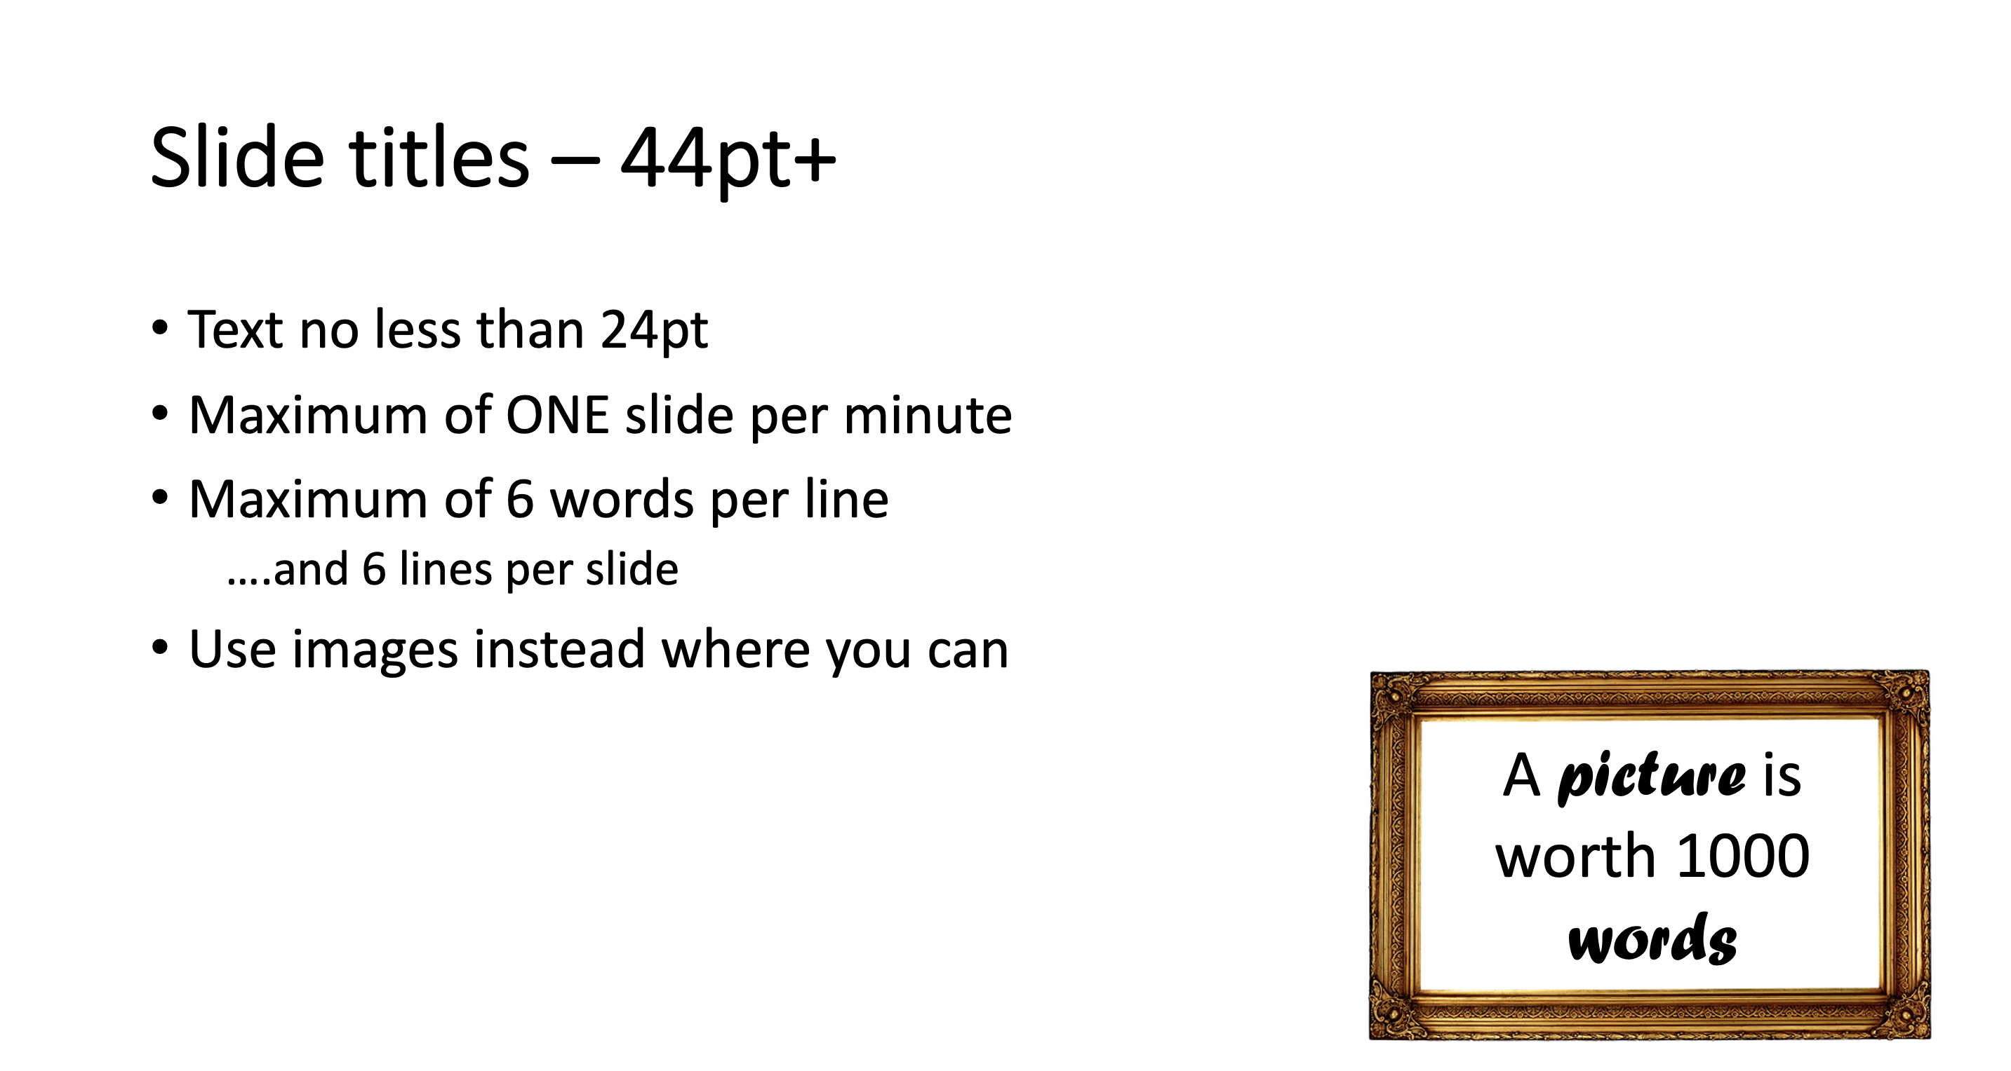
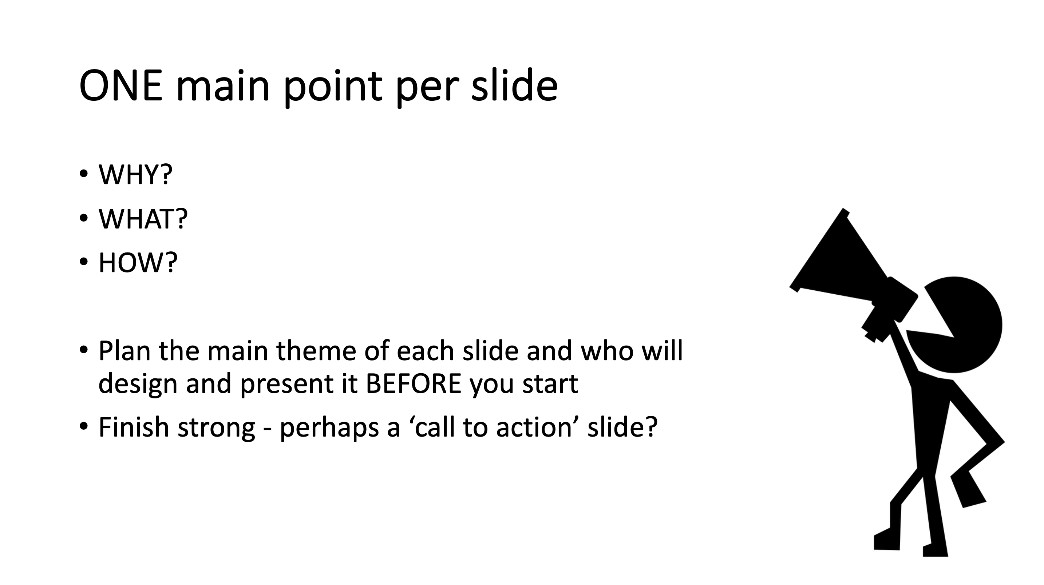

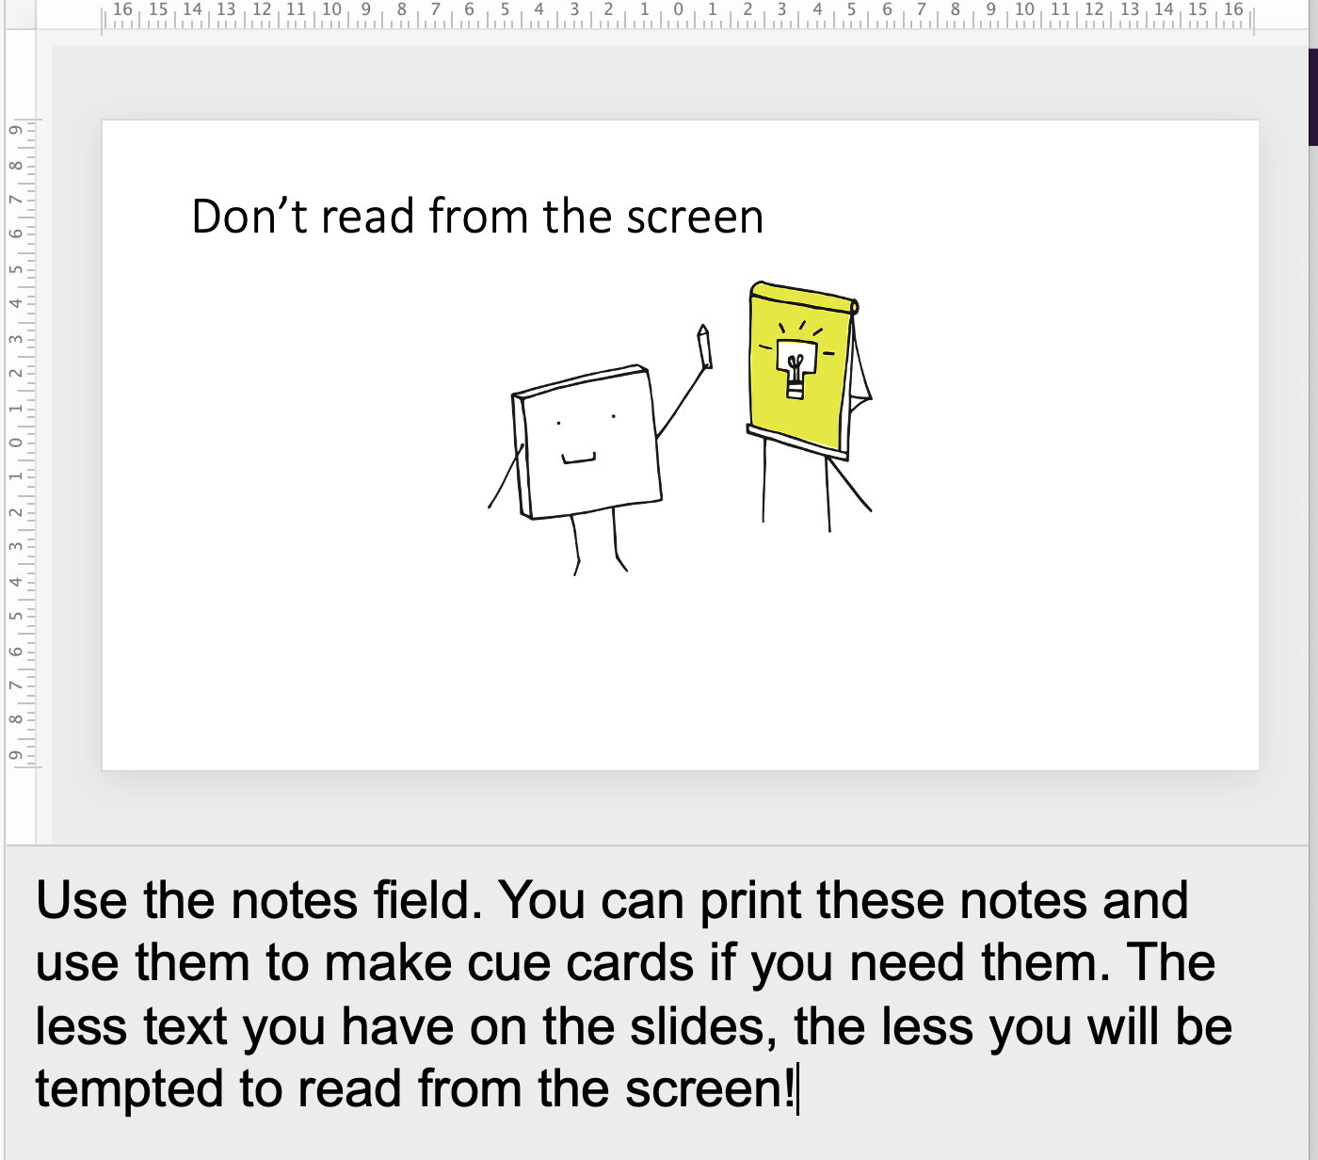
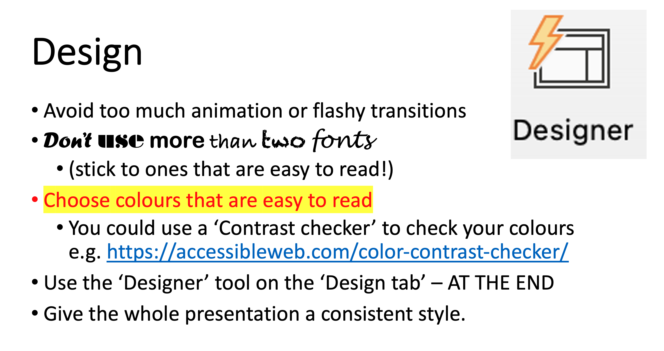

Don’t forget to make a note of all the sources you used on the last slide!

Who is your audience?
What do you want people to do?

Why?

Slide | Main point | Who is responsible?
1 | Title slide:
2
3
4
5
6
7 | Reference slide: Put the title and author of all the books, and URLs for any images or websites you used. You don’t need to show this slide when you present.

Posters
Who is your audience?
What do you want people to do?

Why?
Big Headline
To grab attention. Doesn’t need to be at the top.
A few large, clear, simple images or graphs are better than lots of small pictures
Smallest letters should be at least 24pt (or about 1cm) high.
Title should be at least 50pt (2cm) high. Not all CAPS. Clear fonts.
Clear message
- WHY should I care?
- WHAT do you want me to do?
- HOW can I do it?
Use bold colours that are easy to read from a distance.
How are you going to make it?
- Draw/cut/stick?
- Word?
- PPT? If you use PPT, make sure you set the slide size to A3 or A4.
Why have you chosen this method?
How big should it be? Portrait or landscape?
Where are you going to display your poster?
Don’t forget to make a note of all the sources you used, including images. You can do this on the back of your poster to avoid cluttering the front.
Make a rough poster plan on the back of this sheet or on a rough sheet of paper.
You might want to do more than one before you start making your poster, and choose the best.
Think about the key facts/ information/ phrases/ images you MUST include.

