**What is the greatest modern film or stage production of (or based on) ‘Romeo and Juliet’?**

FOSIL Project

Work in pairs to create a five-minute presentation in which you put forward your proposal for what you think should be judged the greatest modern film or stage production of (or based on) ‘Romeo and Juliet’.

**Success Criteria for Your Presentation:**

* Make your methodology clear. What was your criteria for judging productions?
* Evaluate at least two other productions in detail.
* Put forward a precise and sophisticated case in support of your chosen production.
* Make clear where you have taken information from.

Use up to 5 PowerPoint slides to support your presentation.

**Ideas**

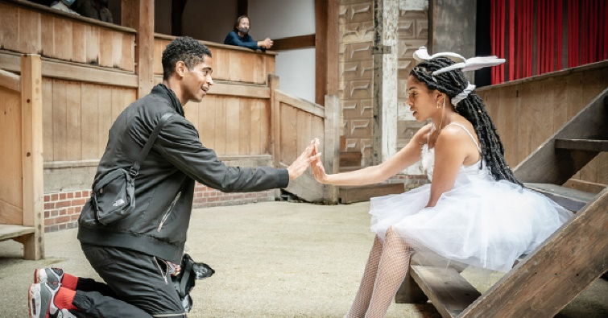

1 Ola Ince, 2021, The Globe

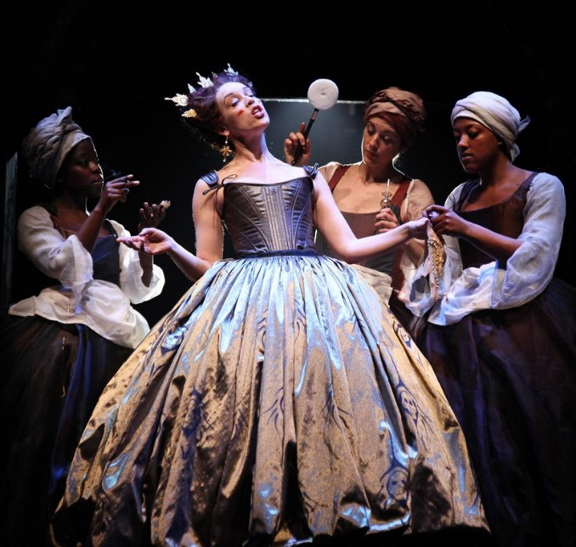

*7 Rupert Goold, 2010, The RSC*

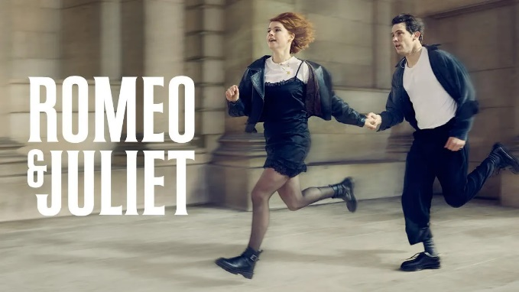

7 Emily Burns, The National Theatre (film), 2021

7 Franco Zefirelli film, 1968

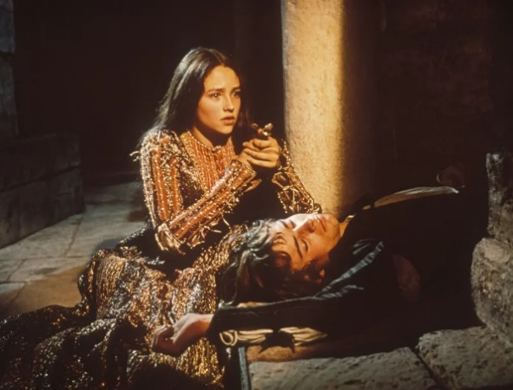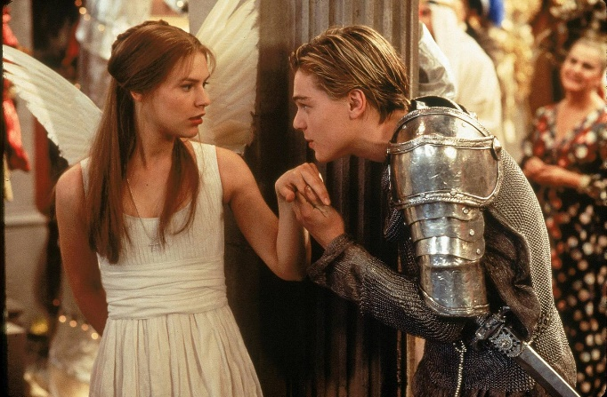

7Baz Luhrmann, Romeo + Juliet, 1996

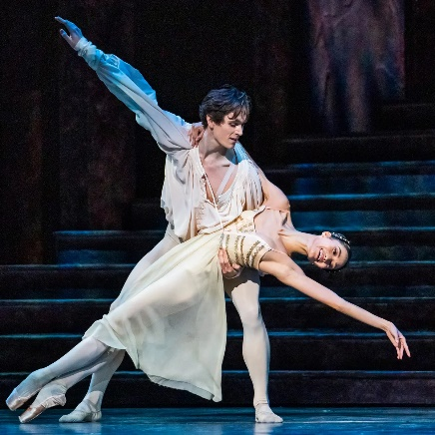

7 Royal Opera House, 2021

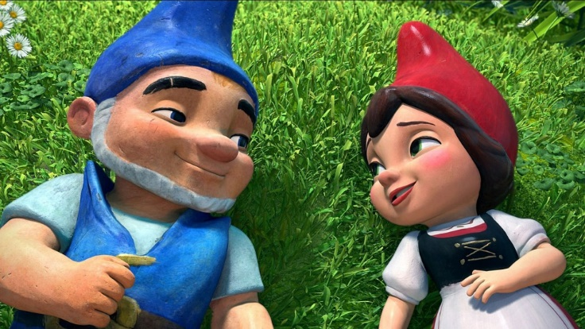

7 Kelly Asbury, Gnomeo and Juliet, 2011

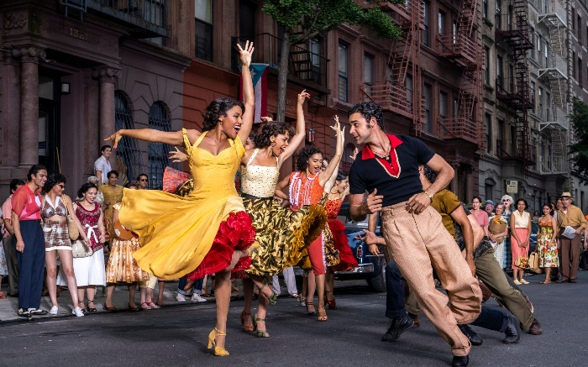

7 Steven Spielberg, West Side Story, 2021

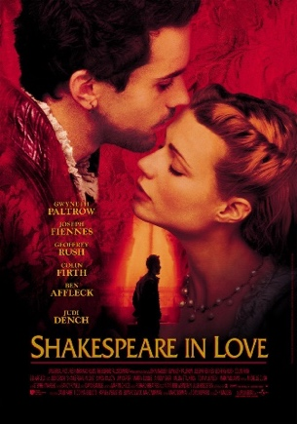

9 John Madden, Shakespeare in Love, 1998

**Step 1: What Do I Already Know?**

8 Steven Spielberg, West Side Story, 2021

In the box below, brainstorm what you already know about different productions of ‘Romeo and Juliet’ and why they could be seen as the ‘greatest’ - or not!

**Step 2: What Questions Do I Need to Ask Myself?**

In the box below, brainstorm the questions you think you’ll need to either ask yourself or to research for this project.

**Step 3a: Which resources will I use for my investigation?**

Explore the recommended resources and decide which resources you will particularly focus on to help your investigation. **Choose THREE productions to investigate.**

Websites with overviews:

1. Royal Shakespeare Company past productions: [Past productions | Romeo and Juliet | Royal Shakespeare Company (rsc.org.uk)](https://www.rsc.org.uk/romeo-and-juliet/past-productions)
2. [A complete guide to the history of Shakespeare's 'Romeo and Juliet' | London Theatre](https://www.londontheatre.co.uk/theatre-news/news/a-complete-guide-to-the-history-of-shakespeare-romeo-and-juliet)
3. [Romeo and Juliet – MIT Global Shakespeares](https://globalshakespeares.mit.edu/play/romeo-and-juliet/)
4. [8 Best Romeo & Juliet Movie Adaptations Ever Made, Ranked (movieweb.com)](https://movieweb.com/romeo-juliet-movie-adaptations/#romeo-and-juliet-1986)
5. [What Are Some Notable Examples of Film Adaptations of Romeo and Juliet? | Britannica](https://www.britannica.com/story/what-are-some-notable-examples-of-film-adaptations-of-romeo-and-juliet)
6. [Stage history | Romeo and Juliet | Royal Shakespeare Company (rsc.org.uk)](https://www.rsc.org.uk/romeo-and-juliet/about-the-play/stage-history)
7. [Romeo and Juliet, from Ashcroft to Zeffirelli – in pictures | Stage | The Guardian](https://www.theguardian.com/stage/gallery/2019/jun/25/romeo-and-juliet-franco-zeffirelli-in-pictures)

Versions to watch online:

1. [Globe Player | Shakespeare's Globe | Watch On-demand (shakespearesglobe.com)](https://player.shakespearesglobe.com/?v=mi-OeDXhBjI)
2. [Romeo and Juliet | Digital Theatre+ (digitaltheatreplus.com)](https://edu.digitaltheatreplus.com/titles/romeo-and-juliet)
   1. Login: Guernsey Library Service
   2. Password: dtdog@9013
3. [Matthew Bourne's Romeo and Juliet - Official Trailer - YouTube](https://www.youtube.com/watch?v=2NesVA-4d-g)
4. [Watch The Royal Ballet's Romeo and Juliet live in cinemas on 14 February 2022 - YouTube](https://www.youtube.com/watch?v=mi-OeDXhBjI)
5. [Official Trailer: Romeo & Juliet Film with Josh O’Connor and Jessie Buckley - YouTube](https://www.youtube.com/watch?v=7LpS77tqYwU)

Reviews:

1. [Review: On Broadway, ‘& Juliet’ (& Britney & Katy & Pink) - The New York Times (nytimes.com)](https://www.nytimes.com/2022/11/17/theater/and-juliet-review.html)
2. [Romeo and Juliet review – a bold rewiring with no room for romance | Theatre | The Guardian](https://www.theguardian.com/stage/2021/jul/09/romeo-and-juliet-review-globe-london)
3. [Romeo & Juliet: Alfred Enoch stars in the Globe’s wild new production (timeout.com)](https://www.timeout.com/london/theatre/romeo-juliet-review-globe)
4. [Romeo and Juliet review – National Theatre's first film is an ingenious triumph | National Theatre | The Guardian](https://www.theguardian.com/stage/2021/apr/04/romeo-and-juliet-review-national-theatre-sky-arts-josh-oconnor-jessie-buckley#gnomeo-amp-juliet-2011)
5. [Romeo and Julie, National Theatre review: It’s a Sin’s Callum Scott Howells stars in this gut-punching reworking of Shakespeare’s romance (telegraph.co.uk)](https://www.telegraph.co.uk/theatre/what-to-see/romeo-julie-national-theatre-review-sins-callum-scott-howells/)

Literary criticism on Baz Luhrmann:

1. [Pop Goes the Shakespeare: Baz Luhrmann's William Shakespeare's "Romeo + Juliet" (EBSCO Literary Reference Centre)](https://search.ebscohost.com/login.aspx?direct=true&db=lfh&AN=3381904&site=ehost-live)

User ID: guernseylibrary

Password: Guernsey1!

1. [A Companion to Shakespeare and Performance - Google Books](https://www.google.gg/books/edition/A_Companion_to_Shakespeare_and_Performan/dZnoV-mfxmUC?gbpv=1)

Try searching EBSCO Literary Reference Centre for reviews and articles of other films and plays. E.g. search for *Romeo and Juliet production* or *Romeo and Juliet film*. You might want to limit the search to ‘reviews’ using the boxes on the left. Note that you can only access articles that have one of these symbols beneath them: 

**Step 3b: What are the main points from my research?**

Which THREE productions are you going to focus on?

|  |
| --- |
| 1.  2.  3. |

In the boxes below, summarise the main points from your key sources of information. In the Resource column you can either put the letter of a source from the previous page that you have used, or if you use any other sources, put the title and link in the bibliography at the end.

| **Resource** | **Main points** | **How does this help me to make my case?** |
| --- | --- | --- |
|  |  |  |
|  |  |  |
|  |  |  |
|  |  |  |
|  |  |  |
|  |  |  |
|  |  |  |
|  |  |  |
|  |  |  |

**Bibliography**: Add any sources that you found for yourself

|  |  |  |
| --- | --- | --- |
| Resource | Title | Hyperlink |
|  |  |  |
|  |  |  |
|  |  |  |
|  |  |  |
|  |  |  |
|  |  |  |
|  |  |  |

**Step 5: What is the case we will put forward?**

In the boxes below, summarise the case you will put forward in your presentation. Once you have completed this, you should complete your presentation:

Other production considered (and reasons why it was not ultimately chosen):

Other production considered (and reasons why it was not ultimately chosen):

Production chosen as ‘The greatest’:

Key evidence to support choice:

**Step 5: How can we communicate our case most effectively?**

Remember that you are creating a five-minute presentation in which you put forward your proposal for what you think should be judged the greatest modern film or stage production of (or based on) ‘Romeo and Juliet’.

Use up to 5 PowerPoint slides to support your presentation. Plan what will be on your slides below:

|  |  |
| --- | --- |
| **Slide content & purpose** | **What we need to *say*** (script prompts) |
|  |  |
|  |  |
|  |  |
|  |  |
|  |  |

**Success criteria checklist. Have we…**

* Made our methodology clear. What was our criteria for judging productions?
* Evaluated at least two other productions in detail.
* Put forward a precise and sophisticated case in support of our chosen production.
* Made it clear where we have taken information from.

**Step 6: How well did we carry out the research?**

In the boxes below, summarise the strengths and weaknesses of your research and presentation:

What we did well in our research:

What we would change/research further if we had more time:

Main strengths of the presentation:

What we would change if we did it again: