0, 1, 1, 2, 3, 5, 8, 13, 21, 34, 55, 89, 144, 233, 377, 610, 987
Investigating real flowers
Sepal
Petal
Stamen
Carpel
Image by Gini George from Pixabay (fuscia)
Ground rules:
- Stay with your class group. Don’t wander off and join another class.
- Take care on the roads around school. Always use the crossings and look both ways for traffic yourself. Don’t assume someone else is looking.
- Watch your step on uneven ground. Stay away from and do not startle cows.
- You may pick one daisy, do not pick any other flowers.
Watch out for nettles and brambles. Let your teacher know BEFORE going out if you have a history of experiencing strong allergic reactions to bites or stings.

Plant  (name or description) |  | What are you counting?  (e.g. petals, leaf segments, stamens etc.) | How many? | Fibonacci number  (Y/N)
Image by 🌼Christel🌼 from Pixabay | Daisy | Petals
How reasonable is it to say that Fibonacci numbers are common in nature?

The Golden Ratio (1.618 to 3d.p.) in me
 | Measurement A (cm) |  | Measurement B (cm) |  | A ÷B (to 2dp) | Between 1.5 and 1.7?
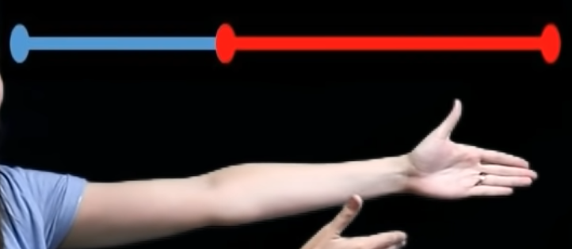 | Elbow to fingertip |  | Shoulder to elbow
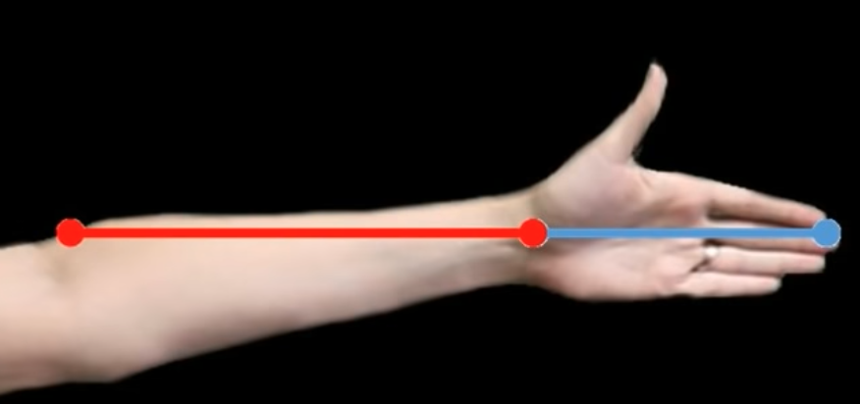 | Wrist to elbow |  | Fingertips to wrist
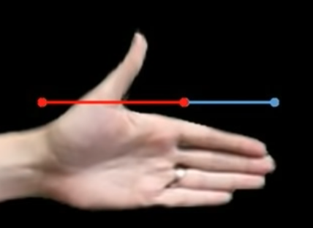 | Bottom of fingers to wrist |  | Length of longest finger
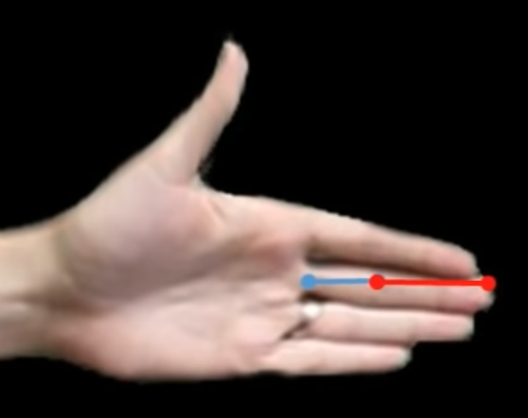 | Top two finger joints together |  | Bottom joint of finger (nearest hand)
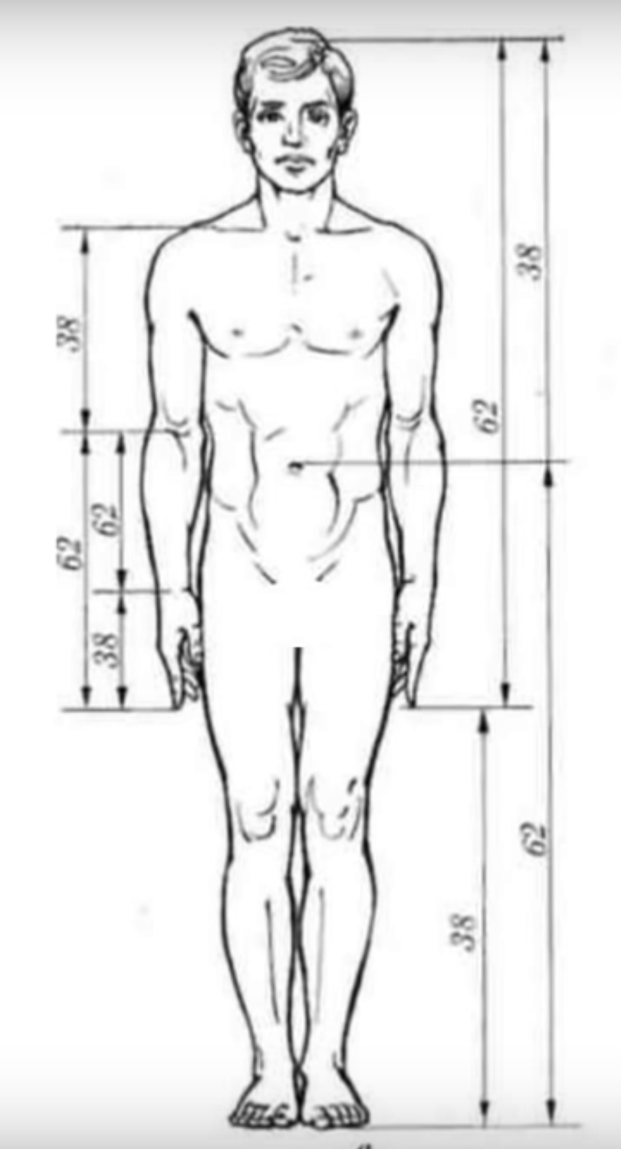 | Top of head to bottom of fingertips |  | Bottom of fingertips to bottom of feet
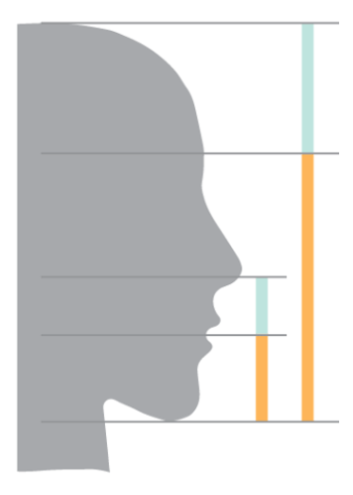 | Eyebrows to bottom of chin |  | Top of head to eyebrows
 | Bottom of chin to mouth |  | Mouth to bottom of nose
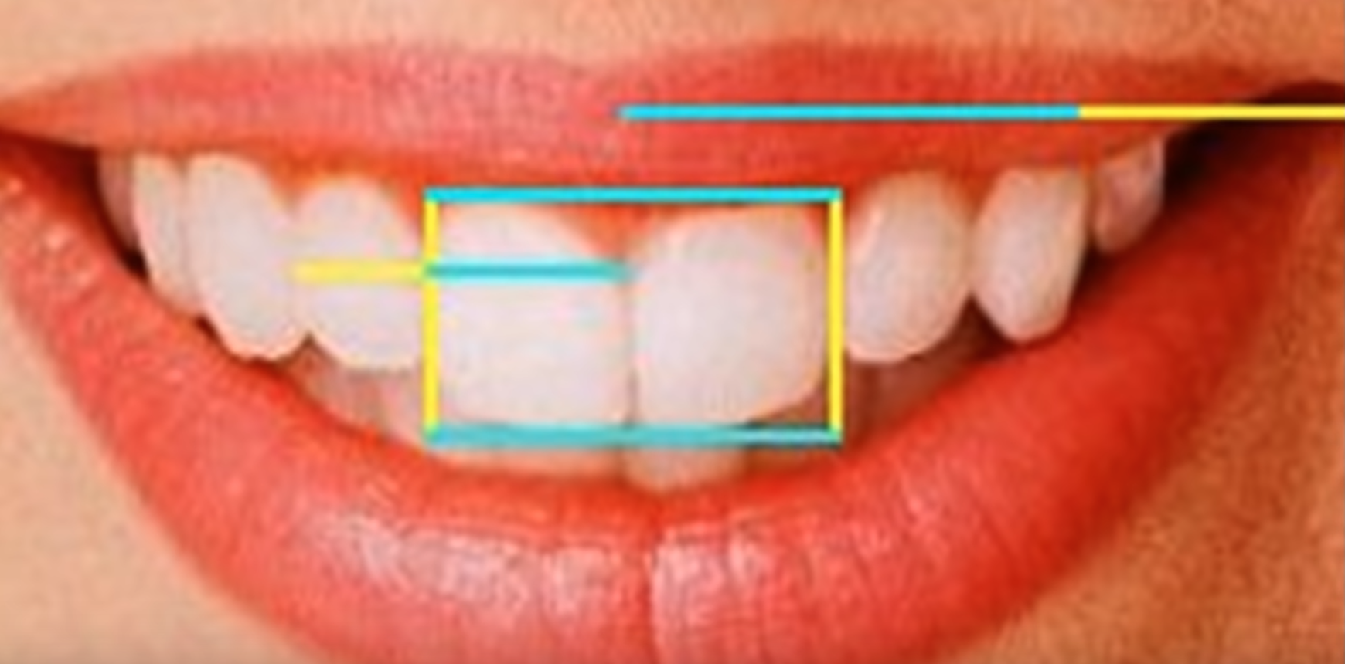 | Width of two front teeth |  | Height of front teeth
 | Width of one front tooth |  | Width of next tooth along

Images from: https://www.slideshare.net/vayappurathu/fibonacci-sequence-and-golden-ratio-10748409 , https://golden-ratio.club/golden-ratio-in-people, https://www.youtube.com/watch?v=c8ccsE_IumM
Reflecting on my inquiry
Something interesting I learnt in this topic (or maybe something that surprised me)
What I thought I did well
What I thought I could do better
Something I would have liked to find out more about if we had more time
How did I feel about doing extended inquiry in Maths?
[Did it change the way I relate to Maths? Was it exciting/ interesting/ uncomfortable/liberating/ boring/ challenging etc]

FOSIL: Learning by finding out for yourself. 4
Y7 Fibonacci Maths inquiry (graphic organisers) by The FOSIL Group is licensed under CC BY-NC-SA 4.0

Name Class Date
Reflecting on my inquiry
Something interesting I learnt in this topic (or maybe something that surprised me)
What I thought I did well
What I thought I could do better
Something I would have liked to find out more about if we had more time
How did I feel about doing extended inquiry in Maths?
[Did it change the way I relate to Maths? Was it exciting/ interesting/ uncomfortable/liberating/ boring/ challenging etc]

