Inquiry guide: what is in this Graphic Organiser pack?
Lesson | Description | Resources required and whether they are included in this Graphic Organisers pack
Lesson 1  CONNECT & WONDER | Introduction to topic and generating questions.  Investigating names for numbers in different languages. Could move on to different counting systems. | - Seeking patterns in number words (see page 2 of Graphic Organisers pack)  - Counting to 100 in 13 different languages (see pages 3-10 of Graphic Organisers pack). Print 1-2 packs per class , cut the sheets into a card for each language, and students share.
Lesson 2  CONNECT | Investigating different numerals and counting systems | - Not included in graphic organiser pack or slides. Lesson designed and run by Maths teacher.
Lesson 3  CONNECT & INVESTIGATE | Placing famous mathematicians from around the world on a map. Thinking about gender and time period as well.  Choosing one mathematician to investigate (homework to gather resources – introduction to databases) | - World map (see page 11 of Graphic Organisers pack)  - Brief biographies of mathematicians (not included due to copyright issues). I printed a pack that the class used as a shared resources from https://www.thefamouspeople.com/mathematicians.php, and https://www.thefamouspeople.com/women-mathematicians.php but they could also work with them online if there was enough computer access for the whole class.
Lesson 4  INVESTIGATE | Investigating and making notes on their mathematician – how did their Maths influence the world? Do we still use it in our lives today? | - Students chose mathematicians and printed biography pages for homework from either MacTutor (https://mathshistory.st-andrews.ac.uk/ ) or Britannica School.  - Investigating mathematicians (see page 12 of Graphic Organisers pack). Intended to be scaled up and printed on A3.
Lesson 5  CONSTRUCT & EXPRESS | Use the evidence gathered to answer the question ‘Is maths a universal language?’  Produce a poster in a group (AND cue cards on their individual mathematician) | - Constructing my argument (see page 13 of Graphic Organisers pack)  - Large pieces of poster paper
Lesson 6  EXPRESS & REFLECT | Poster showcase with short talks on each mathematician. Individual reflection. | - Reflecting on my inquiry (see page 14 of Graphic Organisers pack). Two per page; cut page in half.

Seeking patterns in number words
Language | Example: French | A: | B:
Numbers 10-20:  What patterns can you see here that use the numbers 1-10? Are there any irregularities? | 11-16 sound a little bit like 1-6 with -ze on the end (meaning + 10).  17-20 translate directly as ten-seven, ten-eight, and ten-nine.
Numbers 20-29:  Do these follow a regular pattern? Any exceptions? | Vingt is a new word (it isn’t just 2x10).  Vingt-et-un has an extra ‘and’ in it.  All the rest follow a regular pattern and translate directly as twenty-two, twenty-three etc.
Numbers 30-100:  Can you spot any patterns here? Look very carefully at multiples of 20, for example. | From 30 to 60, all the multiples of 10 end in -ante (meaning x10), and start a bit like the numbers below 10.  70 translates as 60+10, 80 translates as 4x20, 90 translates as 4x20+10!!
What do you think the word for the number 99 would be ? | 4x20+19 = quatre-vingt-dix-neuf
Choose another number below 100: ____. Write this number in each language.
Conclusion: All the languages are different, but can you see similar patterns? Given 1-20, would you be able to guess the English translations for bigger numbers?

English
0 | zero | 10 | ten | 20 | twenty |  |  | counting up in 10’s
1 | one | 11 | eleven | 21 | twenty-one |  | 10 | ten
2 | two | 12 | twelve | 22 | twenty-two |  | 20 | twenty
3 | three | 13 | thirteen | 23 | twenty-three |  | 30 | thirty
4 | four | 14 | fourteen | 24 | twenty-four |  | 40 | forty
5 | five | 15 | fifteen | 25 | twenty-five |  | 50 | fifty
6 | six | 16 | sixteen | 26 | twenty-six |  | 60 | sixty
7 | seven | 17 | seventeen | 27 | twenty-seven |  | 70 | seventy
8 | eight | 18 | eighteen | 28 | twenty-eight |  | 80 | eighty
9 | nine | 19 | nineteen | 29 | twenty-nine |  | 90 | ninety
 |  |  |  |  |  |  | 100 | one hundred

French
0 | zéro | 10 | dix | 20 | vingt |  |  | counting up in 10’s
1 | un | 11 | onze | 21 | vingt-et-un |  | 10 | dix
2 | deux | 12 | douze | 22 | vingt-deux |  | 20 | vingt
3 | trois | 13 | treize | 23 | vingt -trois |  | 30 | trente
4 | quatre | 14 | quatorze | 24 | vingt-quatre |  | 40 | quarante
5 | cinq | 15 | quinze | 25 | vingt-cinq |  | 50 | cinquante
6 | six | 16 | seize | 26 | vingt-six |  | 60 | soixante
7 | sept | 17 | dix-sept | 27 | vingt-sept |  | 70 | soixante-dix
8 | huit | 18 | dix-huit | 28 | vingt-huit |  | 80 | quatre-vingts
9 | neuf | 19 | dix-neuf | 29 | vingt-neuf |  | 90 | quatre-vingt-dix
 |  |  |  |  |  |  | 100 | cent

Yaruba (Sengalese dialect) Group B
0 | òdo | 10 | ẹwa | 20 | ogun |  |  | counting up in 10’s
1 | ọkan | 11 | ọkanla | 21 | ọkanlelogun |  | 10 | ẹwa
2 | eéji | 12 | ejila | 22 | ejilelogun |  | 20 | ogun
3 | ẹta | 13 | ẹtala | 23 | ẹtalelogun |  | 30 | ọgbọn
4 | ẹrin | 14 | ẹrinla | 24 | ẹrinlelogun |  | 40 | Ogoji (short for ogun meéji)
5 | aárùn | 15 | aárùndinlogun* | 25 | aárùndinlọgbọn |  | 50 | aadọta
6 | ẹfà | 16 | ẹrindinlogun | 26 | erindinlọgbọn |  | 60 | ọgọta (short for ogun mẹta)
7 | èje | 17 | ẹtadinlogun | 27 | etadinlọgbọn |  | 70 | adọrin
8 | ẹjọ | 18 | eéjidinlogun | 28 | eejidinlọgbọn |  | 80 | ọgọrin (short for ogun mẹrin)
9 | ẹsan | 19 | ọkandinlogun | 29 | okandinlọgbọn |  | 90 | adọrun
* usually contracted to ẹdogun. Sources: https://polyglotclub.com/wiki/language/yoruba/grammar/onka-yoruba-%28counting-and-numbers-in-yoruba%29 and https://yorubatranslatornetwork.blogspot.com/2015/10/yoruba-numbering-system-1-100-in-yoruba.html |  |  |  |  |  |  | 100 | ọgọrùn (short for ogun maárùn)

German Group B
0 | null | 10 | zehn | 20 | zwanzig |  |  | counting up in 10’s
1 | eins | 11 | elf | 21 | einundzwanzig |  | 10 | zehn
2 | zwei | 12 | zwölf | 22 | zweiundzwanzig |  | 20 | zwanzig
3 | drei | 13 | dreizehn | 23 | dreiundzwanzig |  | 30 | dreißig
4 | vier | 14 | vierzehn | 24 | vierundzwanzig |  | 40 | vierßig
5 | fünf | 15 | fünfzehn | 25 | fünfundzwanzig |  | 50 | fünfßig
6 | sechs | 16 | sechszehn | 26 | sechsundzwanzig |  | 60 | sechsßig
7 | sieben | 17 | siebenzehn | 27 | siebenundzwanzig |  | 70 | siebßig
8 | acht | 18 | achtzehn | 28 | achtundzwanzig |  | 80 | achtßig
9 | neun | 19 | neunzehn | 29 | neunundzwanzig |  | 90 | neunßig
 |  |  |  |  |  |  | 100 | Einhundert

Italian Group B
0 | zero | 10 | dieci | 20 | venti |  |  | counting up in 10’s
1 | uno | 11 | undici | 21 | ventuno |  | 10 | dieci
2 | due | 12 | dodici | 22 | ventidue |  | 20 | venti
3 | tre | 13 | tredici | 23 | ventitré |  | 30 | trenta
4 | quattro | 14 | quattordici | 24 | ventiquattro |  | 40 | quaranta
5 | cinque | 15 | quindici | 25 | venticinque |  | 50 | cinquanta
6 | sei | 16 | sedici | 26 | ventisei |  | 60 | sessanta
7 | sette | 17 | diciassette | 27 | ventisette |  | 70 | settanta
8 | otto | 18 | diciotto | 28 | ventotto |  | 80 | ottanta
9 | nove | 19 | dicianove | 29 | ventinove |  | 90 | novanta
Source: https://www.woodwarditalian.com/lesson/numbers-1-to-100-in-italian/ |  |  |  |  |  |  | 100 | cento
Guernésiais? (Language specific to Guernsey, related to Norman French) Group B
0 |  | 10 | di(x) | 20 | vingt |  |  | counting up in 10’s
1 | ieune | 11 | aonze | 21 | vingt-ieune |  | 10 | dix
2 | daeux/daoux | 12 | douze | 22 | vingt-daeux/daoux |  | 20 | vingt
3 | treis | 13 | treize | 23 | vingt-treis |  | 30 | trente
4 | quate(r) | 14 | quatorze | 24 | vingt- quate(r) |  | 40 | tchérànte
5 | chin(q)(s) | 15 | tchinze | 25 | vingt- chin(q)(s) |  | 50 | chinquànte
6 | si(x) | 16 | seize | 26 | vingt- si(x) |  | 60 | seissànte
7 | saept/sé/sept | 17 | dix-saept | 27 | vingt- saept/sé/sept |  | 70 | septànte
8 | huit | 18 | dix-huit | 28 | vingt-huit |  | 80 | huitànte/octànte/quatre-vingts
9 | neuf | 19 | dix-neuf | 29 | vingt-neuf |  | 90 | nonànte
With thanks to the Guernsey Language Commission for the translation. Guernésiais was historically largely an oral language so there are no set spellings for some words. |  |  |  |  |  |  | 100 | chent

Hindi (India) Group B
0 | shuniye | 10 | das | 20 | bees |  |  | counting up in 10’s
1 | ek | 11 | gyaarah | 21 | ikis |  | 10 | das
2 | dow | 12 | baarah | 22 | bais |  | 20 | bees
3 | teen | 13 | terah | 23 | teis |  | 30 | tis
4 | chaar | 14 | chaudah | 24 | chaubis |  | 40 | chalis
5 | paanch | 15 | pandrah | 25 | pachis |  | 50 | pachas
6 | cheh | 16 | saulah | 26 | chabbis |  | 60 | saadh
7 | saat | 17 | satarah | 27 | stais |  | 70 | sattar
8 | aath | 18 | atharah | 28 | athais |  | 80 | assi
9 | nau | 19 | unnis | 29 | unatis |  | 90 | nabbe
99 = Ninyaanave. It’s really hard to construct new numbers for this language! Ask your teacher for the full list so that you can find your chosen number.  sources: https://blogs.transparent.com/hindi/hindi-numbers-1-100/ |  |  |  |  |  |  | 100 | ek sow

Danish Group A
0 | nul | 10 | ti | 20 | tyve |  |  | counting up in 10’s
1 | en | 11 | elleve | 21 | enogtyve |  | 10 | ti
2 | to | 12 | tolv | 22 | toogtyve |  | 20 | tyve
3 | tre | 13 | tretten | 23 | treogtyve |  | 30 | tredive
4 | fire | 14 | fjorten | 24 | fireogtyve |  | 40 | fyrre
5 | fem | 15 | femten | 25 | femogtyve |  | 50 | halvtreds  short for halvtredje-sinds-tyve, meaning “third half (2.5) times twenty”
6 | seks | 16 | seksten | 26 | seksogtyve |  | 60 | tres  short for tre-sinds-tyve, which means “three times twenty”
7 | syv | 17 | sytten | 27 | syvogtyve |  | 70 | halvfjerds  short for halv-fjerd-sinds-tyve, meaning “fourth half (3.5) times twenty”
8 | otte | 18 | atten | 28 | otteogtyve |  | 80 | firs  short for fire-sind-styve, meaning “four times twenty”
9 | ni | 19 | nitten | 29 | niogtyve |  | 90 | halvfems  short for halv-fem-sinds-tyve, meaning “fifth half times twenty”
In Danish ‘first half’ = 0.5, ‘second half’ = 1.5, ‘third half’ = 2.5 etc. How confusing is that!?  sources: https://www.languagesandnumbers.com/how-to-count-in-danish/en/dan/ |  |  |  |  |  |  | 100 | hundred

Navajo (Indigenous people of North America) Group A
0 | názbas | 10 | neeznáá | 20 | naadiin |  |  | counting up in 10’s
1 | tʼááłáʼí | 11 | łáʼtsʼáadah | 21 | naadįįnłáʼ |  | 10 | neeznáá
2 | naaki | 12 | naakitsʼáadah | 22 | naadįįnaaki |  | 20 | naadiin
3 | tááʼ | 13 | tááʼtsʼáadah | 23 | naadįįntááʼ |  | 30 | tádiin
4 | dį́į́ʼ | 14 | dį́į́ʼtsʼáadah | 24 | naadiindį́į́ʼ |  | 40 | dízdiin
5 | ashdlaʼ | 15 | ashdlaʼáadah | 25 | naadiinashdlaʼ |  | 50 | ashdladiin
6 | hastą́ą́ | 16 | hastą́ʼáadah | 26 | naadiinhastą́ą́ |  | 60 | hastą́diin
7 | tsostsʼid | 17 | tsostsʼidtsʼáadah | 27 | naadiintsostsʼid |  | 70 | tsostsʼidiin
8 | tseebíí | 18 | tseebíítsʼáadah | 28 | naadiintseebíí |  | 80 | tseebídiin
9 | náhástʼéí | 19 | náhástʼéítsʼáadah | 29 | naadiinnáhástʼéí |  | 90 | náhástʼédiin
sources: https://www.languagesandnumbers.com/how-to-count-in-navajo/en/nav/ , https://www.lingalot.com/numbers-in-navajo/  Numbers between 41 and 49 are formed just as for 20, above (e.g. dízdiinashdlaʼ is 45). But for all the other numbers you have to add “dóó ba’aan” (meaning in addition to) between the ten and the unit e.g. tádiin dóó baʼąą ashdla’ is 35. |  |  |  |  |  |  | 100 | tʼááłáhádí neeznáádiin
Turkish Group A
0 | sıfır | 10 | on | 20 | yirmi |  |  | counting up in 10’s
1 | bir | 11 | on bir | 21 | yirmi bir |  | 10 | on
2 | iki | 12 | on iki | 22 | yirmi iki |  | 20 | yirmi
3 | üç | 13 | on üç | 23 | yirmi üç |  | 30 | otuz
4 | dört | 14 | on dört | 24 | yirmi dört |  | 40 | kırk
5 | beş | 15 | on beş | 25 | yirmi beş |  | 50 | elli
6 | altı | 16 | on altı | 26 | yirmi altı |  | 60 | altmış
7 | yedi | 17 | on yedi | 27 | yirmi yedi |  | 70 | yetmiş
8 | sekiz | 18 | on sekiz | 28 | yirmi sekiz |  | 80 | seksen
9 | dokuz | 19 | on dokuz | 29 | yirmi dokuz |  | 90 | doksan
sources: https://www.languagesandnumbers.com/how-to-count-in-turkish/en/tur/ |  |  |  |  |  |  | 100 | yüz

Welsh Group A
0 | sero | 10 | deg | 20 | daudeg |  |  | counting up in 10’s
1 | un | 11 | undeg un | 21 | daudeg un |  | 10 | deg
2 | dau | 12 | undeg dau | 22 | daudeg dau |  | 20 | daudeg
3 | tri | 13 | undeg tri | 23 | daudeg tri |  | 30 | trideg
4 | pedwar | 14 | undeg pedwar | 24 | daudeg pedwar |  | 40 | pedwardeg
5 | pump | 15 | undeg pump | 25 | daudeg pump |  | 50 | pumdeg
6 | chwech | 16 | undeg chwech | 26 | daudeg chwech |  | 60 | chwedeg
7 | saith | 17 | undeg saith | 27 | daudeg saith |  | 70 | saithdeg
8 | wyth | 18 | undeg wyth | 28 | daudeg wyth |  | 80 | wythdeg
9 | naw | 19 | undeg naw | 29 | daudeg naw |  | 90 | nawdeg
Source: https://www.languagesandnumbers.com/how-to-count-in-welsh/en/cym/  sources: https://polyglotclub.com/wiki/language/yoruba/grammar/onka-yoruba-%28counting-and-numbers-in-yoruba%29 and https://yorubatranslatornetwork.blogspot.com/2015/10/yoruba-numbering-system-1-100-in-yoruba.html |  |  |  |  |  |  | 100 | cant

Māori (Indigenous people of New Zealand) Group A
0 | kore | 10 | tekau | 20 | rua tekau |  |  | counting up in 10’s
1 | tahi | 11 | tekau mā tahi | 21 | rua tekau mā tahi |  | 10 | tekau
2 | rua | 12 | tekau mā rua | 22 | rua tekau mā rua |  | 20 | rua tekau
3 | toru | 13 | tekau mā toru | 23 | rua tekau mā toru |  | 30 | toru tekau
4 | whā | 14 | tekau mā whā | 24 | rua tekau mā whā |  | 40 | whā tekau
5 | rima | 15 | tekau mā rima | 25 | rua tekau mā rima |  | 50 | rima tekau
6 | ono | 16 | tekau mā ono | 26 | rua tekau mā ono |  | 60 | ono tekau
7 | whitu | 17 | tekau mā whitu | 27 | rua tekau mā whitu |  | 70 | whitu tekau
8 | waru | 18 | tekau mā waru | 28 | rua tekau mā waru |  | 80 | waru tekau
9 | iwa | 19 | tekau mā iwa | 29 | rua tekau mā iwa |  | 90 | iwa tekau
sources: https://www.languagesandnumbers.com/how-to-count-in-maori/en/mri/ |  |  |  |  |  |  | 100 | kotahi rau

Mandarin Chinese Group A
0 | líng | 10 | shí | 20 | èr shí |  |  | counting up in 10’s
1 | yī | 11 | shí yī | 21 | èr shí yī |  | 10 | shí
2 | èr | 12 | shí èr | 22 | èr shí èr |  | 20 | èr shí
3 | sān | 13 | shí sān | 23 | èr shí sān |  | 30 | sān shí
4 | sì | 14 | shí sì | 24 | èr shí sì |  | 40 | sì shí
5 | wǔ | 15 | shí wǔ | 25 | èr shí wǔ |  | 50 | wǔ shí
6 | liù | 16 | shí liù | 26 | èr shí liù |  | 60 | liù shí
7 | qī | 17 | shí qī | 27 | èr shí qī |  | 70 | qī shí
8 | bā | 18 | shí bā | 28 | èr shí bā |  | 80 | bā shí
9 | jiǔ | 19 | shí jiǔ | 29 | èr shí jiǔ |  | 90 | jiǔ shí
sources: https://www.berlitz.com/blog/count-chinese-numbers-mandarin |  |  |  |  |  |  | 100 | yī bǎi

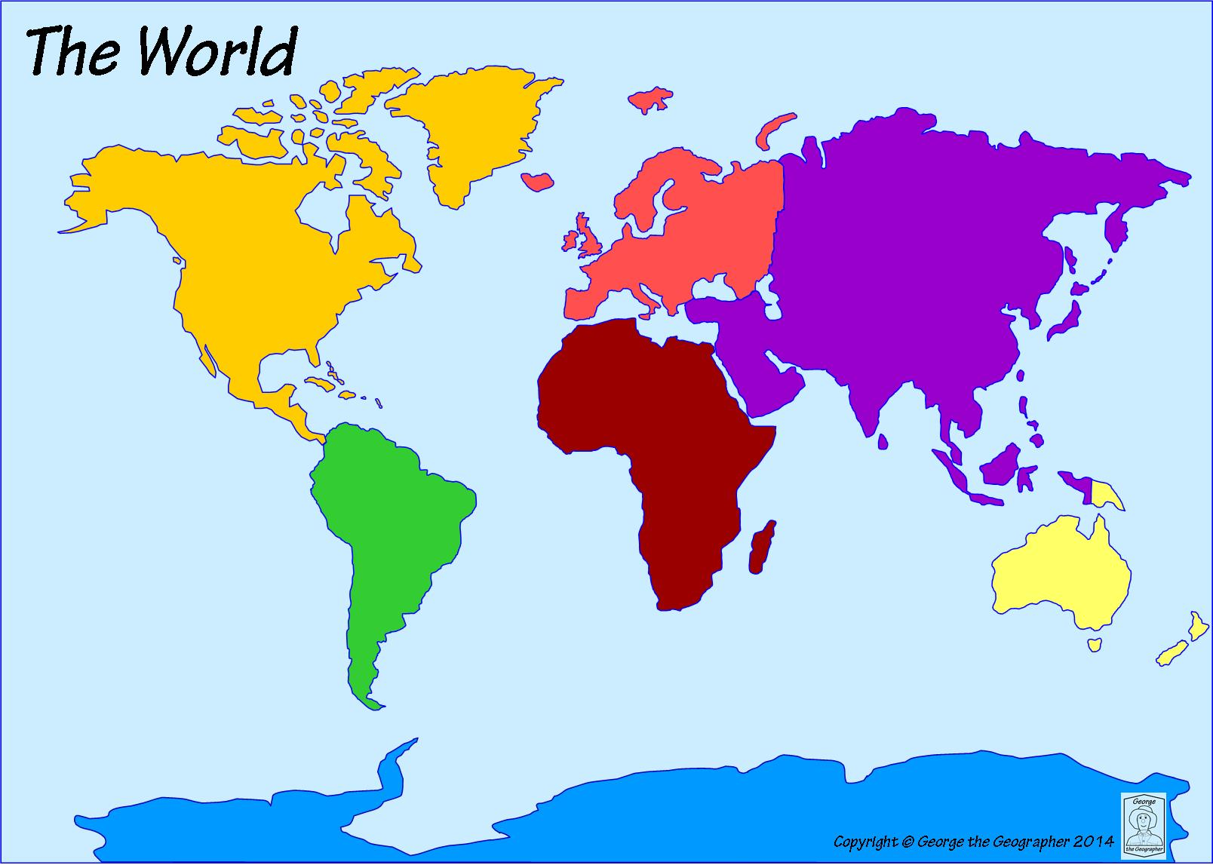
Europe
Name | Year born | Country

Asia
Name | Year born | Country

Oceania
Name | Year born | Country

Africa
Name | Year born | Country

North America
Name | Year born | Country

South America
Name | Year born | Country

Mathematicians around the world

Investigating Mathematicians
Source: | Name of mathematician:  Where is your info from? Britannica School MacTutor Another site (give details):
What information have I found? |  |  | Why is it relevant to my inquiry?
WHERE was my mathematician born and where did they live and work? |  |  | Does the country matter? Any idea of the wider context for that country? If they moved around, why do you think that happened?
WHEN were they born/ did they die? How old were they when they died? |  |  | Does the time period matter? Any idea of the wider context for that time period?
What maths were they famous for? |  |  | Why is this maths important? Can you explain it? Can you give examples of how it is used?
Are they famous for anything other than maths? What? |  |  | Did this other work relate to their maths? Do you think older mathematicians are more or less likely to work in a wide range of different fields?
Anything else interesting about their life and work?

Constructing my argument
 | No, this is evidence that Maths is NOT a universal language | Yes, this is evidence that Maths IS a universal language
Counting in different languages
Counting in ways from different countries
(e.g. base 60)
Mathematicians from different countries
My conclusion: Would I describe Maths as a universal language?
Now produce a poster in your group. You might want to produce different sections on small pieces of paper and stick them on. Your poster should have:
- A large, clear, bold title (Is Maths a universal language?)
- Something about counting in different languages (could you write the same number in several languages)
- Something about different systems of counting (again, could you write the same number in several systems)
- A panel on each of your mathematicians
- Your group’s answer to the question

You will also need to talk about your mathematician, so make sure you have each produced some cue cards.

Reflecting on my inquiry
Something interesting I learnt in this topic (or maybe something that surprised me)
What I thought I did well
What I thought I could do better
Something I would have liked to find out more about if we had more time
How did I feel about doing extended inquiry in Maths?
[Did it change the way I relate to Maths? Was it exciting/ interesting/ uncomfortable/liberating/ boring/ challenging etc]

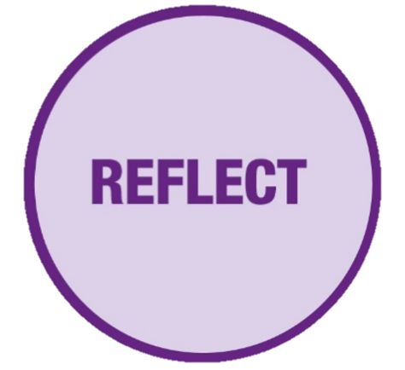
FOSIL: Learning by finding out for yourself.
Universal-Language-Reflect by The FOSIL Group is licensed under CC BY-NC-SA 4.0

Reflecting on my inquiry
Something interesting I learnt in this topic (or maybe something that surprised me)
What I thought I did well
What I thought I could do better
Something I would have liked to find out more about if we had more time
How did I feel about doing extended inquiry in Maths?
[Did it change the way I relate to Maths? Was it exciting/ interesting/ uncomfortable/liberating/ boring/ challenging etc]

