Accessing FOSIL resources: QuickStart guide
This document: Sharepoint -> Whole School Resources -> FOSIL Resources -> Accessing FOSIL Resources.docx
The best way to access FOSIL resources is through the FOSIL Group website. All resources are free to download and use and you do not need to register to do so.
You are free to use the resources as they are, adapt them yourself, or to ask Darryl & Jenny for support in creating something specific for your inquiry. If you do adapt a resource or produce something new, do let us know as we would love to hear what you are doing and (with your permission) to share it on the site.
There are three routes in to exploring the resources available.
- Start on the main FOSIL Cycle page
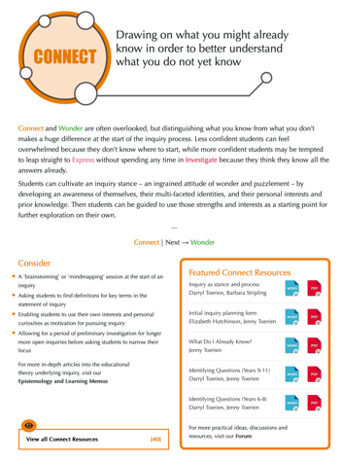
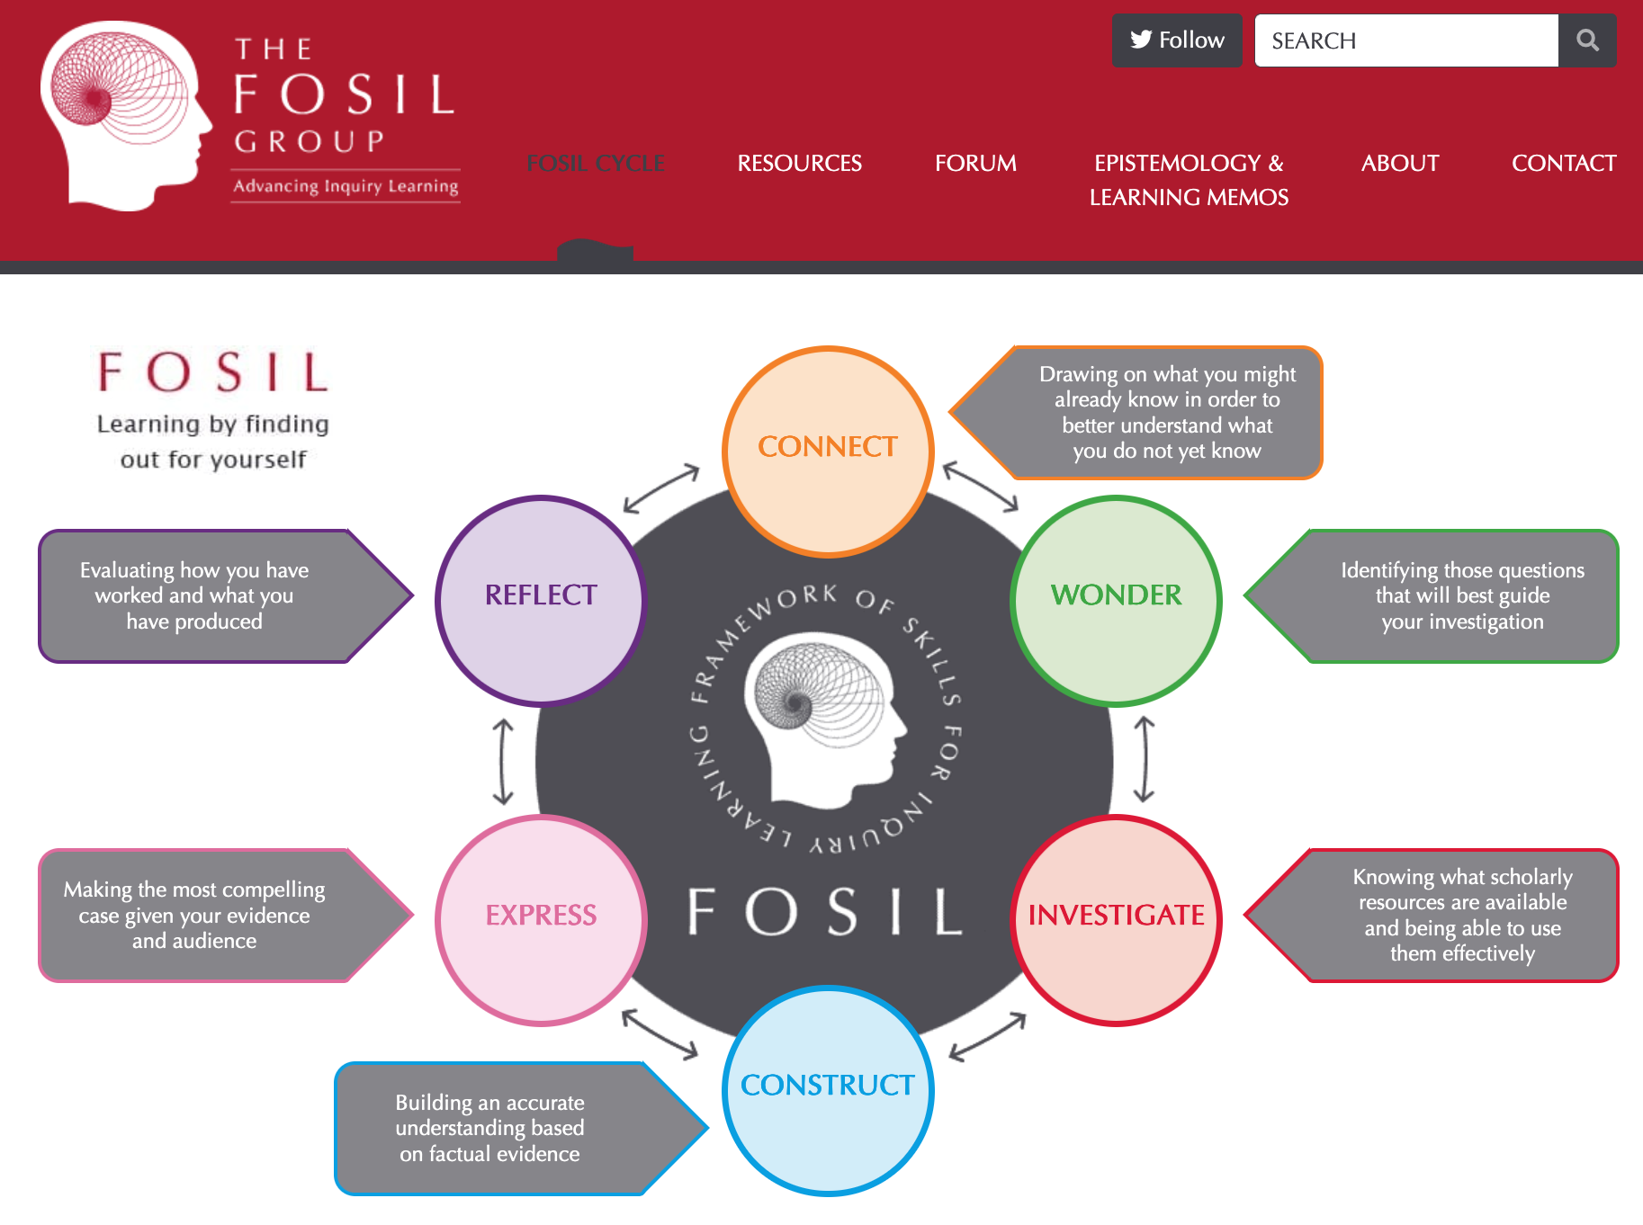
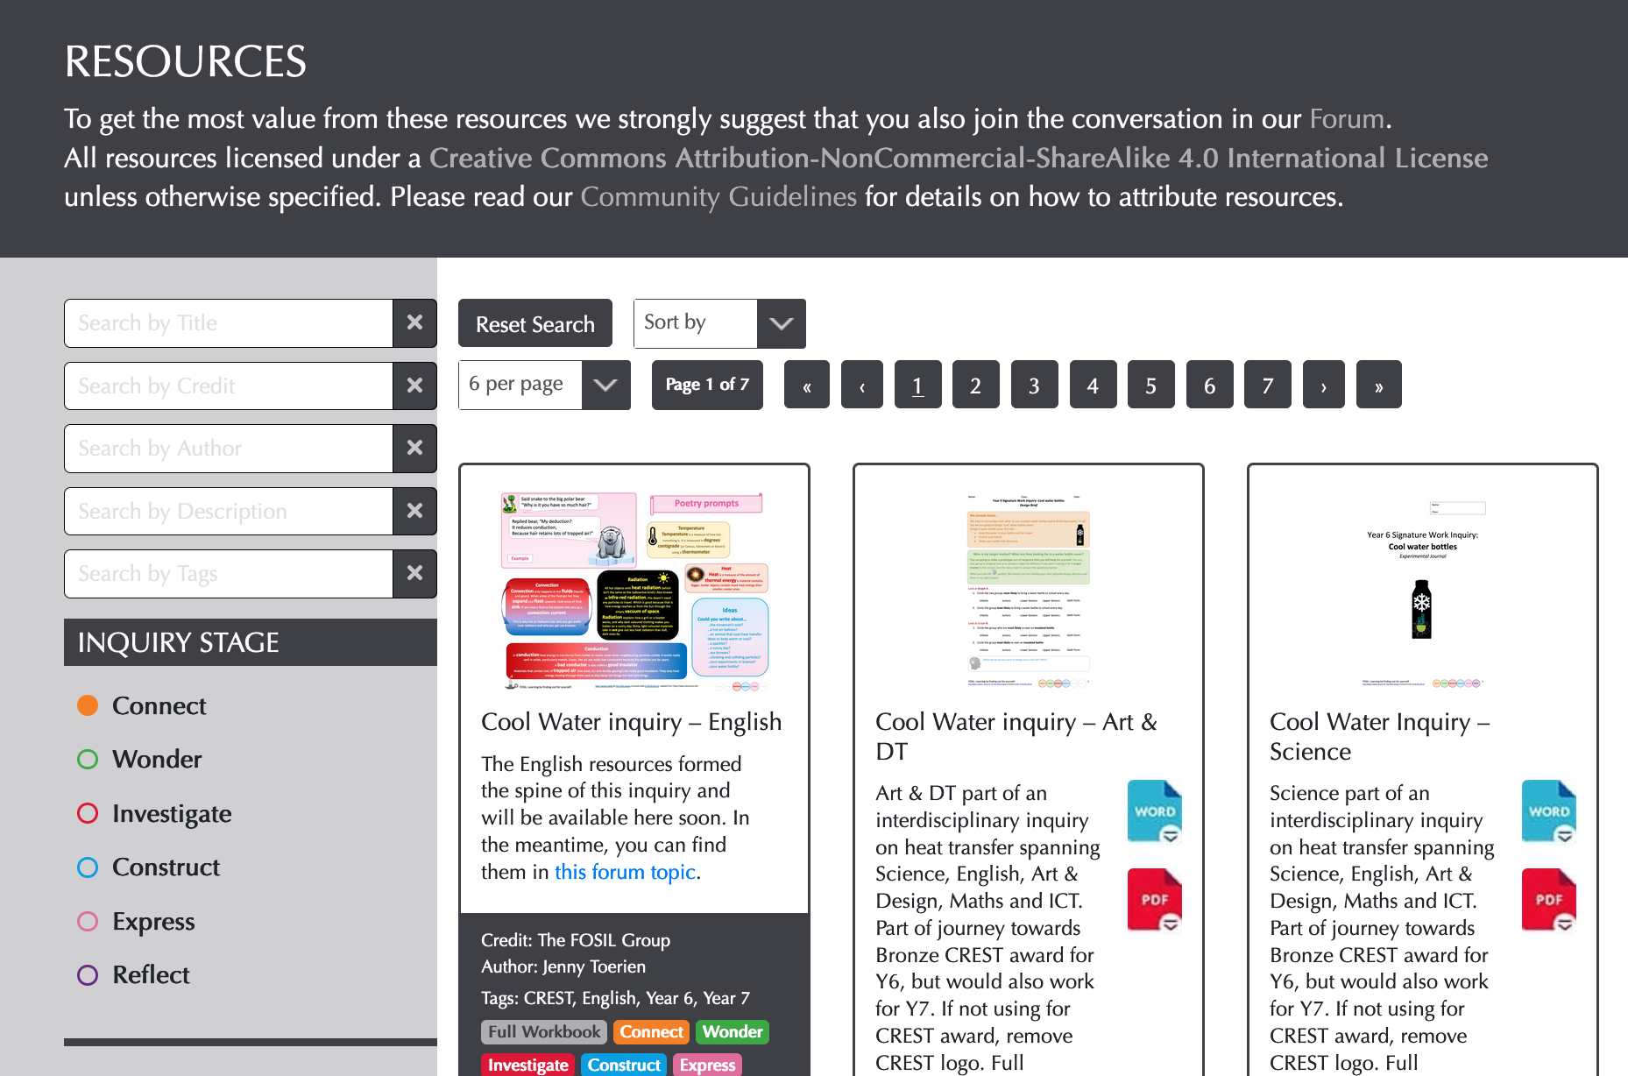
Click on a stage of the cycle that you are particularly interested in (or the link in the centre, which leads to the Skill Frameworks page). Each cycle stage has a page that explains that stage in more detail, gives some teaching tips to consider for that stage, recommends some featured resources to support that stage and gives a link to all resources that include that stage.

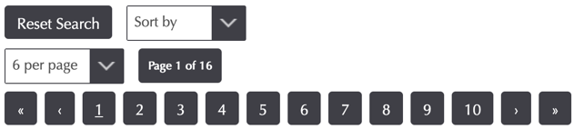
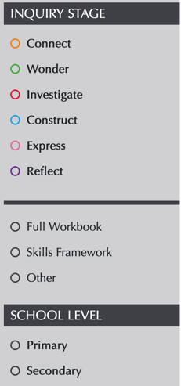
- Start on the Resources page
Here you can either browse using the controls at the top to scroll through all the resources or the radio buttons at the side to limit your browsing to a particular cycle stage, stage or school or type of resource. This is a particularly good way to access the Skills Framework, for example, and Full Workbook allows you to look at resources that cover a whole inquiry (from which you could then just choose to use resources from one or two stages that suit your unit).
Alternatively, you might prefer to search. The most useful searches when you are starting out are:
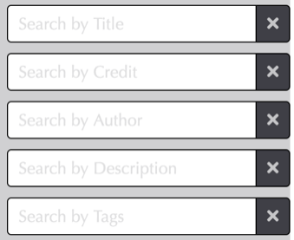
Title: Try searching for ‘Investigative Journal’, ‘Template’ or ‘Essay’ for some of our most immediately useful resources in a wide range of contexts.
Description: Could be useful if you remember something about a resource you want to access but can’t remember the title. E.g. you could type ‘CREST’ to see all resources with descriptions involving the CREST award, or ‘Forum’ to see all resources with linked forum posts.
Tags: These are often subjects or year groups, so you could try e.g. ‘Mathematics’, ‘Art’, ‘Year 8’ or ‘A-level’. While this is a good starting point, be aware that the tag will relate to the subject or year in which that resource was first used, and many resources have much broader use than that. If there are no resources tagged for your subject yet it does not mean that there are none that might be useful to you. Also, the tags at the bottoms of the resource boxes are hyperlinks, so you can just click on a tag you like to see all resources with that tag.
- Start in the Forums
The Forums are the place where most of the site activity happens. You do not have to be a member in order to read them, but you do need to sign up to join the conversations. Membership is entirely free and we would encourage you to join in the conversations because this is both where some of the best professional development happens and a form of group memory, making sure that insights aren’t lost to the community.
While all the forums are interesting, the most useful starting points are:
- The FAQs subforum in Announcements and General Information has a growing list of answered questions and general ‘how-tos’. If you do sign up as a site member, please read the subscribing to the forums FAQ.
- The Inquiry and Resource Design forum is really the heart of the site. This is the best place to go to get a sense of how the resources are used in the classroom, to get ideas for your own inquiries, and to post your own thoughts and comments (a super professional development tool and a great way to create your own online inquiry portfolio).
- The FOSIL Presentations forum is an archive of all the presentations we have delivered relating to FOSIL. This can be a useful place to look for a presentation that you have attended and wish to revisit, to browse FOSIL related professional development or to get ideas for your own presentations.
We hope you find the site useful. Please do come and have a chat or email us if you want some further support – or to tell us what you have been doing.

Creating your own resources
All resources on the site (unless otherwise stated) are shared under a Creative Commons Attribution-NonCommercial-ShareAlike 4.0 International License. You are welcome to adapt, use and distribute them under the same license. The Creative Commons wiki has an excellent article on best practices for attribution and you can see the full FAQ on this topic here: https://fosil.org.uk/forums/topic/how-should-i-attribute-resources-that-i-use-from-this-site/
If you are creating a resource from scratch, you might find the Templates helpful. You can access these by typing Template into the Title search box on the Resources page. Note that if you are creating a resource that you might like to share on the site in the future, you need to be particularly careful about potential copyright issues with content that you include (particularly images). We recommend using royalty/copyright free images in all your work as a matter of course. There are many sites that provide these - I generally use Pixabay, but there are plenty of other sites available.

