ZoteroBib quickstart guide
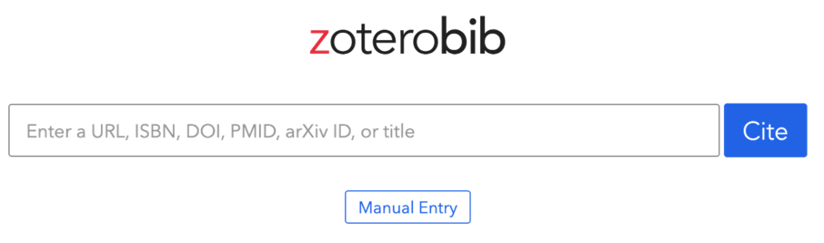

- Search for zoterobib OR go directly to https://zbib.org/
- For online sources paste the URL into the search box (see next section for books and other offline sources) and click ‘cite’.
- Check the result. Does it match your source?
  - Author (is this correct? Is it missing?)
  - Title (is this correct? Is it in sentence case Not Title Case)
  - Date (this is often missing)
- If something is missing or incorrect, click Edit. See over for examples.
- If you have a ‘Corporate Author’ (an organisation rather than a person, or a username rather than an actual name, you will need to change the author type (see below)
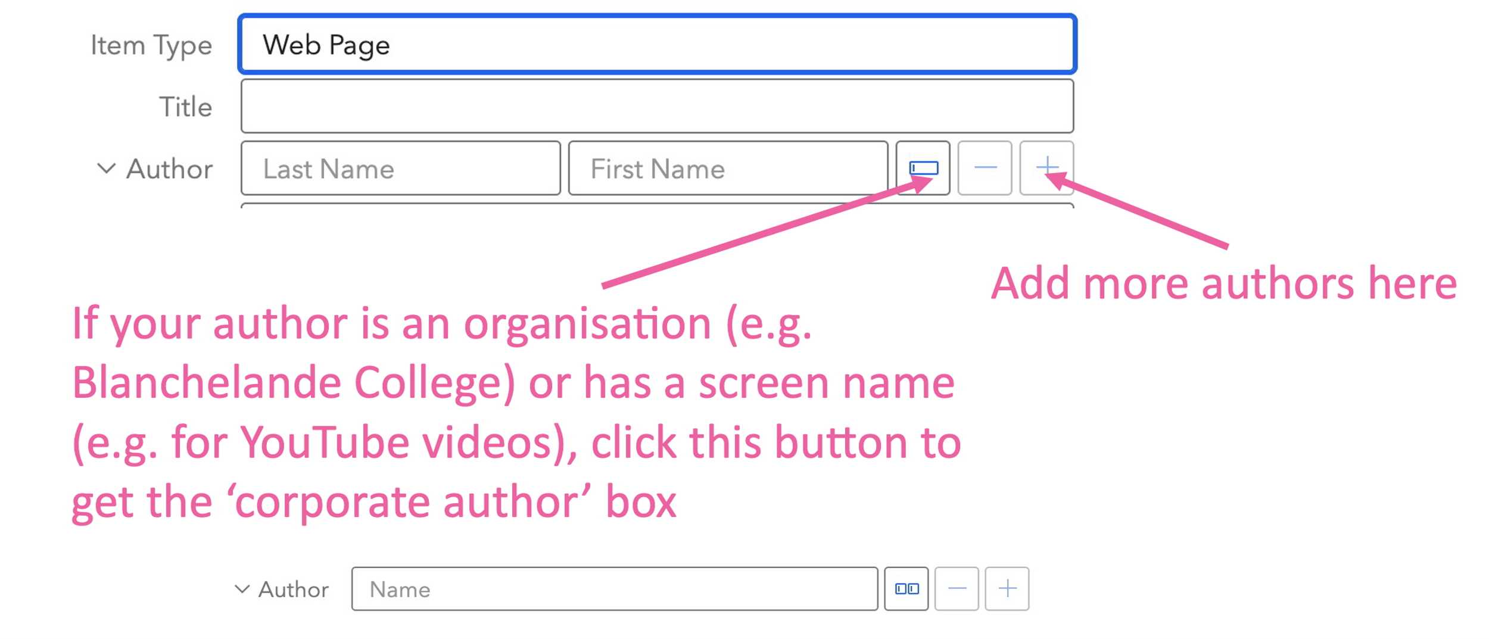
- When finished, click ‘Done’, then make sure you have selected the right referencing style
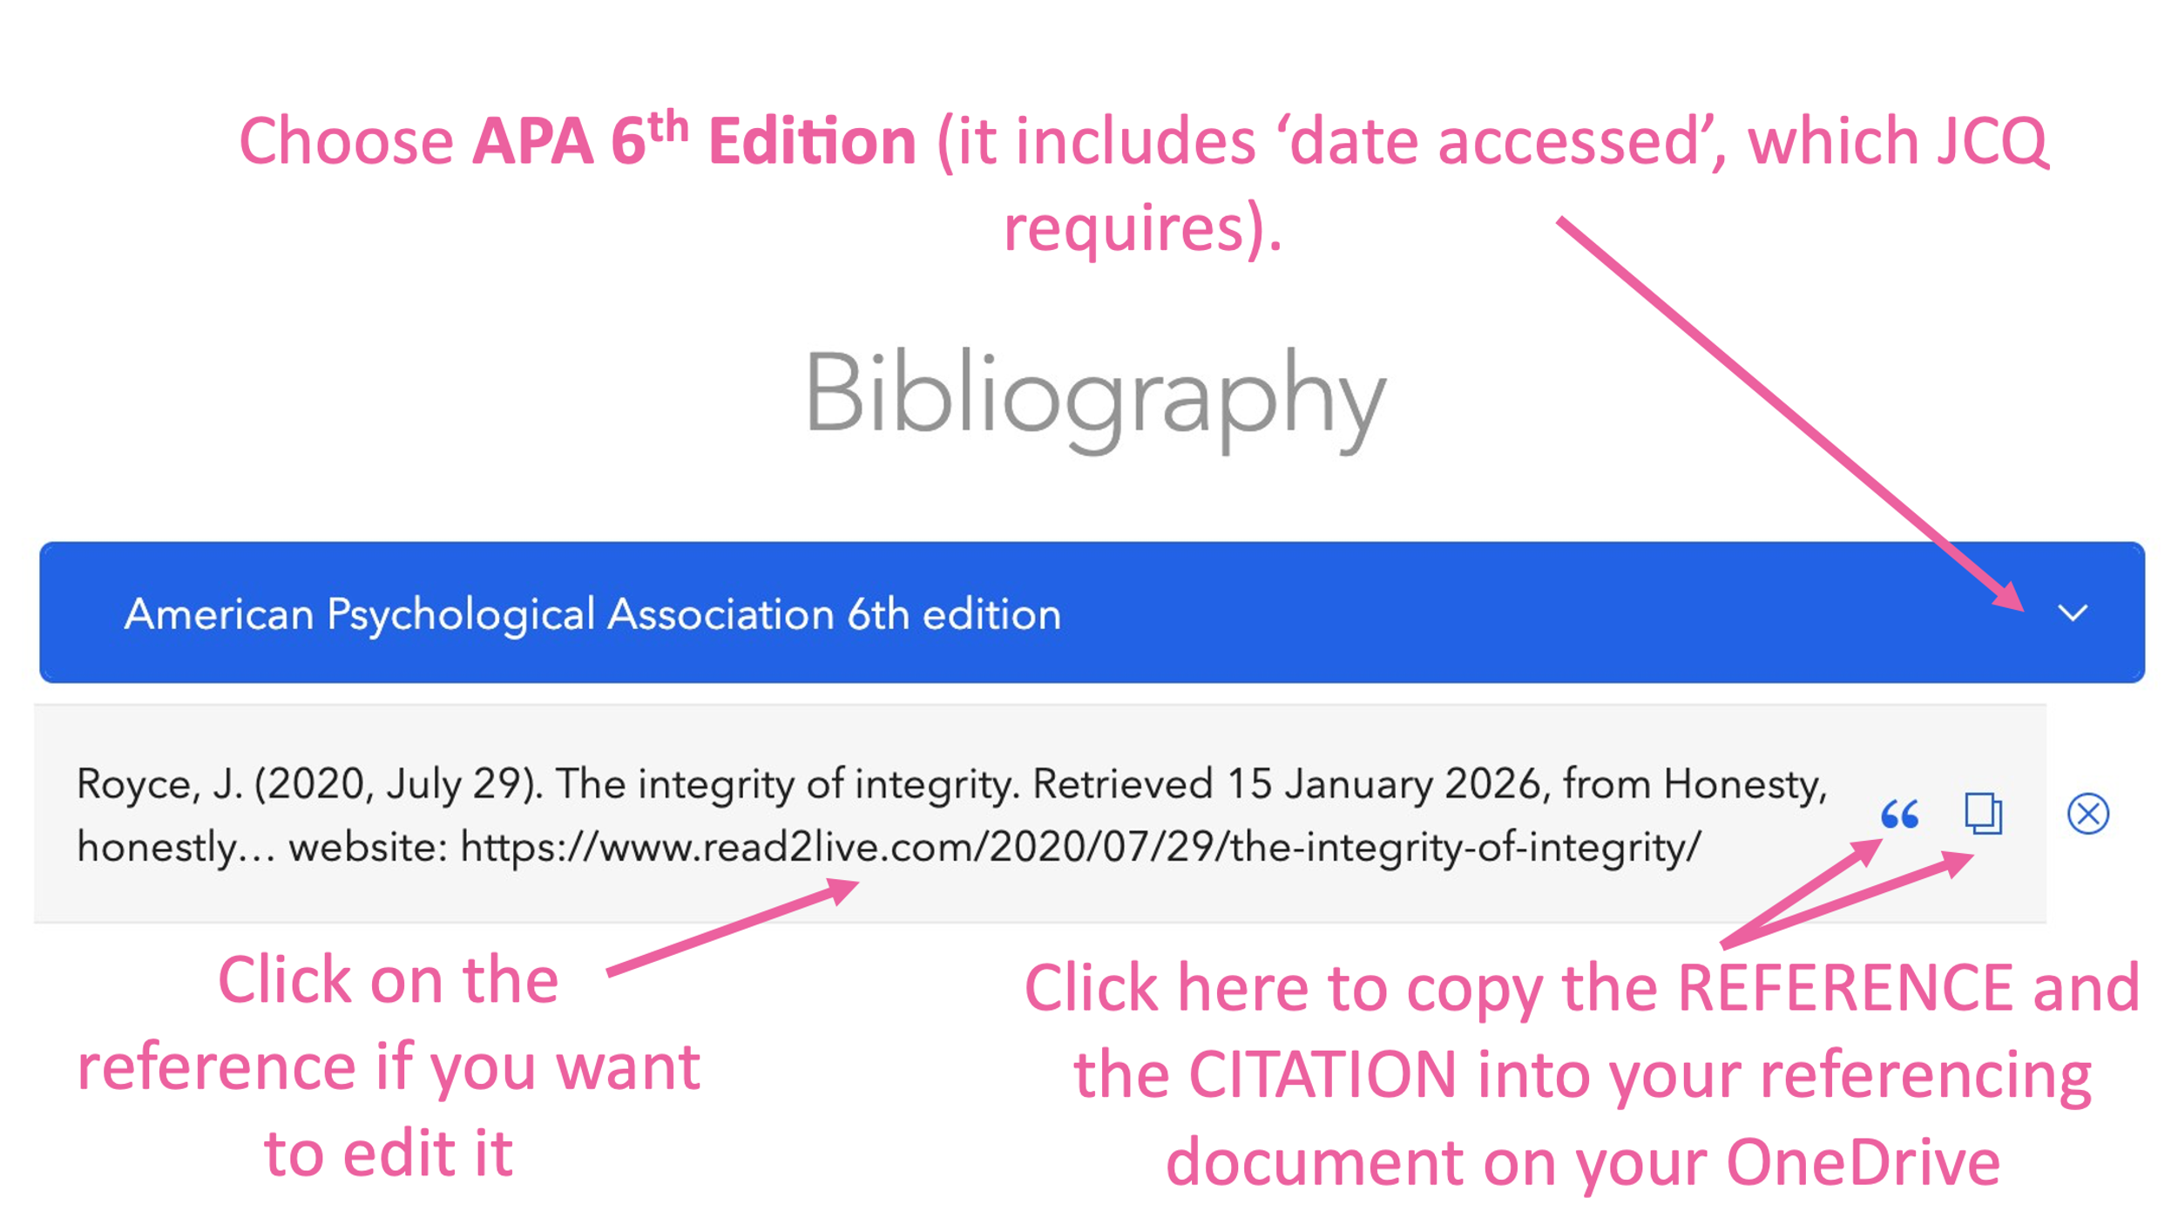

- Copy your reference and citation into your referencing document so they are ready to use in your report.

Common item types:
- Web Page: use for all types of website including YouTube videos. Leave Website Type blank except for videos, where you put Video!
- Book: use for most books
- Journal article: use for articles you find on sites like Google Scholar or JSTOR
- Book section: use if you have only used one chapter in a book where there are different authors for different chapters
- Newspaper/magazine article: best for PRINT newspapers and magazines. If you used an online version it is often easier just to reference as a website
- Podcast: for podcasts!
- Blog: can use this instead of website for sites that are obviously blogs – but it doesn’t matter too much

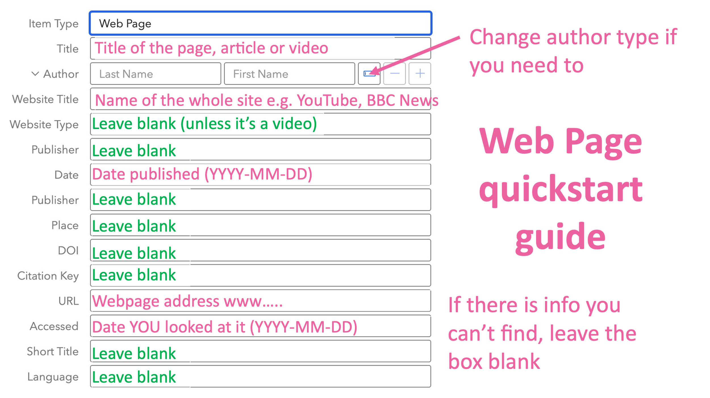
YouTube video example

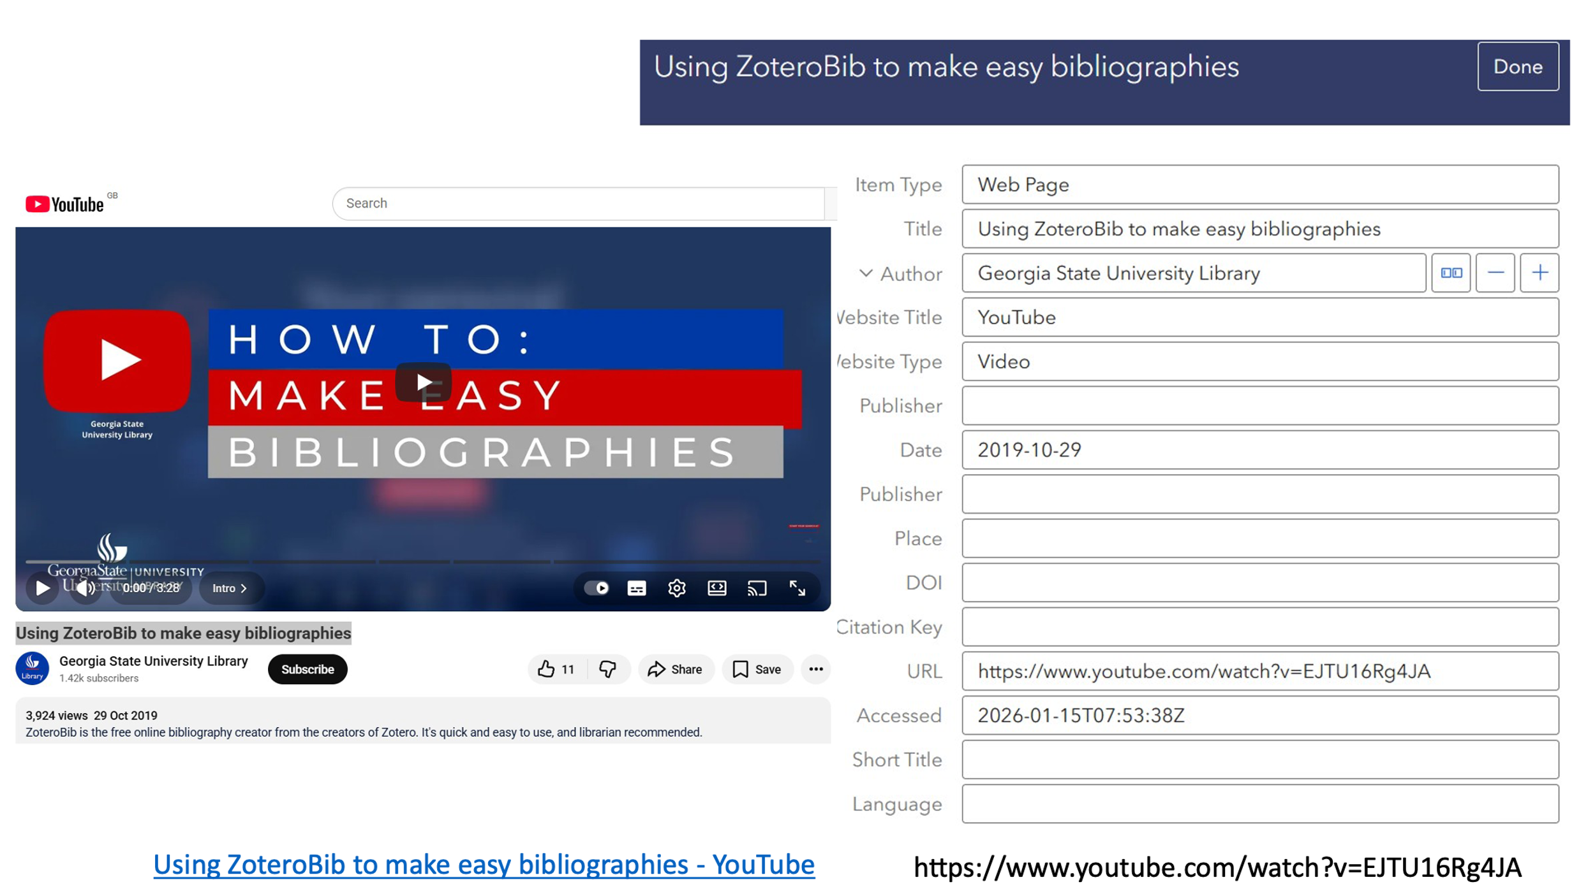

Books
If you know the ISBN (barcode on the back, or listed on the copyright page), paste it into the search box. This will often give you one, very accurate result, like the one below:
Watch out for odd punctuation and cases that you might need to fix (in the example below the place of publication is in square brackets, which should be removed).
Alcott, L. M. (2015). Jo’s boys. [London]: Puffin Books.
If you need to change anything, use the Edit function as for websites.
You only need to worry about the fields down to ‘place’ (unless you used an online copy of the book). You can ignore everything else.
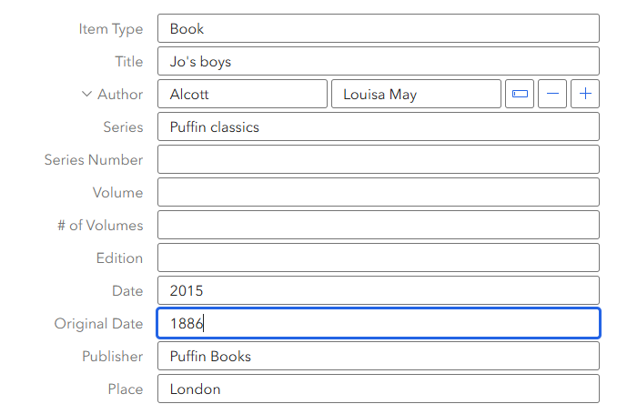
If the book says e.g. ‘2nd edition’ then type ‘2nd’ in the Edition box
For a classic book like Jo’s Boys, you will also want to add the original publication date. Only do this for books over about 20 years old!

You can also search for a book by title if you don’t know the ISBN, but this is much harder because you then have to sort through a list to work out which edition you used.

Journal Articles
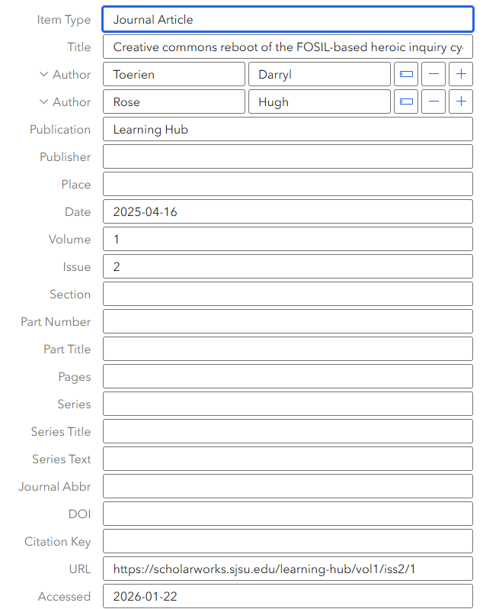
The URL can sometimes be a good place to find the volume and issue number or the date
If there is a print edition available, or if the article is a PDF, you should put the page numbers too

